**Stage 2**

**Look up**

**Value set**

**Flex field**

1. **Kff**
2. **Dff**
3. **Eff**

**An Oracle Database is a system for storing and managing data. It's like a digital filing cabinet where businesses keep important information, like customer details or inventory. It helps with quickly finding and organizing this information, making it easier for companies to handle large amounts of data efficiently and securely.**

**Iaas paas saas**

**• IaaS (Infrastructure as a Service): This is a cloud computing service that provides essential computing resources such as virtual machines, storage, and networks on demand. It's like renting a virtual data center where you can run your applications. You manage the operating system, applications, and data, while the service provider takes care of the underlying infrastructure.**

**• PaaS (Platform as a Service): This service offers a platform allowing customers to develop, run, and manage applications without dealing with the underlying infrastructure. It's like renting a complete development environment where you can focus on coding and testing your software without worrying about the hardware, operating system, or server management.**

**• SaaS (Software as a Service): This service delivers software applications over the Internet on a subscription basis. It's like renting software instead of buying it. You access these applications through a web browser, and the service provider manages everything behind the scenes, including the infrastructure, data, and updates.**

**Modules and products (STORE AS FND_APPLICATION_B (**this will have pk **) AND FND_ APPLICATION_TL(PK + LANGUAGE) )**

Financial - Accounting hub , general ledger , payables , receivables(credit to cash ) , Lease Accounting , treasury , fixed assets , expense report , project management .

Scm : entire production flow of goods or services — from the beginning stage of sourcing materials to delivering the final product to consumers

Hcm : This is about managing a company's workforce effectively, covering areas such as recruitment, onboarding, training, performance management, and employee engagement

We are using finance and hcm only in this course

Cx : This refers to how customers perceive their interactions with a company. It encompasses all touchpoints, from browsing a website to receiving support

Industry and compliance

**Process Flows p2p**

1. **Requisition: This is the process of requesting the items or services needed for the business. For example, an employee might request new office supplies like pens, paper, and a printer.**
2. **Identify the Supplier and Request for Quotation (RFQ): Once the requisition is approved, the procurement team identifies potential suppliers and asks them to provide quotes or offers for the requested items. For example, they might contact three different suppliers to get the best price for the requested printer and office supplies.**
3. **Negotiation with Supplier (Blanket Purchase Agreement): After reviewing the quotes, the procurement team negotiates terms such as price, delivery schedule, and payment terms with the chosen supplier. A blanket purchase agreement might be created, which is an agreement to purchase a certain amount of goods over a period of time at a set price. For example, the company might agree to buy all its office supplies from one supplier for the next year at a discounted rate.**
4. **Awarding the Negotiation (Accept the Supply): Once negotiations are finalized, the supplier is awarded the purchase contract. For example, the supplier and the company sign an agreement to supply the office materials.**
5. **Shipments:**
   * **Advance Shipment Notice: The supplier sends a notification that the goods are on their way. For example, the supplier might send an email stating that the printer and paper will arrive in three days.**
   * **Send Material: The supplier ships the requested items to the company. For example, the office supplies are delivered to the company’s address.**
   * **Inspection: Upon arrival, the company inspects the goods to ensure they meet the required standards. For example, checking the printer to make sure it functions correctly.**
   * **Put Away in Inventory: The items are added to the company’s inventory for future use. For example, the office supplies are stored in the supply closet.**

**Financial Fusion Model**

* **Generate Invoice for Payment: Once the goods are received and inspected, the supplier sends an invoice to the company’s finance department requesting payment for the delivered items. For example, the supplier sends a bill for the office supplies.**
* **Payment on Due Date: The finance department processes the invoice and schedules the payment to be made on the agreed due date. For example, if the payment terms are 30 days, the finance department ensures the supplier is paid within 30 days from the date of the invoice.**

IF THE SUPPLIER SEND RAM (RETURN MATERIAL AUTH) ONLY THEN RETURN IS POSSIBLE

DEBITE MEMO(IF WE ARE RAISING AGAINST THE SUPPLIER) AND CREDIT MEMO (IF SUPPLIER IS RAISING AGAINST US) BOTH ARE NEGATIVE INVOICES

IF THE SUPPLIER ASK FOR ADVANCE THEN WE WILL PROVEIDE THEM PRE PAYAMENT ADVANCE.

IF THE USER NEED SUPPLY URDENGTLY : SUPPLIER CHECKS FOR LIST OF USERS WHO FREQUENTLY PURCHASE SUPPLY

BLANKET PURCHASE AGREEMENT : NEGOCIATION WITH SUPPLIER

EMPLOYEE EXPENSE RECORD (POWER TO PURCHASE FOR CERTAIN LIMITS)

General ledger needs for transaction(any kind of payment hit the general ledger)

* ACCOUNT asset – current asset , long term asset, liability ,income, and expenses
* DEBIT OR CREDIT
* AMOUNT

TRANSACTION DATE

**ORDER TO CASH**

When an order is received o2c starts

Availability to promise

Check availibity

Order managment

1. Booking : it check the availability date , schedule the orders

Shipping module

1. Shipping : picking ,packing and shipping . after shipment wait for acknowledgment
2. Ship confirmation acknowledgement

Receivable module

1. Invoice from receivable module
2. Received payment

Cash management module

1. Bank reconciliation

**ORGANIZATION STRUCTURE**

TYPES

* LEGAL
* MANAGERIAL
* FUNCTIONAL

Interprise(company) have different legal entity and each entity have different ledger

LEGAL STRUCTURE : first company from where it starts

Before creating any …….ledger is imp

Their should be atleast **primary ledger** that will store payments or transaction and **secondary multiple ledger** is for hierarchical companies(india to us to uk) . there is also a **reporting ledger ie** if you wants to send multiple reports to any company or organization

**Create a ledger 4Cs**

Chart of account : structure instance of segments . we cannot update the chart of account . three mandortory segments are primary , cost center and natural account segment

1. Primary -

* Currency : This specifies the currency for ledger entries
* Callender : This sets the accounting periods, like fiscal years and quarters
* Account convention : This is the accounting method or rules followed, such as accrual or cash basis accounting. It governs how transactions are recognized and recorded.

Company

1 LE LE 2 LE 3 (ledger)

* 1. BU
     1. INVENTORY (PHYSICAL INV)

1.2.1.1 LOGICAL INV (Sub inv)













**LANGUAGE TRANSALATION**

TO use to have read lang according to us …either use _tl or Language = usernv(‘LANG’ )

**LOOK UP**

**FND_LOOKUP_TYPES_B(TABLE NAME)**

LOOKUP_TYPE



GENDER (LOOK UP)_ Gender(meaning) FND_LOOKUP_TYPES_TL



L-T L ANG MEANING (TRANSTABLE) SOURCE LANG

GEN US GENDER (GENDER VALUE) US

“ F SEX US F



“ G GEND US

“ H “ US

L_T_B

 Lt_TL L_T L_C

L_C_B GENDER M

“ F

LC_TL



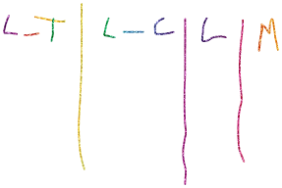TL TABLE ONLY HAVE MEANING AND DESCRIPTION

**VALUE SETS**

TO CREATE DROP DOWN

* INDEPENDENT : (EX LIST OF COUNTRIES INDIA, US, GERMAN) **(TRANSLATABLE)**
* DEPENDENT : (BASED ON VALUES OF INDEPENDENT VALUES FOR EXAMPLE IF THE VALUE IN INDEPENDENT IS INDIA THEN WE CHOOSE VALUES IN DEPENDENT AS HINDI MARATHI MALYALAM ETC. ) **(TRANSLATABLE)**
* TABLE : WE JUST HAVE TO WRITE SELECT STATEMENT THAT WILL TAKE VALUE FROM TABLES
* SUBSET : SUBSET IS SUBSET OF INDEPENDENT VALUE

HOW TO CREATE VALUE SET

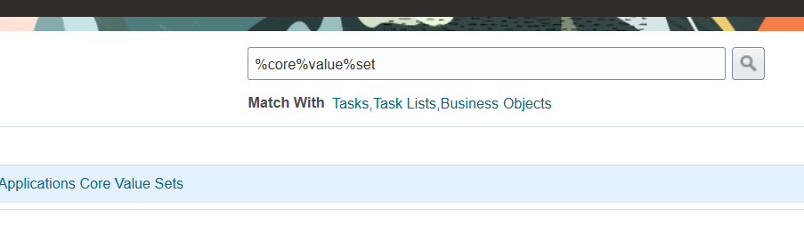

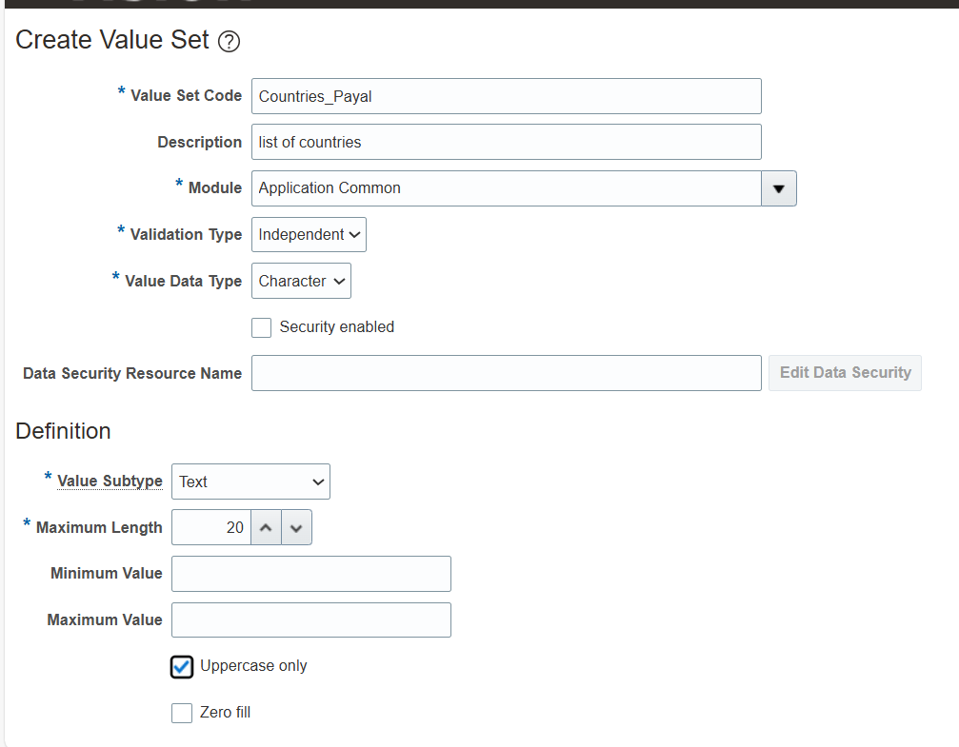

Save ……………manage values

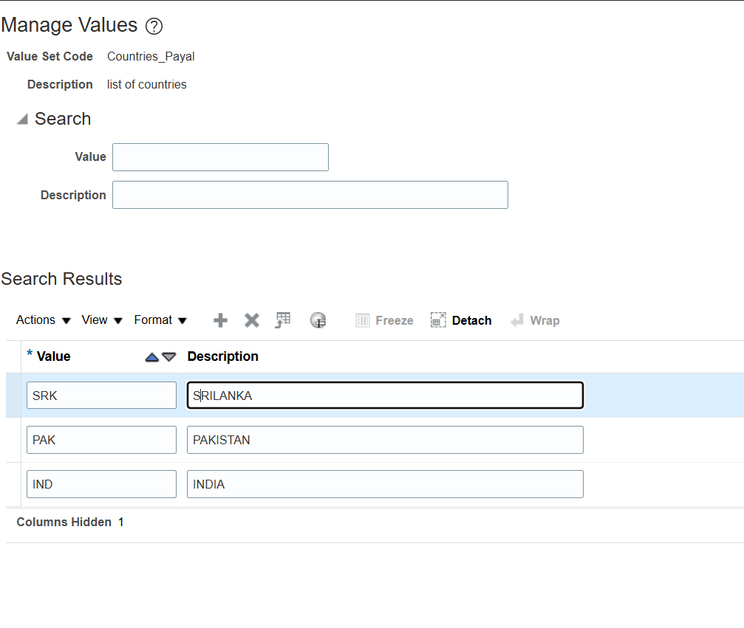

Create another value set

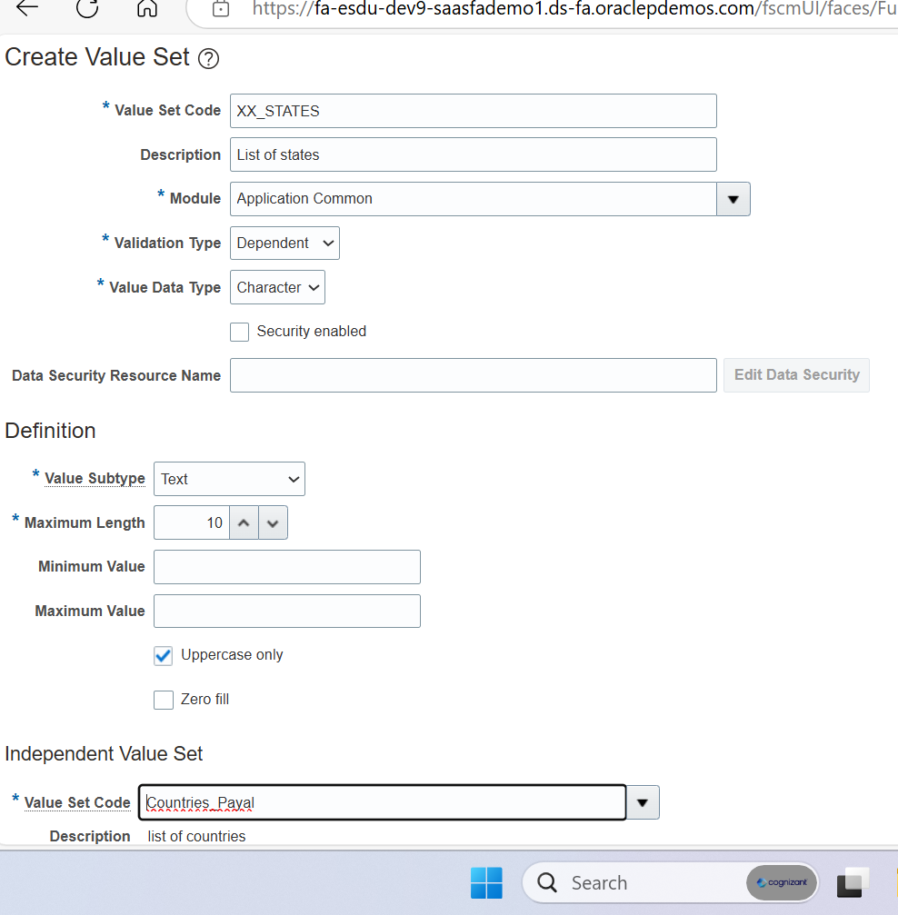

**NO . OF TABLES**

* **FND_APPLICATION_B TABLE INFORMATION AND APPLICATION**
* **“ “ _TL IF APPLICATION NAME IS SAME THEN …………………………………………………SEARCH BY FND NAME**
* **FND_LOOKUP_TYPES_B TYPES**
* **“ “ “ _TL**

**………………………………………………….**

* **FND_LOOKUP_VALUES_B CODES**
* **“ “ “ _TL**

**EXAMPLE**

**YES_NO**

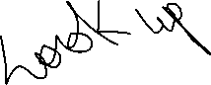

**Y YES**

**FLEX FIELDS**

Is created by us for users to enter data

* Key kff
* Descriptive dff
* Extensible eff

**Dff** : available in all screens

Stored in the same db record



Max # of columns is fixed (30 cols , 30 numbers)

Context is optional here



Attributes (fields)



**Context is way of grouping attributes**

**KFF : key is primary key here ,every combination of field is unique**

**Definition(class) and then instantiation(object)**



** Def instance**

** Context**

**Segments**

**EX. Locator**

**EFF : stores additional information about object**

**They are not available on all screens**

**Can store unlimited columns**

**Data is stored in another table**

**Eff can store multiple rows for a single context**

**Person extra info**

**Assignment extra info**

**Example of eff**

**Item name – pedigree**

**Context day wght qnt no. of feeding**

**Feeding info 0 5 50 3**

** 5 7 160 3**

**7 10 200 2**

**Like single name and context but multiple rows**



**IN CASE OF CONFIGURATION WE CAN ONLY CHANGE MEANING AND DESCRIPTION ONLY. THIS RULE IS ONLY FOR SYSTEM ORACLE**



**WE CAN DO ANYTHING LIKE DELETE OR UPDATE ON THE TABLE THAT WE CREATE**





**EX OF VALUE SET**

**PRECISION : TOTAL NO OF DIGITS INCLUDING DECIMAL POINT(PRECISION FOR 100.00 IS 6)**

**SCALE : AFTER HOW MANY DIGITS DECIMAL WILL COME (FOR 100.00 SCALE IS 2 )**

**Same dependent value can’t be repeated for the same independent value but same dependent value can be used for different independent value**

**How to create Lookup …manage common lookup**

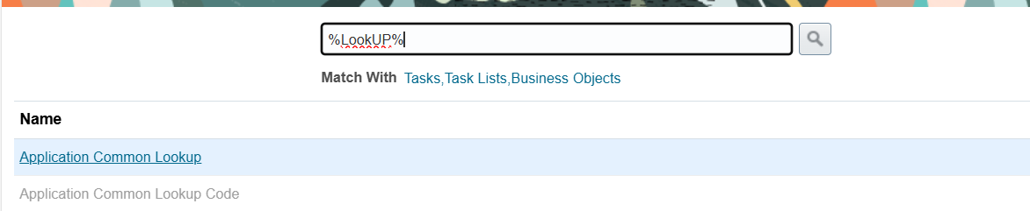

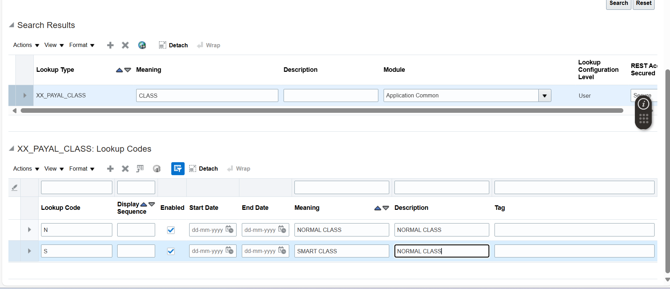

**How to create Descriptive FF**

**%payable%Desc%Flex%.............search invoices and edit………manage context ……..create context**

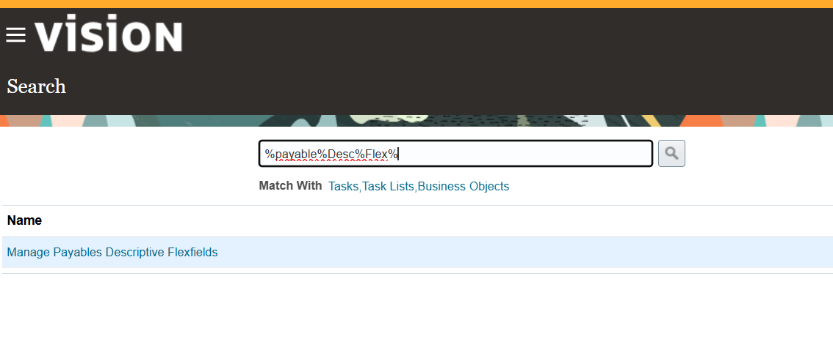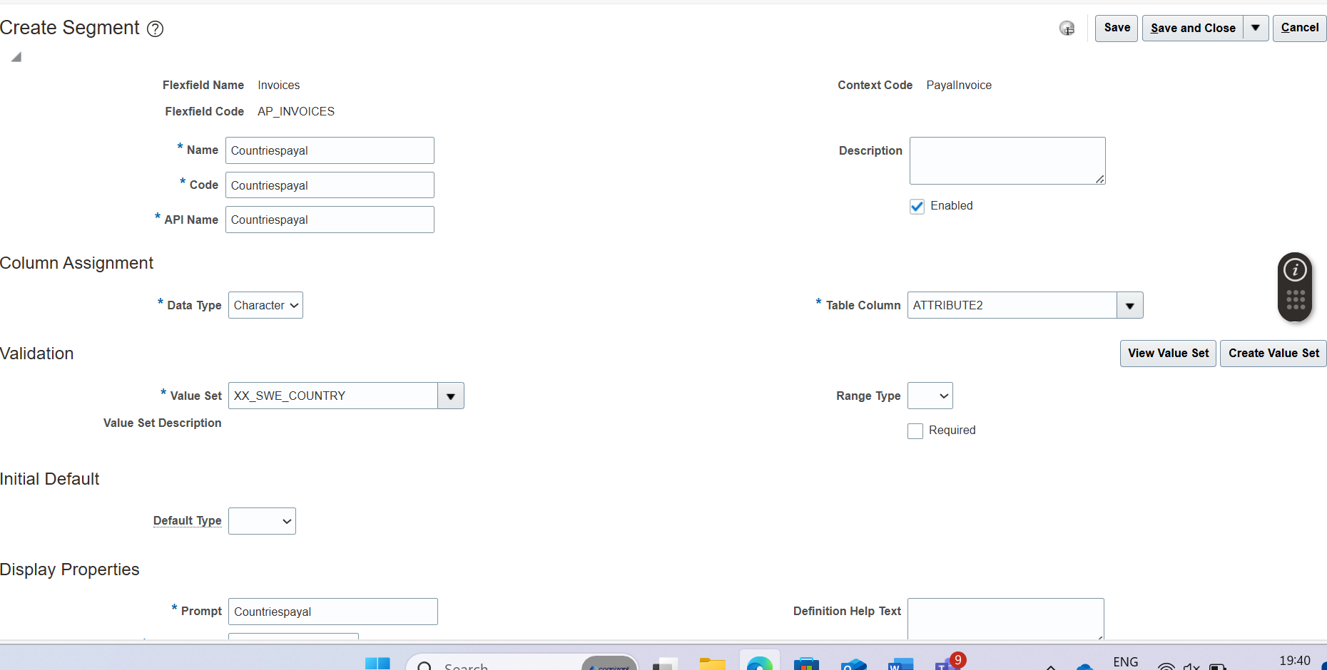

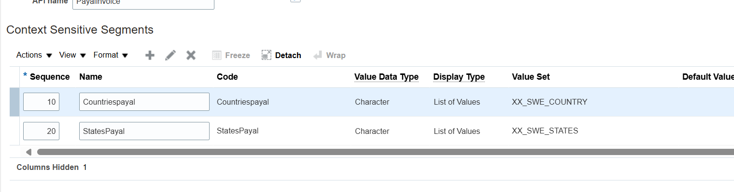

**Save and close deploy…………..go to home ………..payables….show more…….additional info…………**

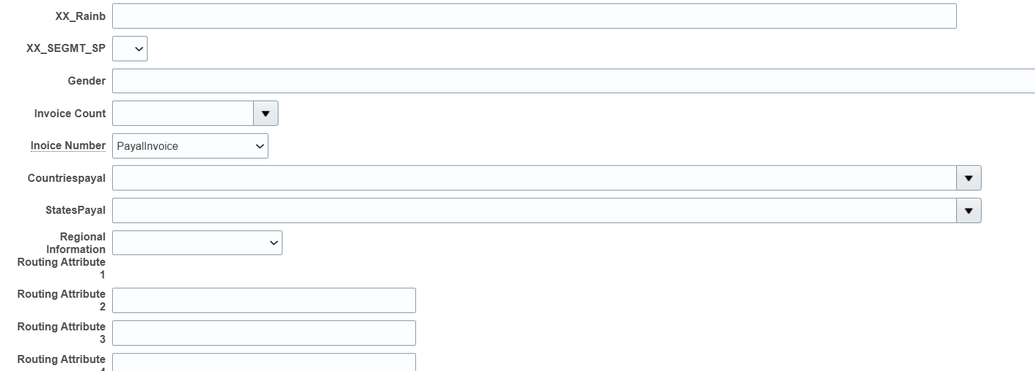

**How to create kff**

**%inv%value%set …………inventory management ………create value set with different name………….SAVE AND CLOSE**

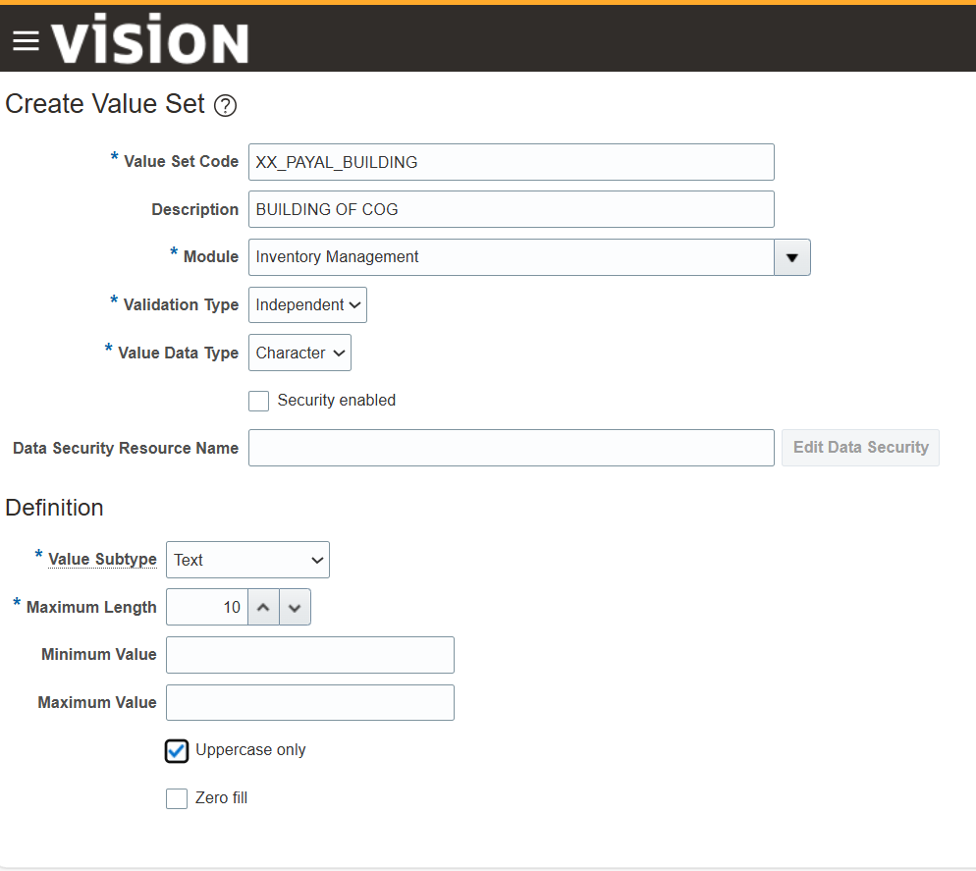

**First make value sets (building, department, racks)…save them and then open %inv%flex%fields**

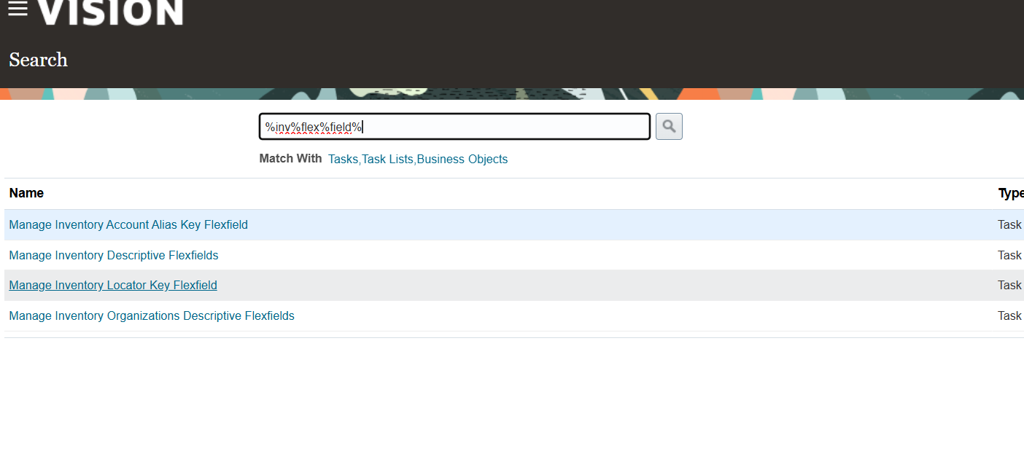

**Inventory manag…….manage structure……CREATE STRUCTURE**

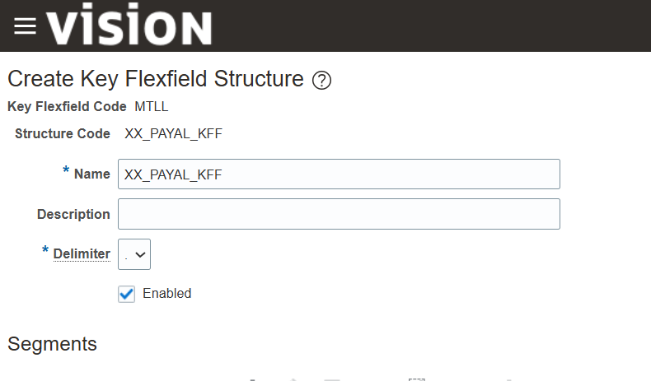

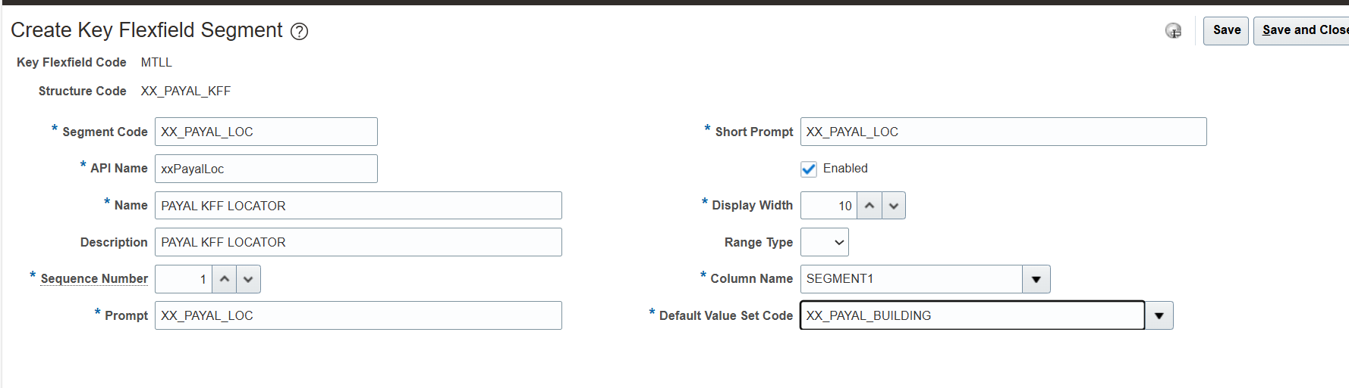

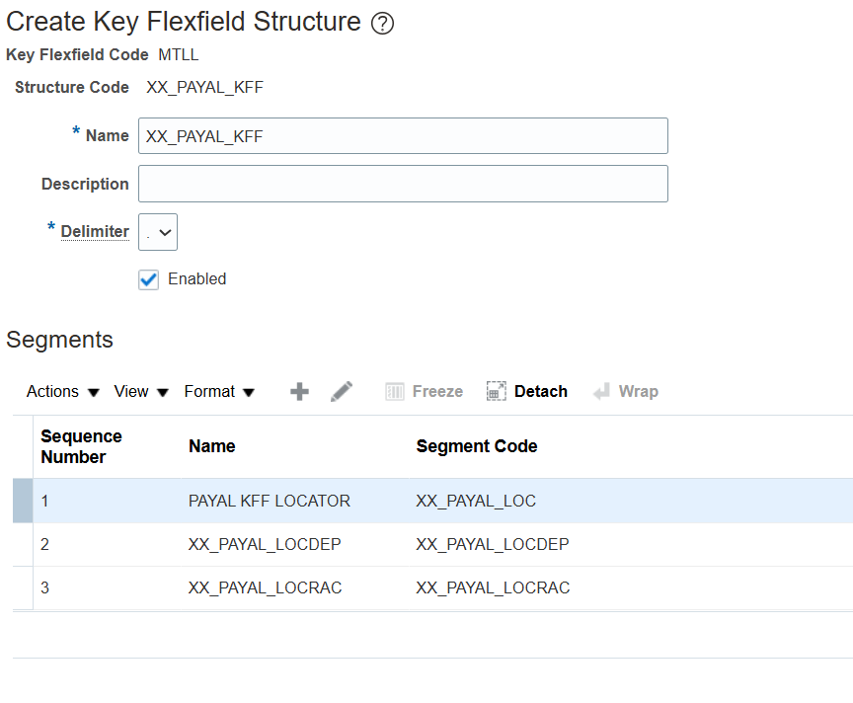

**Save till manage till deployment….then manage structure and instantance**

**Till now in manage structure we made classes now in manage and instances we are creating objects**

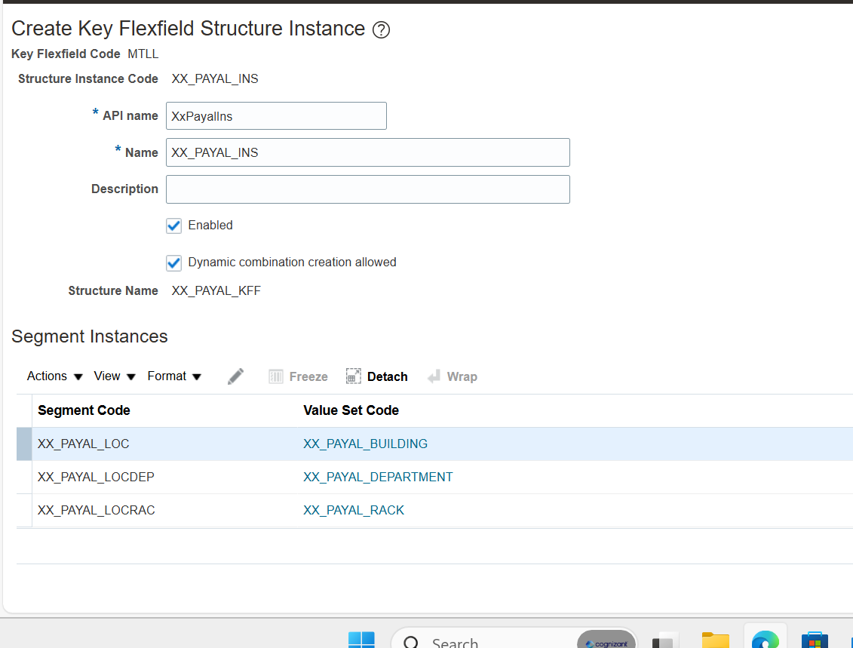

**SAVE TILL DEPLOYMENT**

**To check its working or not**

**%sub%inv%loc**

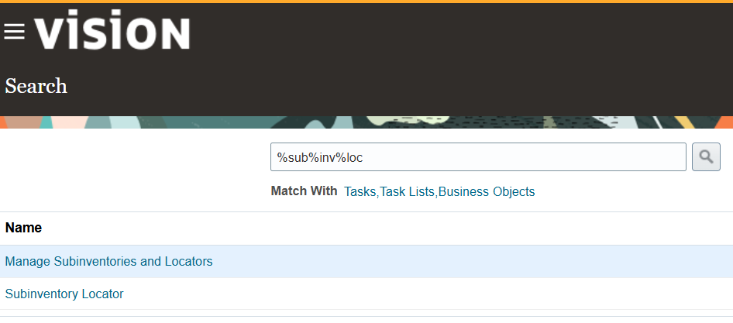

**sub inventory (means creating the space next only we can add the product)**

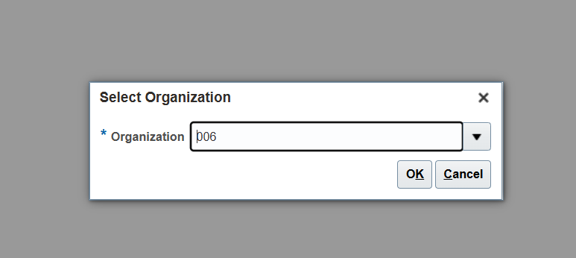

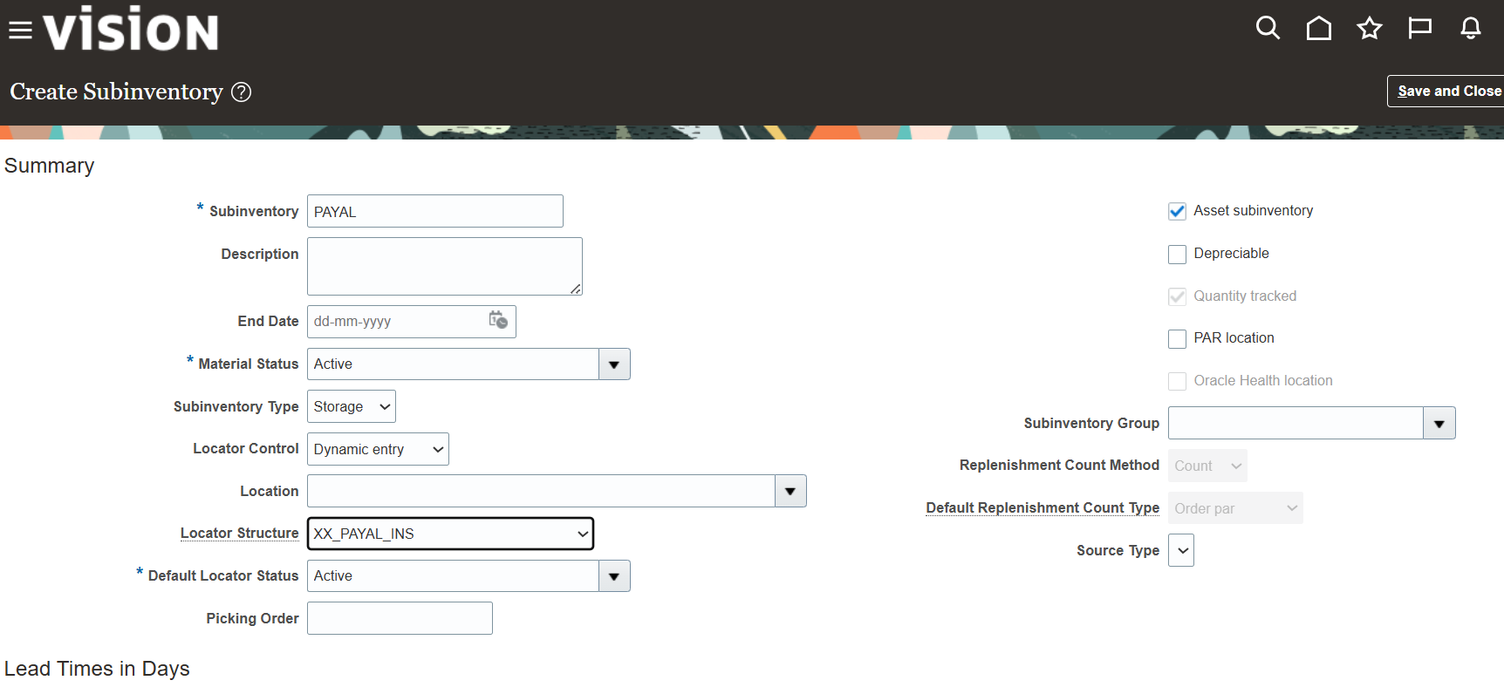

**MANAGE LOCATOR**

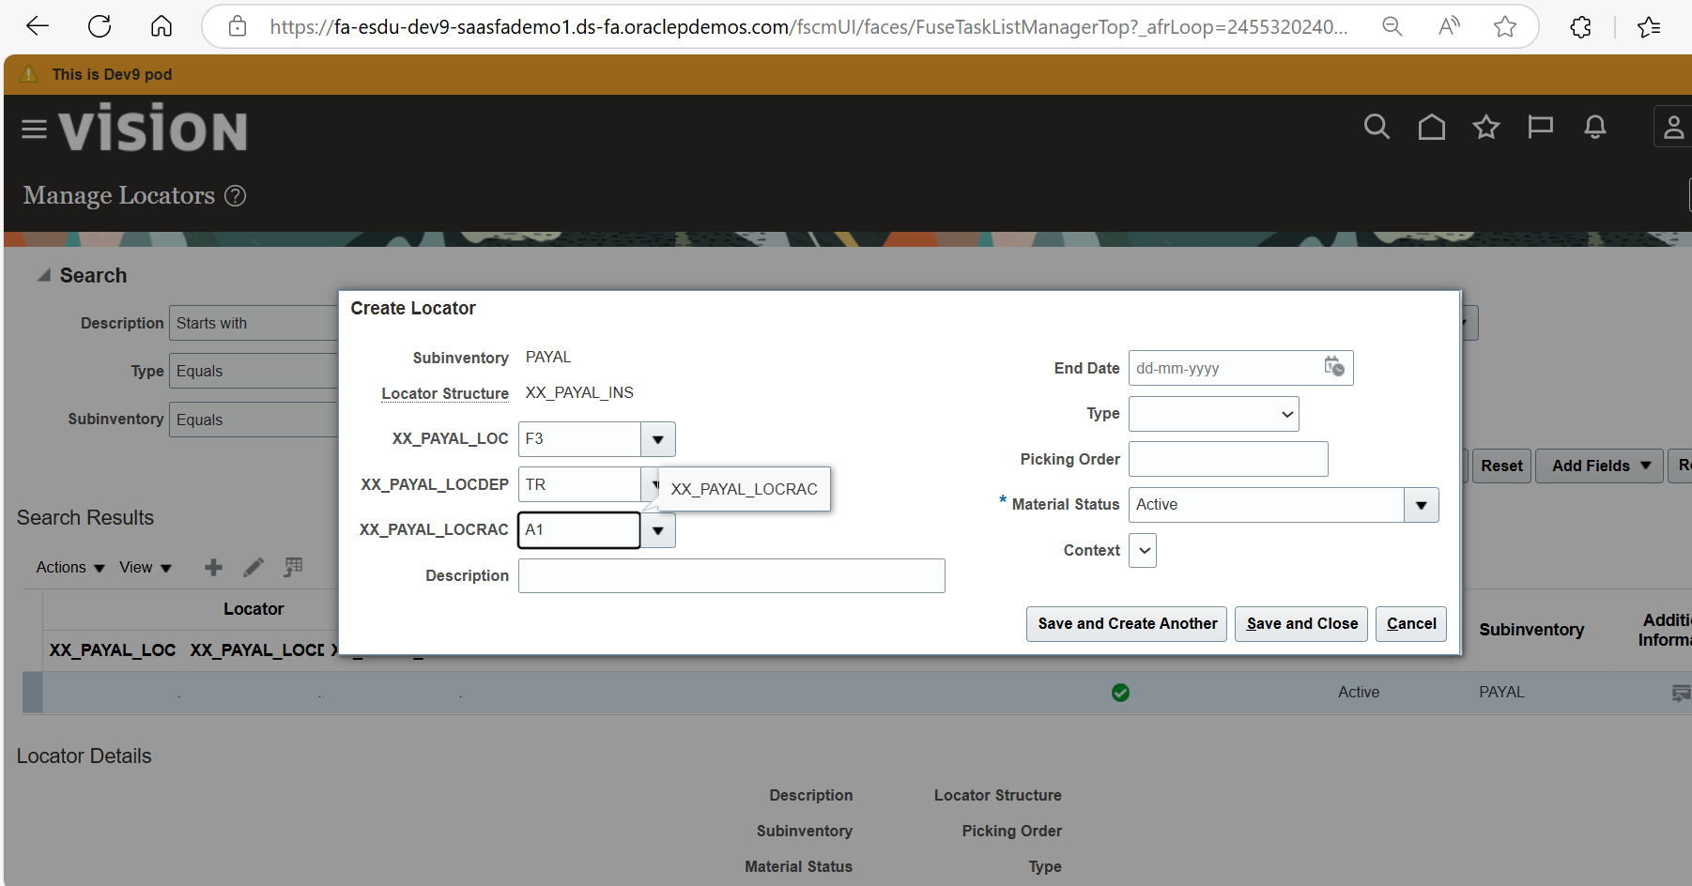

**EXTENSIBLE FLEX FIELD**

**%EXT%FLEX%FIELD% manage extensible field search item item extended attributes manage context create context context sensitive segments (then create 3 names AND one for time) save and close till manage extensible flexfield**

**Associate whatever we created**

**Again pages and attributes pages create page name(payal attributes) then look down and see attributes group then do select and add search payal contributor save ……DONE save and close till manage extensible fleaxfield**

**%EXT%FLEX%FIELD% manage extensible field search item item extended attributes manage context create context context sensitive segments CREATE SEGMENT FOR TIME THEN SAVE SAVE AND CLOSE TILL MANAGE EXTENSINBLE**

**LOGOUT LOGIN HOME PAGE PRODUCT MANAGEMENT PRODUCT INFORMATIO N MANAGEMENT SEARCH ITEM – ITEM AND AS00104 SELECT ANY ITEM SPECIFICATIONS SELECT YOUR OPAGE UNDER ITEMS ADD ROW AND THEN ADD DATA SAVE**

**G**

**bv**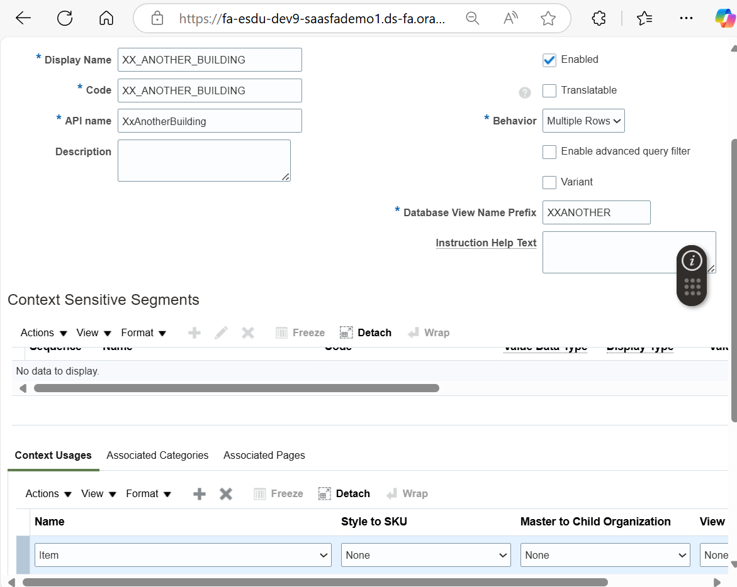

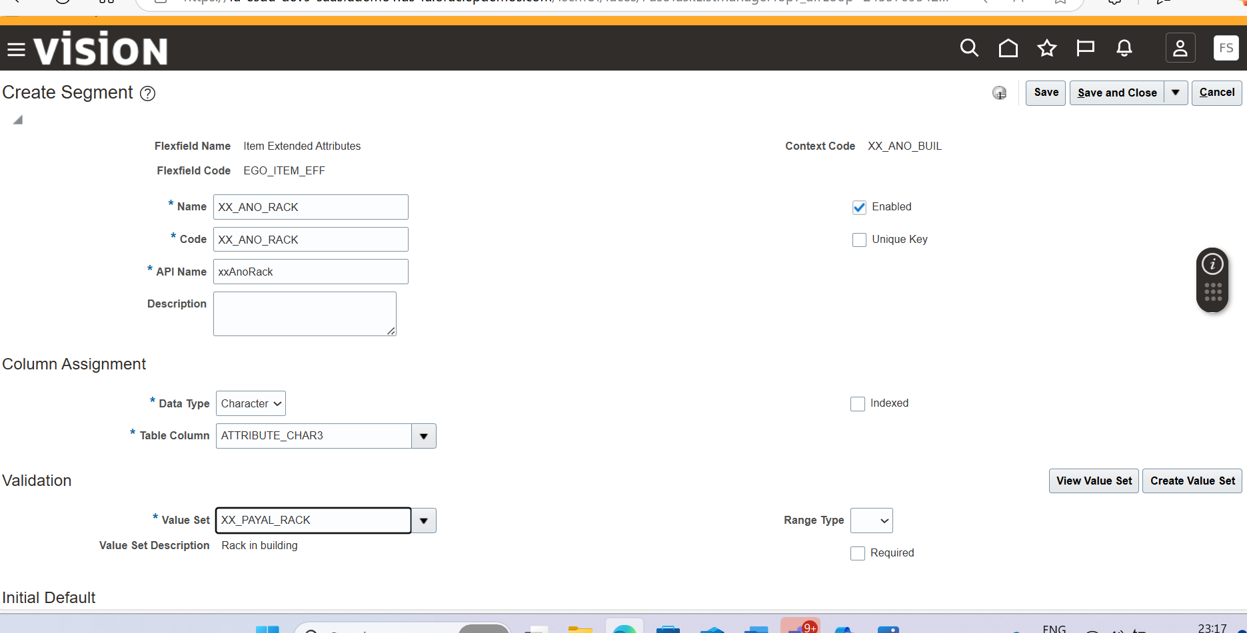

**SECURITY IN ORACLE**

**TYPES**

**FUNCTION SECURITY : ANY TASK THAT WE ARE DOING IS FUNCTION SECURITY LIKE CREATE INVOICES**

**DATA SECURITY: ON DATA WHICH WE ARE DOING TASK IS DATA SECURITY**

**FUNCTION SECURITY**

**EACH TASK WE PERFORM IS PRIVILEDGES ,**

**PRIVILEDGE AND ABSTRACT CANNOT DIRECTLY ASSIGN TO USER**

**DUTY ROLE CAN STORE ONE OR TWO ABSTRACT ROLES**

**JOB ROLE**

**USER CAN ONLY ACSESS EITHER DUTY ROLE OR JOB ROLE**

**PROFILE OPTION**

**set variables and values**

**config variable = value**

**AFLOF_PATH = /…./…/…../….**

**AFLOG_LEVEL = S**

**SEARCH %PROFILE%OPTION% MANAGE PROFILE OPTIONS SEARCH FOR AFLOG SELECT AFLOG ENABLED AND THEN EDIT**

**[ SET VALUES to a config var ]**

**AFLOG – level = severe/info/warning**

**While defining the variable we can set the default value**

**Definition = manage profile options**

**Set variable = query that perform the validation of the max 2 column values.**

**1 column visible (visible to user)**

**2 column (is basically kind of primary key that will only useful in database for retrieving values)**

**Security**

**Enable & updatable**

**Can set can update**

**Priority goes from bottom**

**Eg:= level enable (set the values) updatable**

**Site yes -**

**Profile (product) - -**

**User yes yes**

**Set value :- manage administrator profile values**

**Site**

**Product**

**user**

**ACCESS TABLES**

**Referring to oracle docs**

If we want to refer to a important table in the p2p then we have to go to payables and in the payable section there are some table that are important that we have to identify

One of the most important tables in Oracle Fusion (**Receivables)** is **RA_CUSTOMER_TRX_ALL**. This table stores the header information for all receivables transactions, including invoices, debit memos, and credit memos. Key columns in this table include:

* **CUSTOMER_TRX_ID**: The primary key for the transaction.
* **TRX_NUMBER**: The transaction number.
* **BILL_TO_CUSTOMER_ID**: The ID of the customer being billed.
* **TRX_DATE**: The date of the transaction.

|  |  |
| --- | --- |
| * ar_interest_headers_all | * INTEREST_HEADER_ID |

**The RA_CUSTOMER_TRX_ALL table in Oracle Fusion is crucial for managing invoice, debit memo, credit memo, and bills receivable information. Here are some of the most important columns that are frequently used:**

1. **CUSTOMER_TRX_ID: The unique identifier for each transaction.**
2. **TRX_NUMBER: The transaction number.**
3. **TRX_DATE: The date of the transaction.**
4. **BILL_TO_CUSTOMER_ID: The identifier for the billing customer.**
5. **SOLD_TO_CUSTOMER_ID: The identifier for the customer to whom the goods or services are sold.**
6. **SHIP_TO_CUSTOMER_ID: The identifier for the customer to whom the goods are shipped.**
7. **SET_OF_BOOKS_ID: Identifies the ledger associated with the transaction.**
8. **CREATION_DATE: The date and time when the row was created.**
9. **LAST_UPDATE_DATE: The date and time when the row was last updated.**
10. [**LAST_UPDATED_BY: The user who last updated the row**](https://docs.oracle.com/en/cloud/saas/financials/24b/oedmf/racustomertrxall-5191.html)

**IMPORTANT TABLE IN ORACLE DOCS UNDER RECIEVABLE SECTION**

**day-to-day accounts operations. Billing, Receivables Balances, Revenue Management, and Credit Management.**

* **AR_CMGT_CREDIT_DATA_INT**

**This table contains the imported credit data.**

**Pk: CREDIT_DATA_ID  This column uniquely identifies each credit data entry, making it essential for tracking**

**PARTY_ID: This column uniquely identifies the customer associated with the credit data, which is crucial for linking credit information to specific customers.**

* **AR_PAYMENT_SHEDULES_ALL**

**Tracks payment schedules for transactions.**

**PAYMENT_SCHEDULE_ID:  this is a primary key that tracks  payment schedule entry,**

**Amount_due_remaining : Indicate remaining amount due , easy to understand outstanding amount**

**AR_CASH_RECIEPTS / RECOS /**

**CASH_RECEIPT_ID: this is a primary key which mainly tracks entry of cash receipts**

**Amount : amount of the cash receipts.**

**Tracks cash receipt details.**

* **RA_CUSTOMER_TRX_LINES_ALL**

**This table stores line information about invoices, debit memos, credit memos, and bills receivable.**

**PK:**

1. **CUSTOMER_TRX_LINE_ID: The primary key for the table, uniquely identifying each transaction line.**
2. **CUSTOMER_TRX_ID: A foreign key linking to the RA_CUSTOMER_TRX_ALL table, which stores the header information for the transaction.**
3. **LINE_TYPE: Indicates the type of line, such as 'LINE' for regular invoice lines, 'TAX' for tax lines, 'FREIGHT' for freight lines, and 'CHARGES' for other charges.**
4. **DESCRIPTION: A description of the transaction line.**
5. **QUANTITY_ORDERED: The quantity of the product ordered.**
6. **QUANTITY_INVOICED: The quantity of the product invoiced.**
7. **UNIT_SELLING_PRICE: The selling price per unit for the transaction line.**
8. **EXTENDED_AMOUNT: The total amount for the transaction line, calculated as quantity multiplied by the unit selling price.**

**TCA (TRADING COMMUNITY ARCHITECTUR)**

**SUPPLIER**

** CUSTOMER**

** HZ_PARTIES(BANK)**

** BANKS**

** EMPLOYEE**

**HZ_PARTY_RELATIONASHIP**

** HZ_PARTIES_SITES(BRANCH) HZ__LOCATIONS**

** HZ_PARTIES_SITE_USES**

** SUPPLIER**

**PARTY POZ_SUPPLIERS POZ_SUPPLIER_CONTACT**

**PARTY SUPPLIER POZ_SUPPLIER_SITES_ALL_M**

**PSU**

**CUSTOMER**

**P HZ_CUST_ACCOUNTS**

**PS HZ_CUST_ACCT_SITES_ALL**

**PSU HZ_CUST_SITE_USES_ALL**

Customer specific table

party

1. **HZ_CUST_ACCOUNTS**: This table stores information about customer accounts. Each customer account is associated with a party and can have multiple sites and contacts.

Party site

1. **HZ_CUST_ACCT_SITES_ALL**: Contains information about customer account sites, including site usage (e.g., bill-to, ship-to).

Party site uses

1. **HZ_CUST_SITE_USES_ALL**: Stores the specific uses of customer account sites, such as billing or shipping purposes.

**BANK**

**AP_BANKS**

**_BANK_BRANCHES**

**AP_BANK_ACCOUNTS**

**BI PUBLISHER**



**ONLINE OLTP (ORACLE DB) DATA WAREHOUSE (ESS BASE)**

**(NEW DATA OR RECENT DATA) OLD DATA**



**TWO REPORTS ARE POSSIBLE FINANCIAL REPORTING STUDIO**

* **BI PUBLISHER (FRS)**
* **OTBI(ORACLE TRANSACLTIONAL BUSSISNESS)**

**ARCHITECTURE**

**BIP WORKS IN THREE STAGES**

1. **GENERATES : THE DATA WE CAN USE SQL TO GENERATE DATA , W/S,EXCEL . DIFFERENT SOURCES OF DATA WILL COMBINE TOGETHER TO MAKE IT REPORT**



1. **PUBLISH THE DATA : RICH TEXT FORMAT (RTF) WHICH GENERATE HTML DDL XCEL WORDPPT ETC**



**THEN XPT**

**THEN WE HAVE EXCEL ONLY GENERATE EXCEL**

**PDF THAT ONLY GENERATE PDF**

**ETEAXT THAT WILL GENERATE TEXT**



1. **DISTRIBUTE THE DATA : MEANS WHERE TO SEND REPORT IE. BY EMAIL ATTACHMENT , PRINT IT , FAX, ETC**

**LEFT THREE DOTS TOOLS REPORTS AND ANALYTICS BROWSE CATALOG select my folder on above that drop icon Is there select and create new folder with payal name expand again drop icon data model**

**Write this select query**

**select papf.person_number, ppnf.first_name, ppnf.last_name**

**from per_all_people_f papf, per_person_names_f ppnf**

**where 1=1**

**and trunc(sysdate) between papf.effective_start_date and papf.effective_end_date**

**and trunc(sysdate) between ppnf.effective_start_date and ppnf.effective_end_date**

**and papf.person_id = ppnf.person_id**

**and ppnf.name_type = 'GLOBAL'**

**and ppnf.first_name like :P_FIRST_NAME || '%'**

**YOU NEED SEE QUERY IS WORKING FINE OR NOT**

**Dat select rows view**

**Then go to structure**

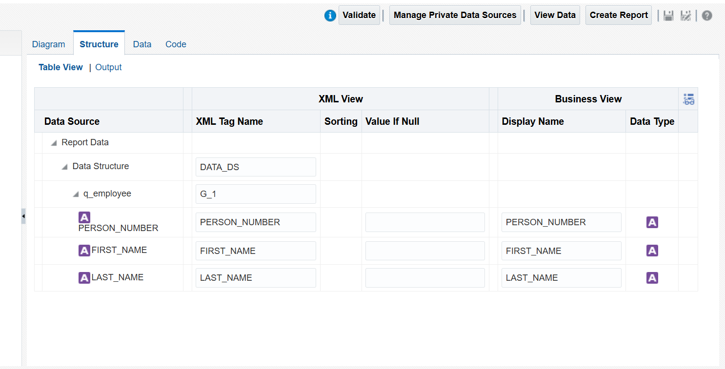

**Create parameter , ie to choose desirable data that we want**

**select papf.person_number, ppnf.first_name, ppnf.last_name**

**from per_all_people_f papf, per_person_names_f ppnf**

**where 1=1**

**and trunc(sysdate) between papf.effective_start_date and papf.effective_end_date**

**and trunc(sysdate) between ppnf.effective_start_date and ppnf.effective_end_date**

**and papf.person_id = ppnf.person_id**

**and ppnf.name_type = 'GLOBAL'**

**and ppnf.first_name like :P_FIRST_NAME || '%'**

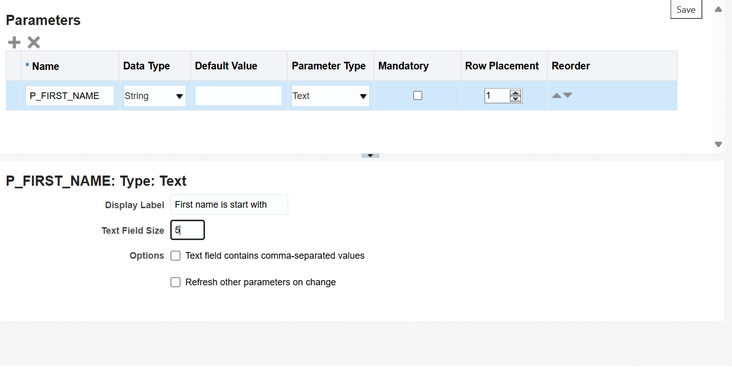

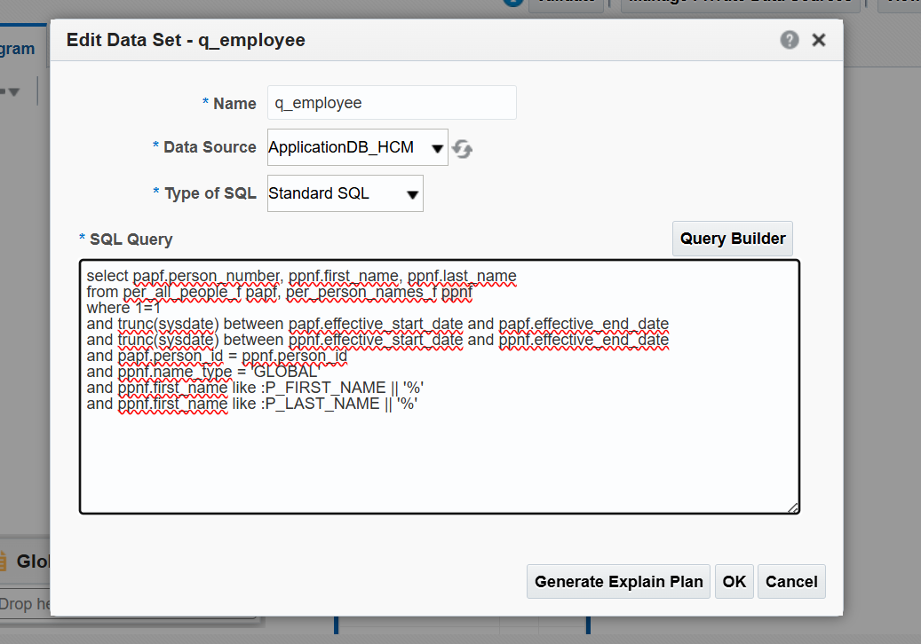



**For last name as parameter also**

**Always save sample report**

**Before creating a report u must add sample data this can be done when we view the data there is an option called “save as sample data” this will not create further issues when u are making a sample report**

**CREATE REPORT**

**In right corner there is create report use report editor next finish**

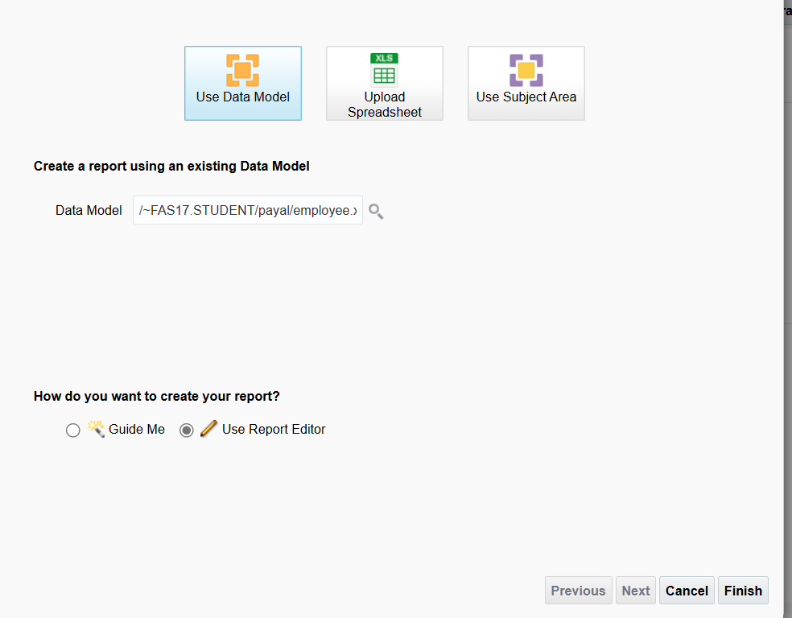

**Save as payal report then choose blank select data table drag and drop it**

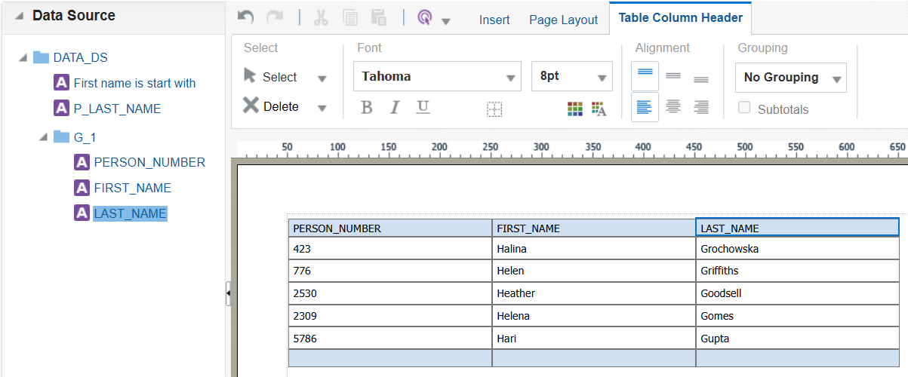

**Lets edit person name or edit things**

**Select person name go to properties**

**Now select page header ………choose layout grid……**

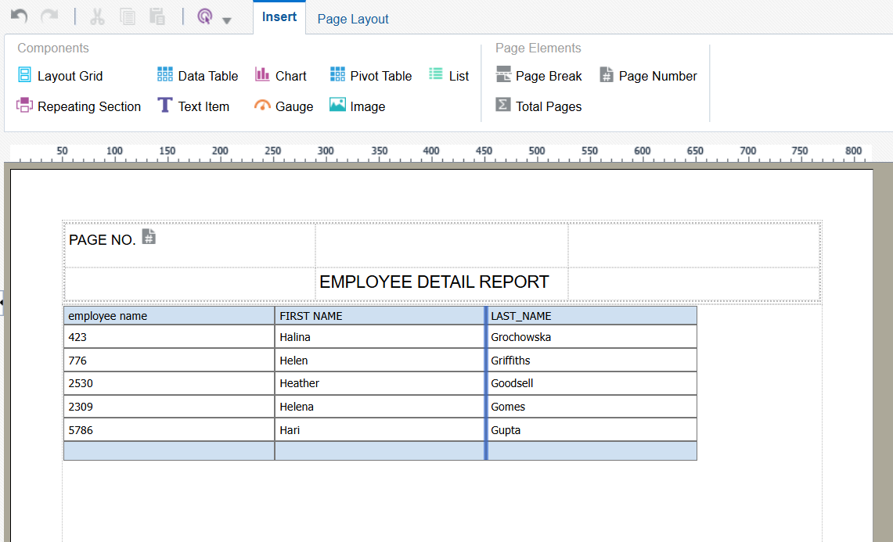

**After editing these things do save and done then go on view reports**

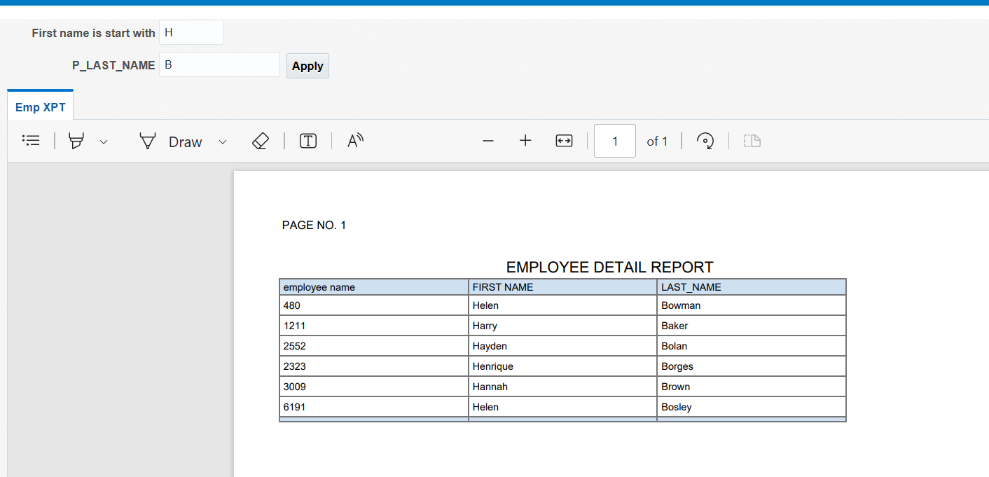

**How to create Invoices**

**AP_INVOICES_ALL**

**AP_INVOICE_LINE_ALL**

**AP_INVOICE_DISTRIBUTION_ALL**

**ai.invoice_id,ai.invoice_num,s.vendor_name,ss.vendor_site_code,ai.invoice_currency_code,ai.payment_currency_code,**

**ai.invoice_amount,ai.amount_paid,ai.invoice_type_lookup_code**

**from ap_invoices_all ai,poz_suppliers_v s,poz_supplier_sites_v ss**

**where 1=1**

**and ai.vendor_id=s.vendor_id**

**and ai.vendor_site_id=ss.vendor_site_id**

**and ai.vendor_id=:P_VENDOR_ID**

**Select invoice_id, line_number, line_type_lookup_code, item_description, amount**

**From ap_invoice_lines_all**

**Steps to create**

**Catalog create data model first put 1query in diagram sql query save as then create anotherfor 2nd sql , diagram sql query then do save Now join two tables by just dragging first table id to another**

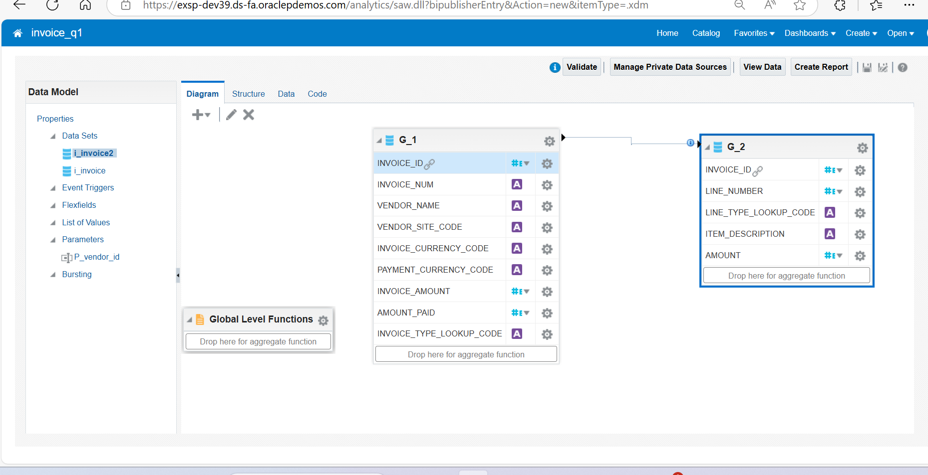

**List of values for vendor id(AGAR M VENDOR ID DAALU TO VENDOR NAME MILE)**

**Go to list of values**

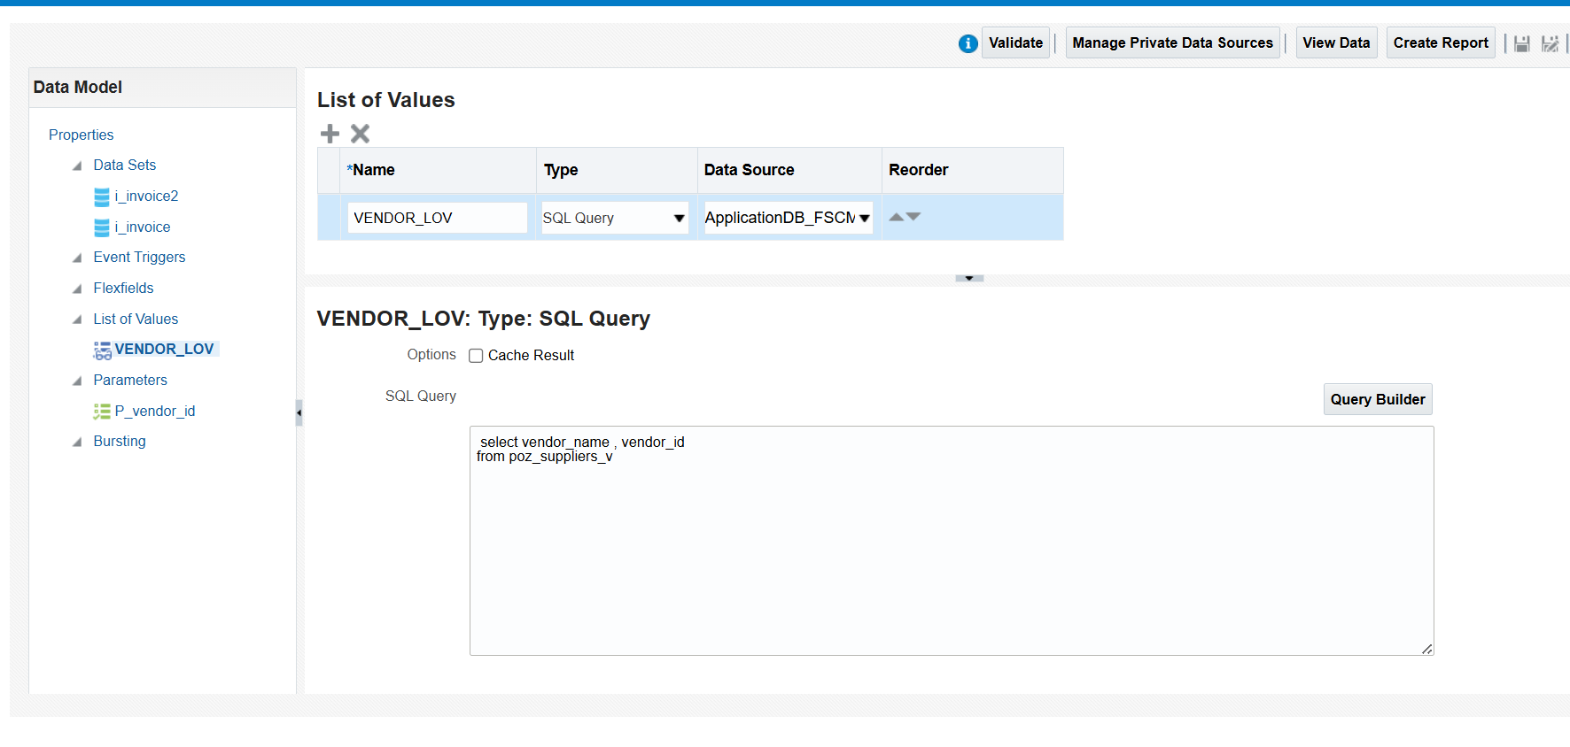

**Now attach list of values to parameter**

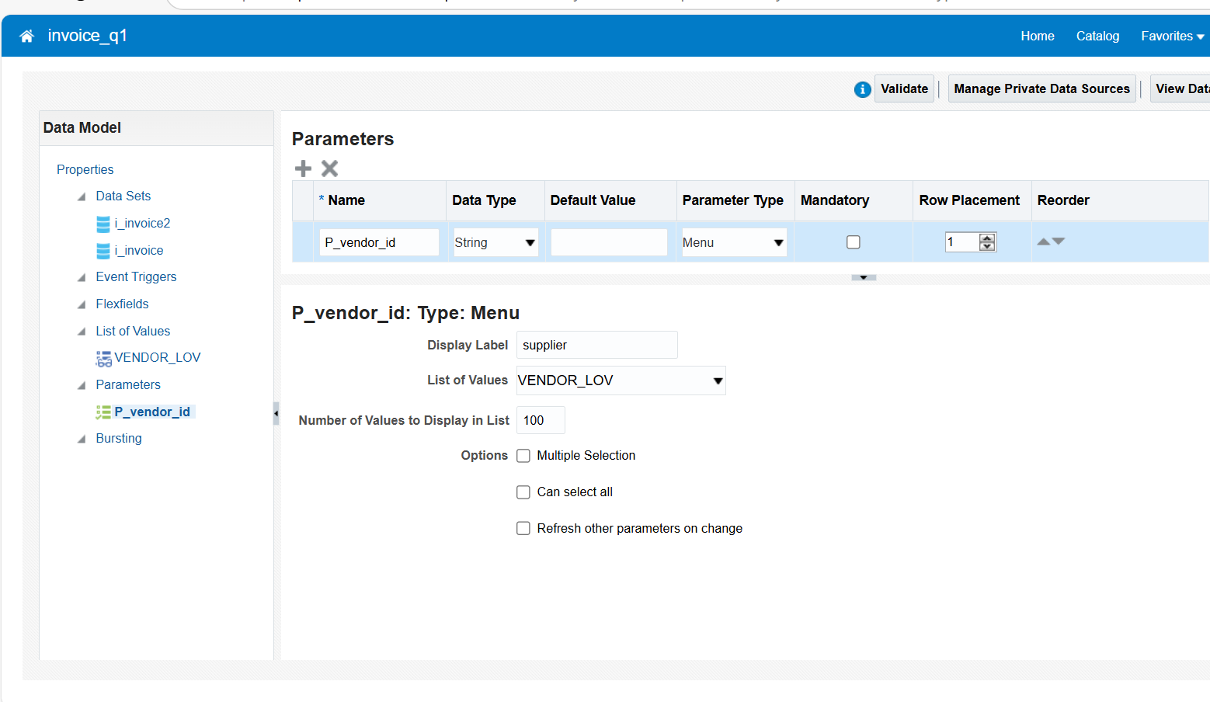

**then save and go to structures change name of g1 and g2 no go to data and view**

**NOW IF YOU WANT TO MAKE OPTIONAL PARAMETER WE WILL USE NVL IE.**

**select ai.invoice_id,ai.invoice_num,s.vendor_name,ss.vendor_site_code,ai.invoice_currency_code,ai.payment_currency_code,**  
**ai.invoice_amount,ai.amount_paid,ai.invoice_type_lookup_code**  
**from ap_invoices_all ai,poz_suppliers_v s,poz_supplier_sites_v ss**  
**where 1=1**  
**and ai.vendor_id=s.vendor_id**  
**and ai.vendor_site_id=ss.vendor_site_id**  
**and ai.vendor_id=NVL(:P_VENDOR_ID, ai.vendor_id)**

**types**

**and ai.vendor_id = :p_vendor_id ---mandatory**

**and ai.vendor_id = NVL (:p_vendor_id, ai.vendor_id) -----optional para**

**and ai.vendor_id in( :p_vendor_id)----multi select mandatory para**

**and (coalesce(p_vendor_id,null) IS NULL OR ai.vendor_id IN (:P_VENDOR_ID)) ---multiselect and optional**

**How to create group by in the data model**

**Select vendor name from that table click ctrl and drag to vendor_site_code then click vendor_name setting then click on group by (click on the vendor site setting icon button) ,after that join link will disappear then again join by dragging both id**

**Now go to structure change g1 to invoice site and g2 to g2 invoice**

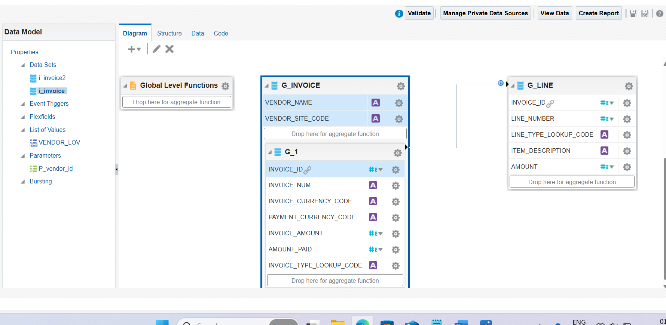

**Create aggregate function**

**Drag line number in drop here aggregate**

**Formula column should be in same group** 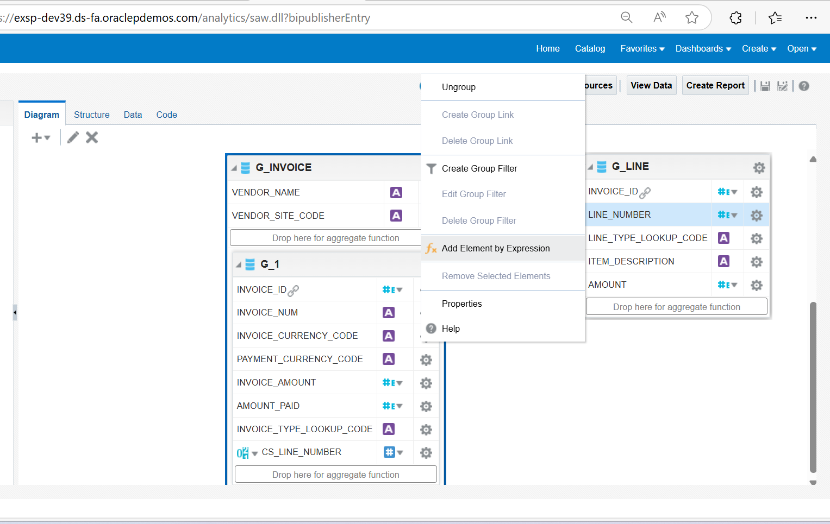

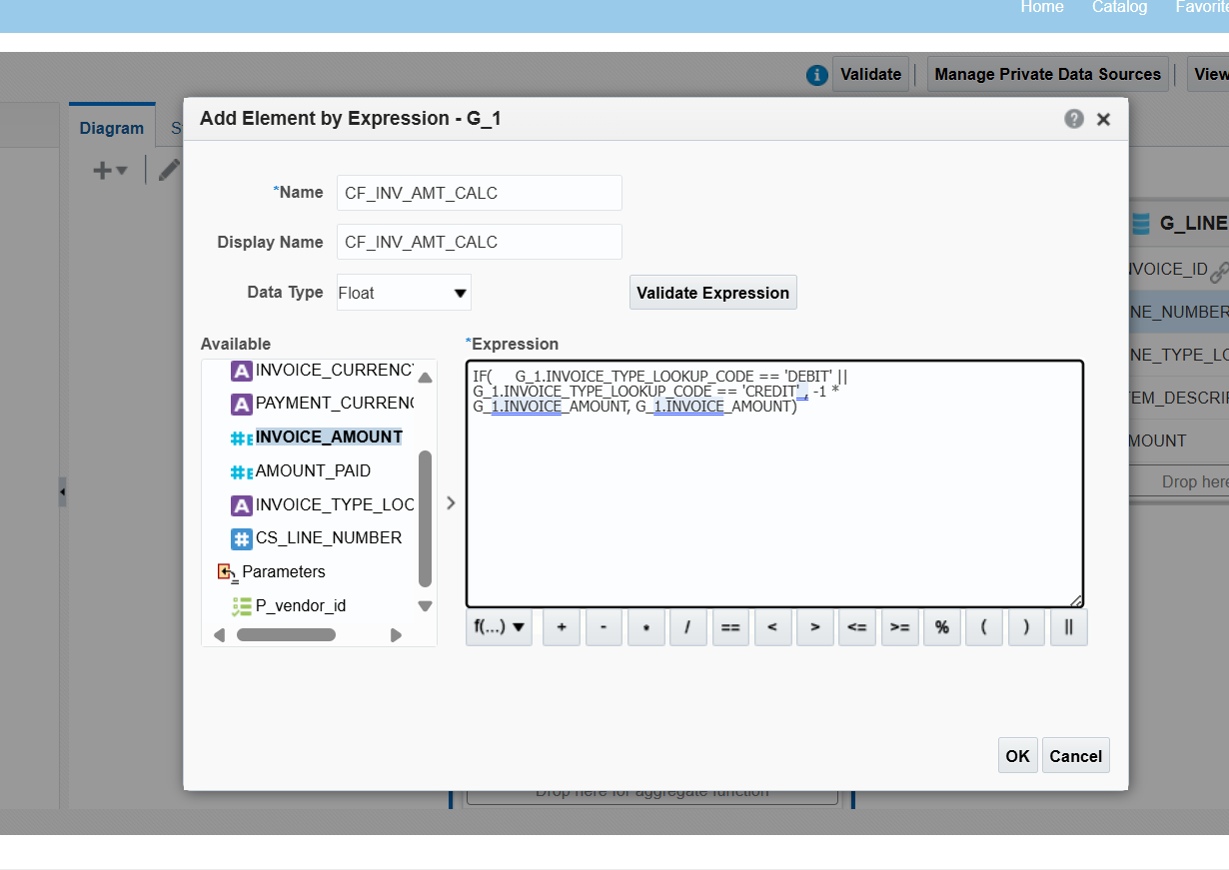

**DRAG FUN TO VENDOR SITE CODE THEN CHANGE THE FUNCTION TYPE TO SUMMARY THEN GO TO STRUCTURE CHANGE CS1 TO OTHER NAME**

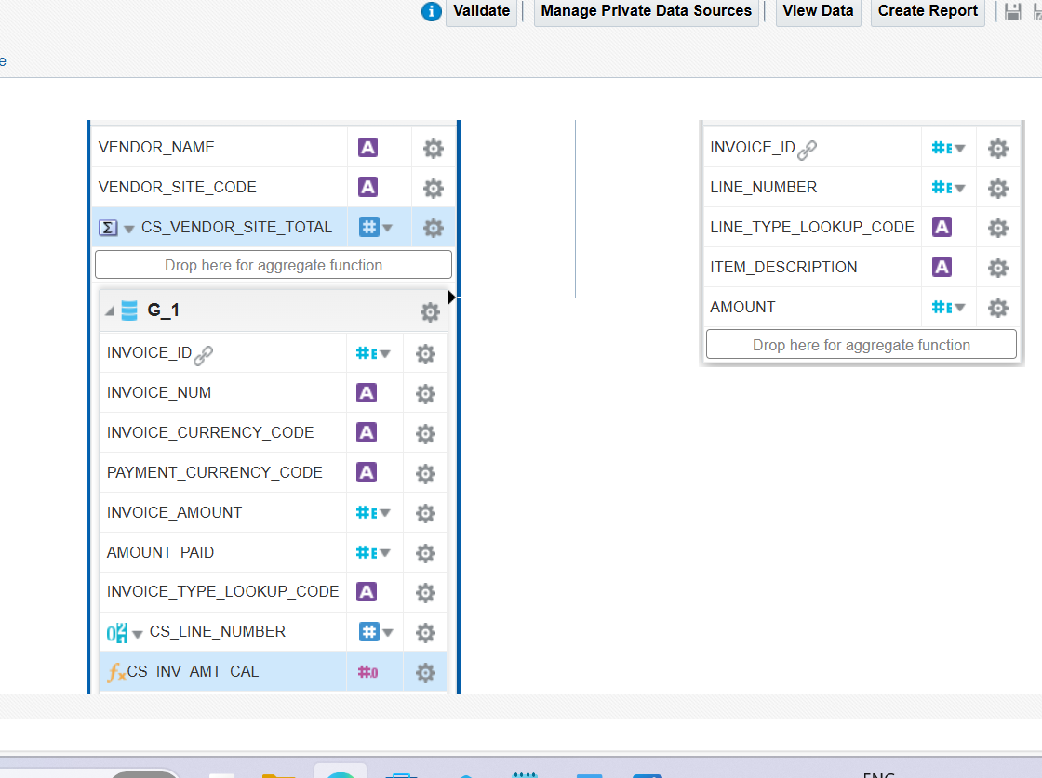

**HOW TO BACKUP**

**GO TO CATALOG ….GO TO MY FOLDER……THEN GO TO PAYAL……...MORE……..ARCHIVE…..OK**

**START WITH BI PUBLISHER**

**WORDS BI PUBLISHER XPORT FILE REPEATING GROUP FIRST CHOOSE G1 WITH NO BREAK THEN CHOOSE G1_INVOICE WITH GO TO INSERT , INSERT 4*4 TABLE GO TO BI PUBLISHER THEN FIELDS THEN INSERT VALUES DOUBLE CLICK VALUES AND CHANGE NAME AND VALUES THEN SAVE AS RICH TEXT FORMAT(VERY IMP)**

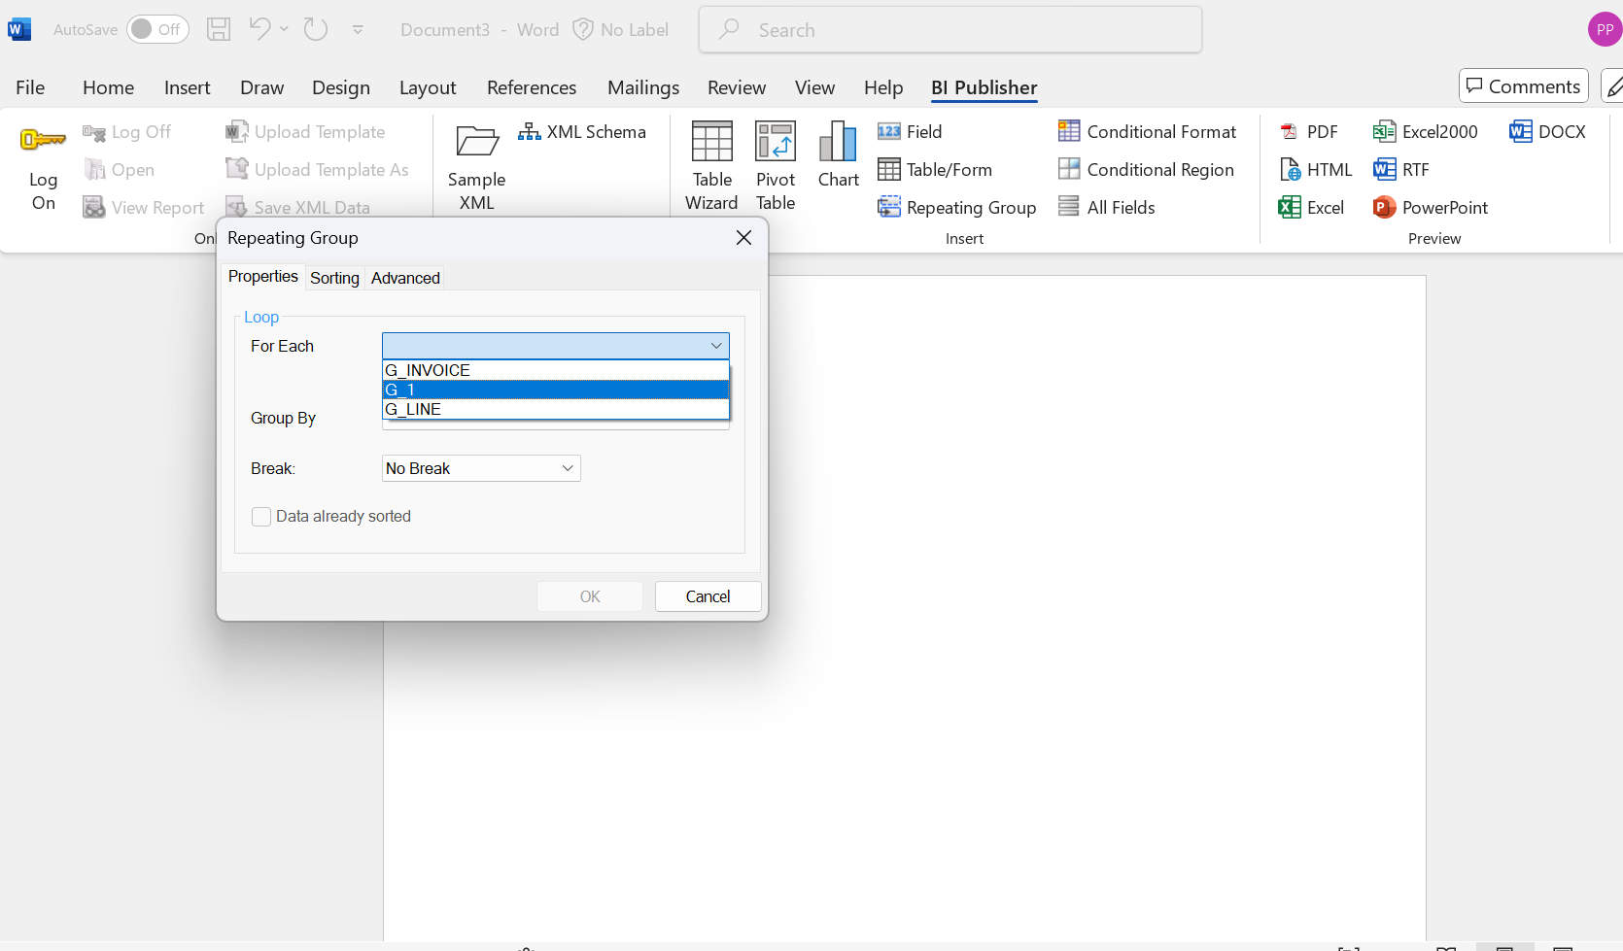

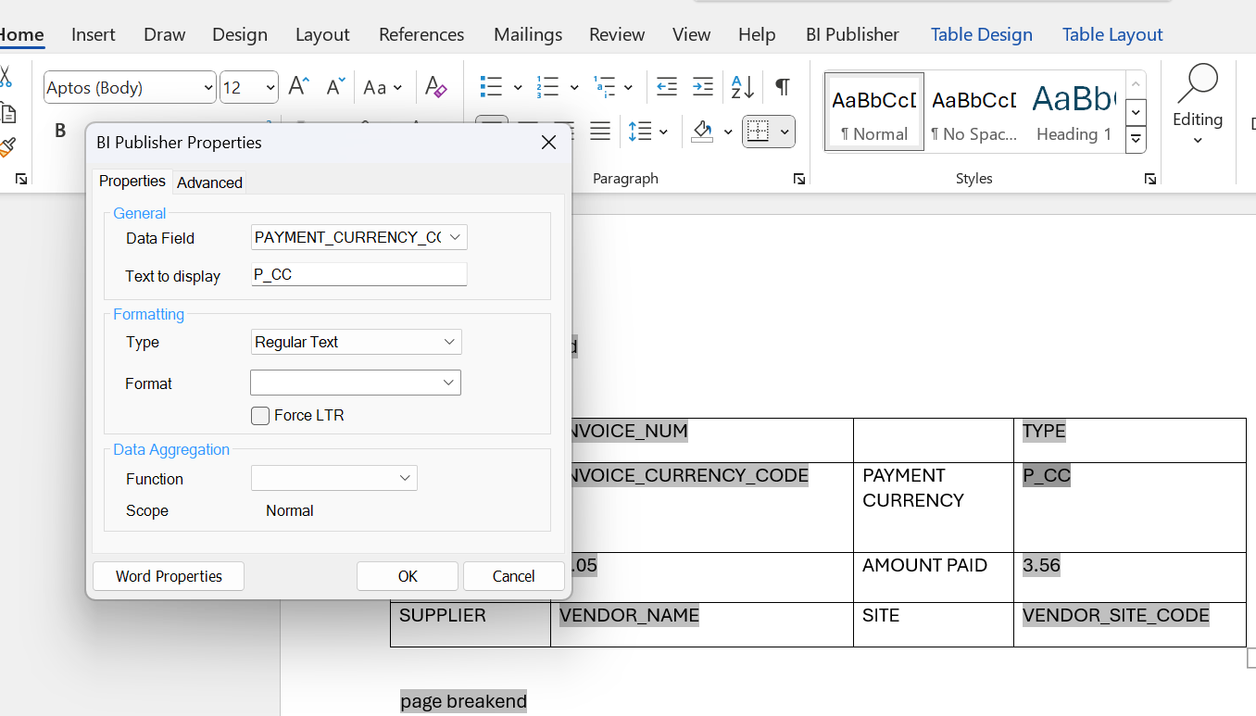

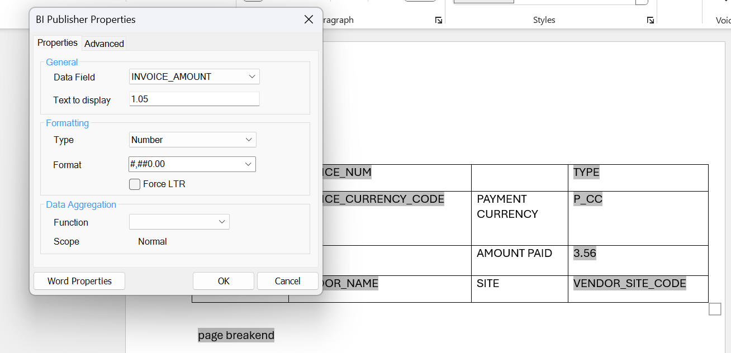

**Before u upload go to field browser and since vendor site code and name is from the parent node in the xml write it in the format “?../”**

**An example can be found like this: <?../VENDOR_NAME?>**

**GO BACK TO THE BROWSER**

**Browse Catalog then go to the chart symbol and click on Report**

**Click on the search button and search for the saved file within the folder name and click on OK.**

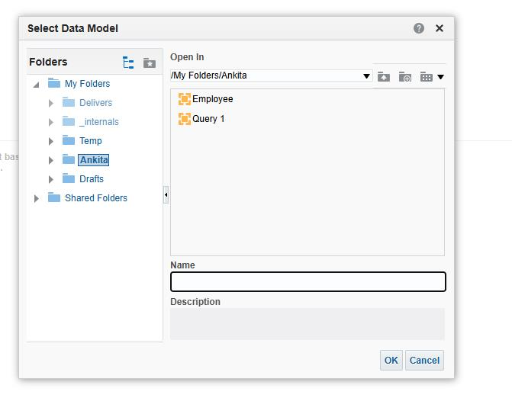

**Then click on upload rtf,txt….. option and click on the saved world file and upload.**

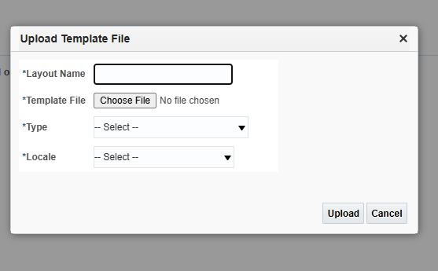

**Save it by giving a relevant name. Click on view Report. Select a Supplier.**

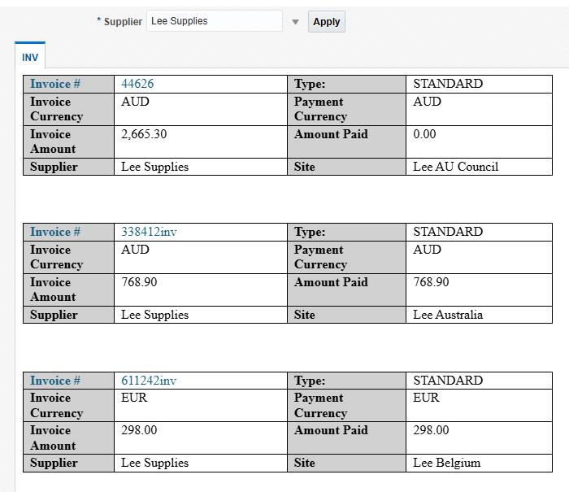

**By changing it to pdf we can see the page break option being executed.**

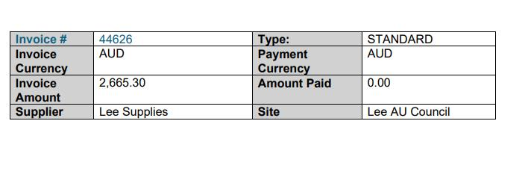

**EXCEL TEMPLATE**

OPEN EXCEL

GO TO BI PUBLISHER

LOAD SAMPLE XML DATA

Click on field browser. A POP-UP MENU APPEARS.

SELECT INDIVIDUAL REQUIRED FIELDS (FROM G_INVOICE GROUP INTO EACH CELL,

IN THE SAME ROW INSERT G_VENDOR_SITE) AND GIVE HEADINGS TO THOSE FIELDS.

LEAVE ONE ROW BLANK THEN INSERT DATA FOR THE NEXT FIELDS(G_LINE)

INSERT THE SUMMARY(LINE COUNT) AS LINE TOTAL INSERT IT BELOW THAT COLUMN.

HIGHLIGHT THE SECOND SET OF ROWS AND GO TO PUBLISHER AND SELECT REPEATING GROUP.

NOW HIGHLIGHT WHOLE OF INVOICE PART AND CLICK ON REPEATING GROUP.

SAVE IT IN *.XLS FORMAT.

RIGHT CLICK AND GO TO UNHIDE METADAT. IT’LL OPEN A SHEAT WITH ALL CODE HERE WE CAN CHANGE <?VENDOR_SITE_CODE> TO <?../VENDOR_SITE_CODE>

THEN SAVE AND HIDE THE SHEET AGAIN.

GO TO EXCEL OPTION AND CLICK ON PREVIEW.

**TO MAKE THE HEADING REPEAT:**

GO TO META DETA SHEET

GO TO THE CODE FOR THE REPEATING GROUP. CHECK WHERE IT IS GROUPED.

GO TO FORMULA AND NAME MANAGER LOOK FOR THAT DATA CONSTRAINS NAME.

CHECK THE RANGE AND CHANGE FROM A2 TO A1. THEN CLOSE, SAVE THEN HIDE.

GO TO PUBLISHER THEN EXCEL AND REVIEW.

**TO FORMAT:**

RIGHT CLICK THEN CLICK ON FORMAT CELL(CTRL+1), UNDER NUMBER CLICK ON NUMBER UNDER NAVIGATE NUMBERS CLICK 1ST OPTION FOR NEGATIVE NUMBER. THEN CLICK ON OKAY. THEN CLICK ON THE RESPECTIVE COLUMN, GO TO HOME THEN SELECT BRUSH ICON. DRAG IT TO THE COLUMN WE WANT.

**NOW WE HAVE TO MAKE REPORT OF THIS**

Tools……report and analytics….payal folder……go to right corner select report ……..select invoice search your invoice q1 report ……..save and view report ..select lee….it will get download and open

**BURSTING**

split into multiple part

split by deliver by

split by and deliver by is the key from which we can derive attributes of email such as to ..from ..cc..

**bursting of rtf file**

data mode…bursting…create burst…give split by and deliver by and add query youll get query from google by searching bursting query for oracle fusion

select vendor_site_id key,

'INV' TEMPLATE,

'en_US' LOCALE,  
'PDF' OUTPUT_FORMAT,

'EMAIL' DEL_CHANNEL,  
'INVOICE_'||to_char(sysdate,'yyyymmddhh24miss')||'.pdf' OUTPUT_NAME,  
'true' SAVE_OUTPUT,  
'2382273@cognizant.com' PARAMETER1,   
'' PARAMETER2,   
'OracleServices@cognizant.com' PARAMETER3,   
'Invoice for '||vendor_site_code PARAMETER4,  
'Hi '||vendor_site_code||' ,Please find your invoices attached .Thanks OracleFusionTeam' PARAMETER5,  
'true' PARAMETER6,  
'OracleServices@cognizant.com' PARAMETER7,'' PARAMETER8   
from poz_supplier_sites_v

then catalog………select report …edit.properties…enable bursting ……click create……new report job ……..select report and change parameters …..in output parameter be sure bursting definition is check…..in schedule….in notification add email……in diagnostic select last option….submit….give report job name….then home……in the bottom left click report job history….

**bursting of excel file**

in query make changes in 1. Template name 2. Output format to **‘EXCEL’** 3. Output name should end with ‘.**xls’**

select vendor_site_id key,'INV_XLS' TEMPLATE,'en_US' LOCALE,  
'EXCEL' OUTPUT_FORMAT,'EMAIL' DEL_CHANNEL,  
'INVOICE_'||to_char(sysdate,'yyyymmddhh24miss')||'.xls' OUTPUT_NAME,  
'true' SAVE_OUTPUT,  
'2382273@cognizant.com' PARAMETER1,   
'' PARAMETER2,   
'OracleServices@cognizant.com' PARAMETER3,   
'Invoice for '||vendor_site_code PARAMETER4,  
'Hi '||vendor_site_code||' ,Please find your invoices attached .  
Thanks Oracle Fusion Team' PARAMETER5,  
'true' PARAMETER6,  
'OracleServices@cognizant.com' PARAMETER7,'' PARAMETER8   
from poz_supplier_sites_v

next for the data model create a new bursting where you have to add the above modified query and save it

same steps should be followed for xls template and only in properties we have enable bursting and select excel name …rest everything is same

**OTBI ORACLE TRANSACTIONAL BUSSINESS INTELLIGENCE**

query data that is not stored in table, no need to write query

Two kind of data

Fact : measurable ex. sales

Dimension : attribute of fact ex. Month wise sales, area wise sales

In any report their should be one fact and one dimension

Sometimes dimension is arranged in hierarchy







SUBJECT AREAS : typically modules for example payables and financials , all transaction are stored in subject area

STEPS : tools..report and ana……browse catalog………otbi folder…..create….. .analysis….Search for payable transaction real time….drage details …and click on result

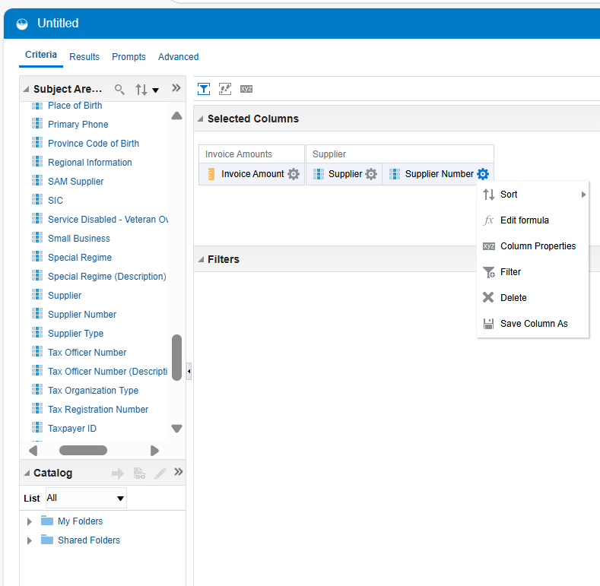

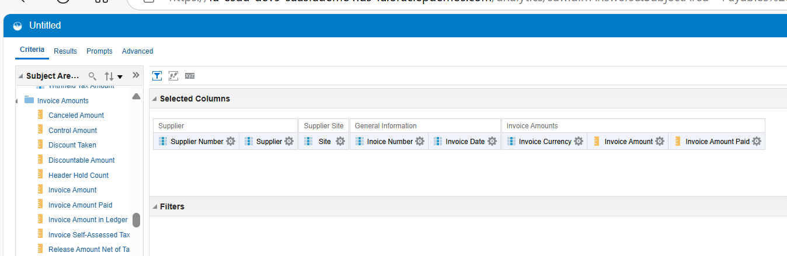

**How to do sorting**

**Setting ..**

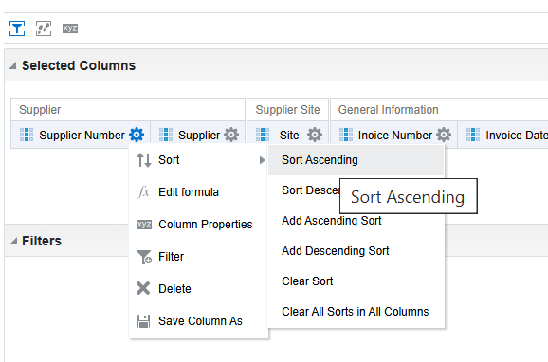

**To increase width go to properties**

**To arrange column go to edit**

**How to create group**

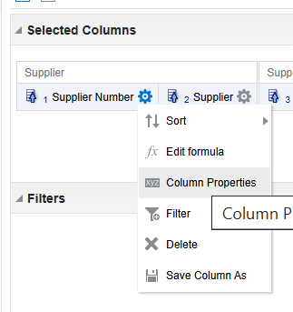

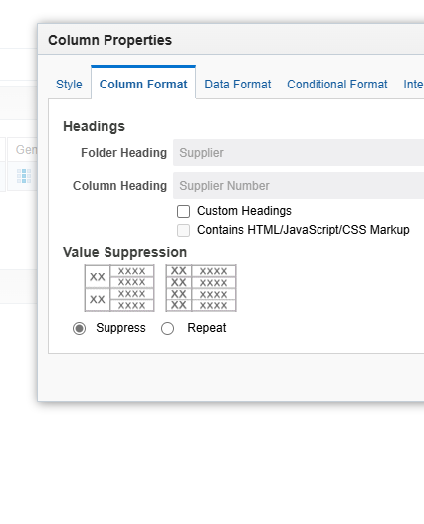

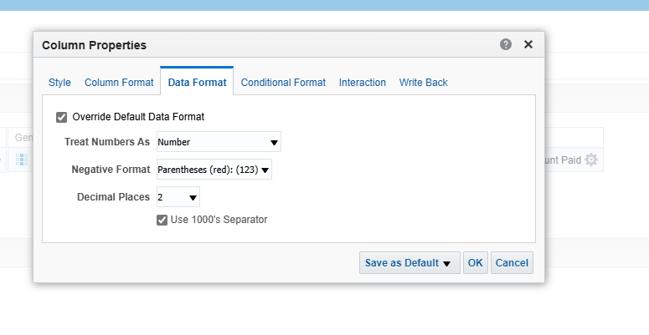

**NOW DO CONDITIONAL FORMATTING**

**Invoice details..generalinfo…..invoice type name….setting…...properties….conditional format……..add format…..invoice type name…….standard…click ok …**

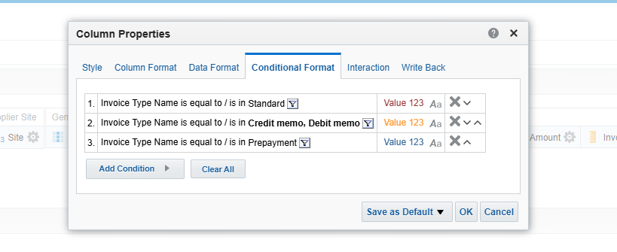

**IF you want data of particular year only**

**Select invoice date…….filter**

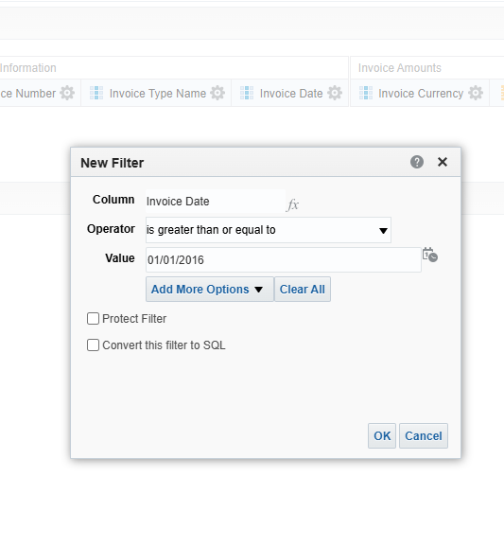

**Now to use drill down for that will select particular thing for which**

**Firstly we have to make one column as primary id**

**So invoice details….general invoice….invoice id .setting …..hide…create another report.catalog……..create analysis……select folders from invoice line**

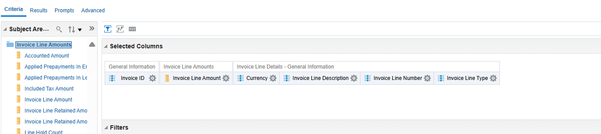

**Make changes in invoice line amount**

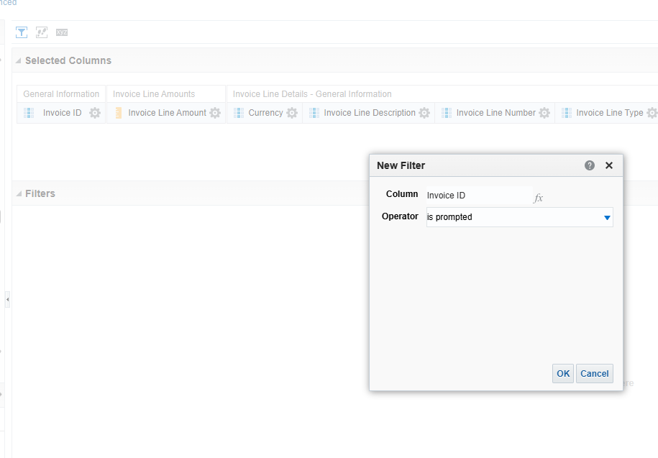

**Now we have to link this invoice line detail into into invoice details for that you have to go to catalog invoice details there invoice id is hidden therefore another primary key type of column is invoice number ..then click on properties ..go to interactions**

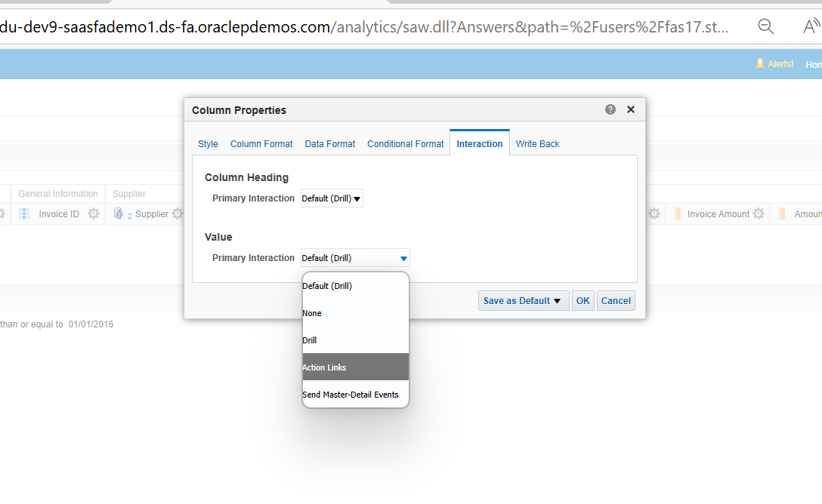 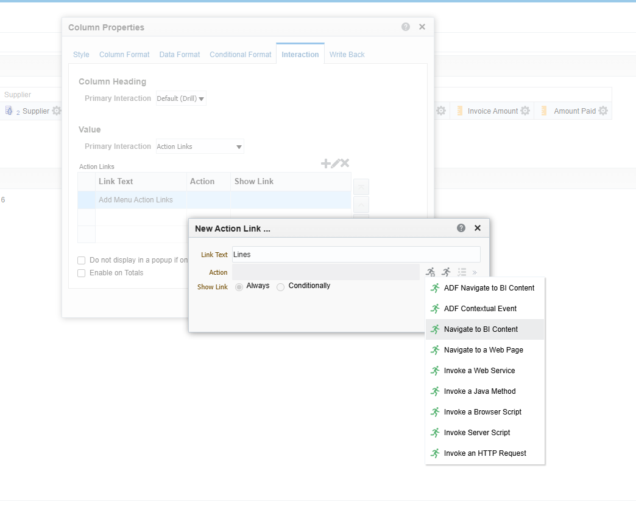

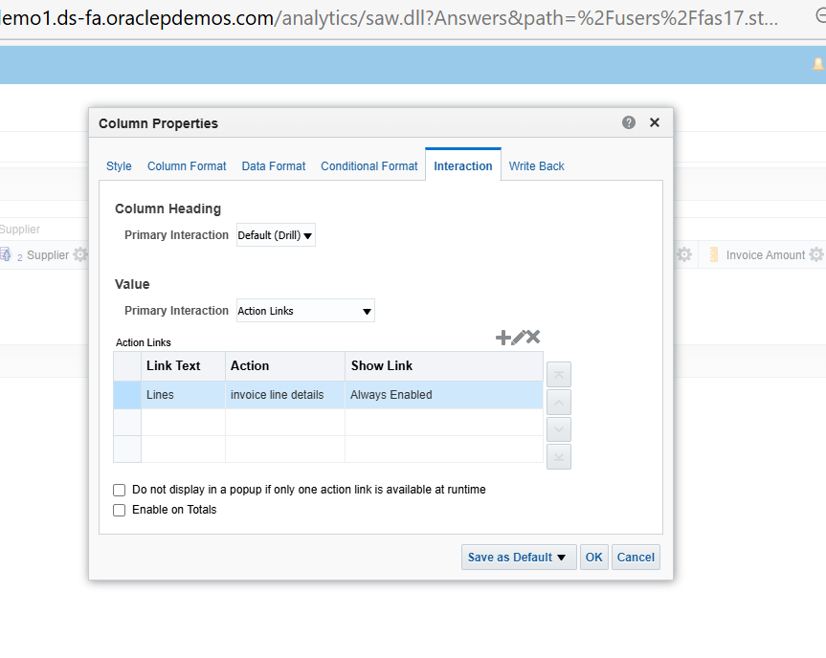

**For example for every invoice number you want to see payment details also then create another analysis add both two subject areas..hide the invoice id and make it prompted and also in payment amount make it change**

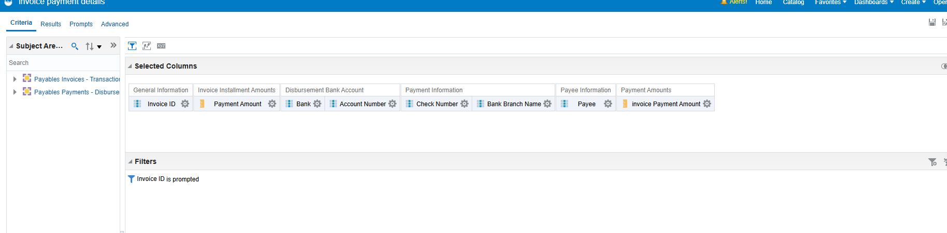

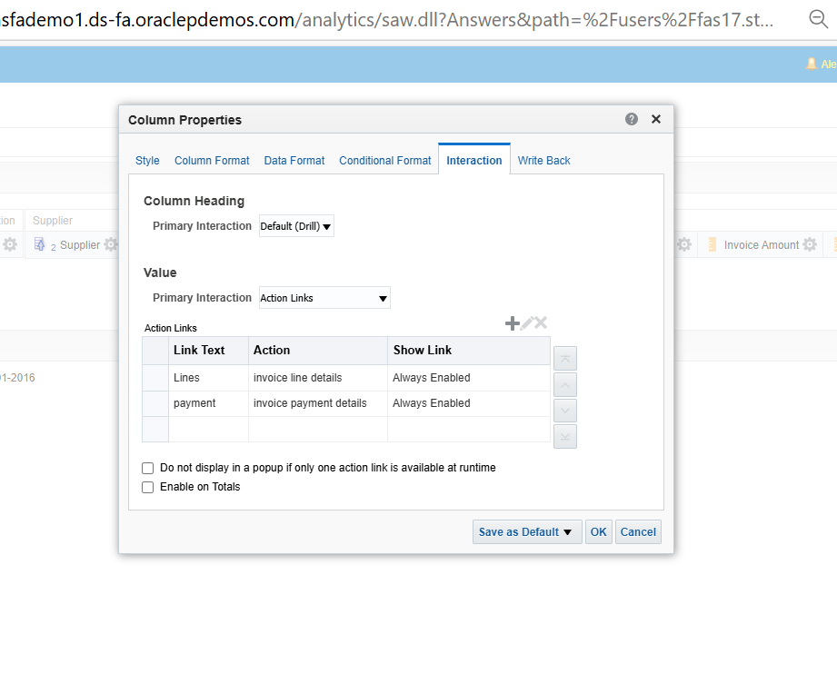

**Now will create report ad show it to dashboard and will make supplier a parameter**

**And also create graph**

**Steps**

**Go to catalog …. invoice details….their make supplier as prompted …go to catalog….create new analysis as invoice amount by currency …. Make supplier as prompted .then go to result**

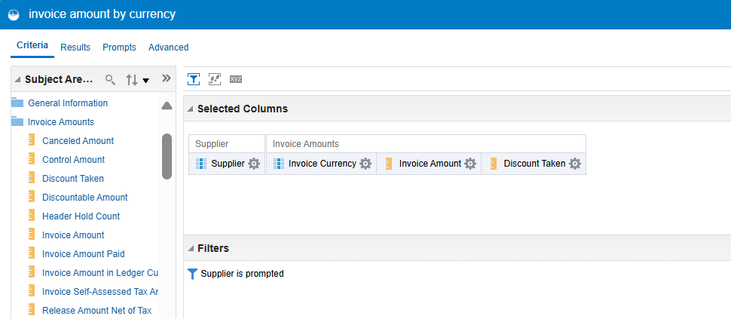

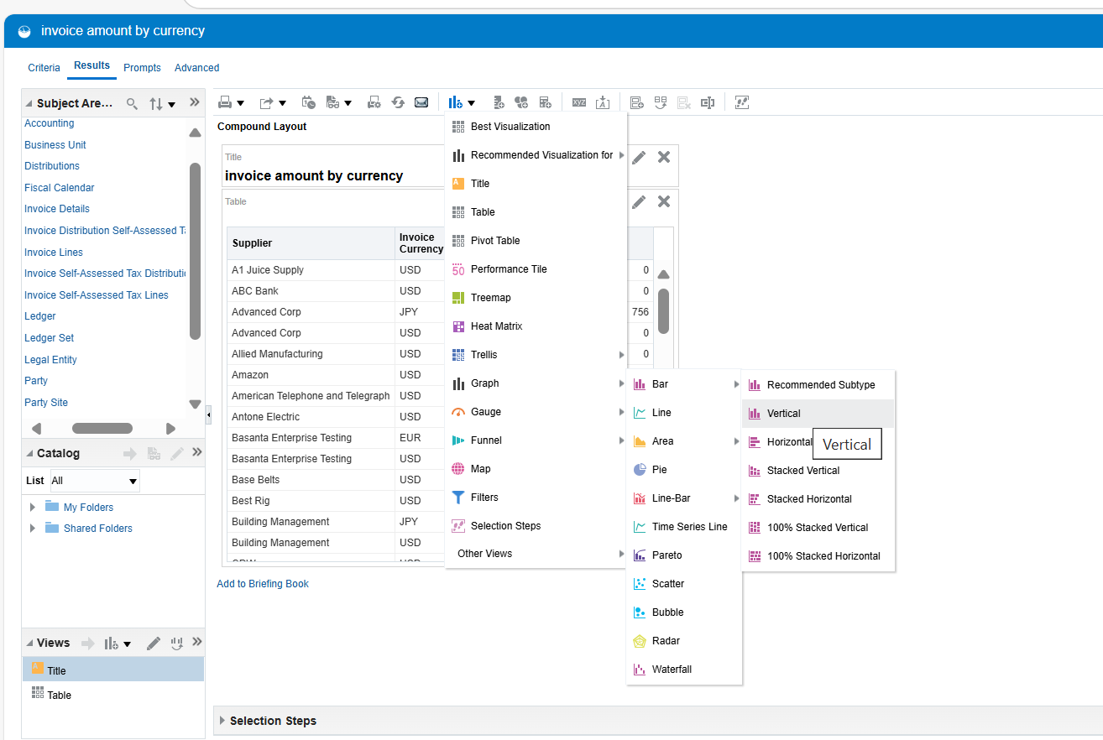

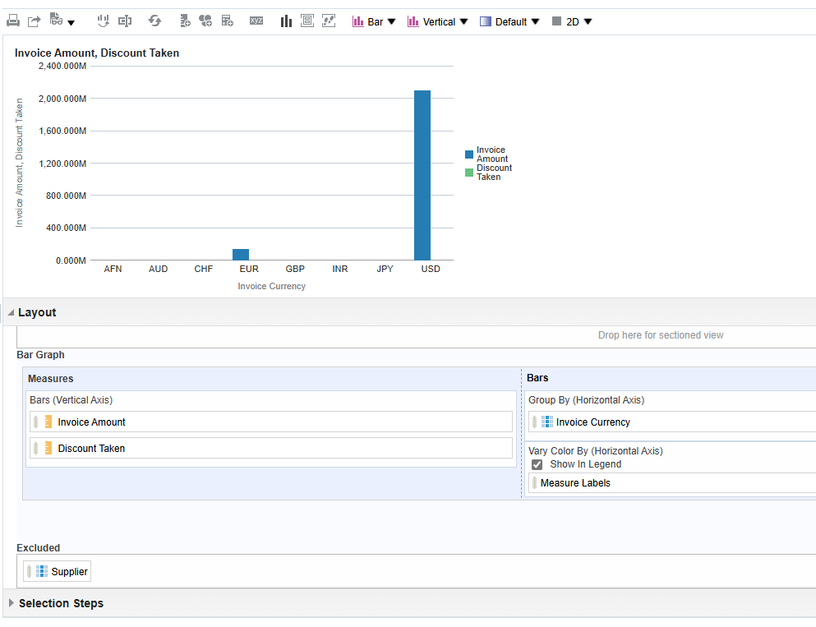

**NOW MAKE DASHBOARD**

**NOW THE THING YOU HAVE TO DO IS SELECT PAYAL ..OTBI…COPY IT AND PAST IT INTO SHARED FOLDER ……..CUSTOM………CREATE FORLDER WITH PAYAL …PAST**

**CLICK ON CREATE AND SELECT DASHBOARD PROMPT …..THEN CLICK ON PLUS ICON IN DASHBOARD PROMT ……AND SELECT THE APPROPRIAT COLUMN(SUPPLIER)…SELECT SAVE**

**NEXT CLICK ON CREATE DASHBOARD …LOCATION(SHARED FOLDER/CUSTOM/DASHBOARD)…OPEN DASHBOARD ADD COLUMN AND SECTIONS NECESSARARY**

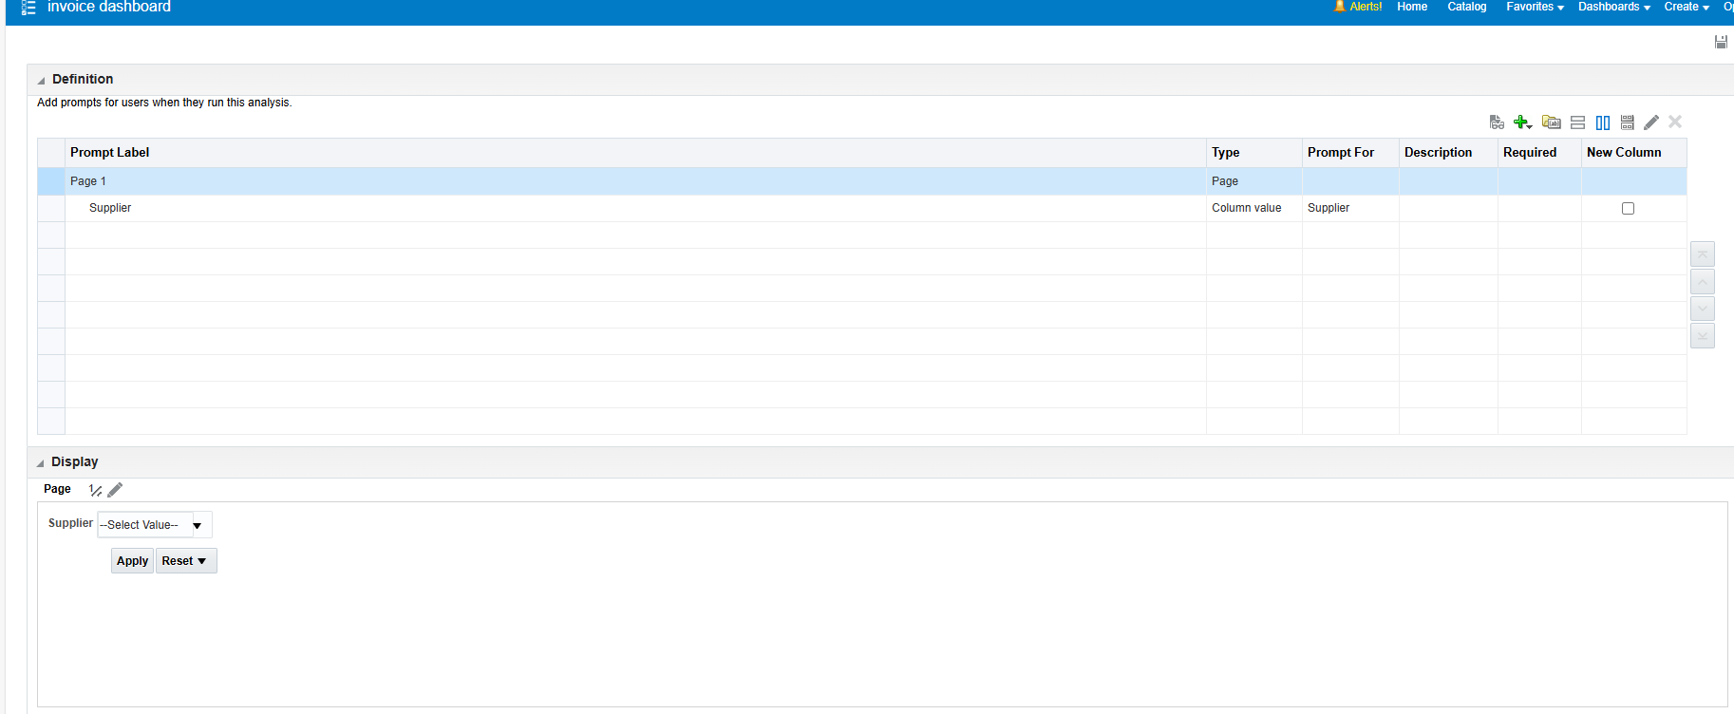

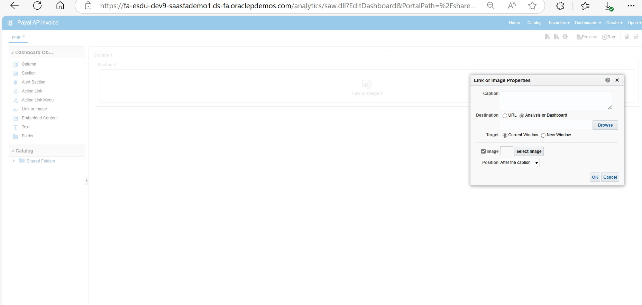

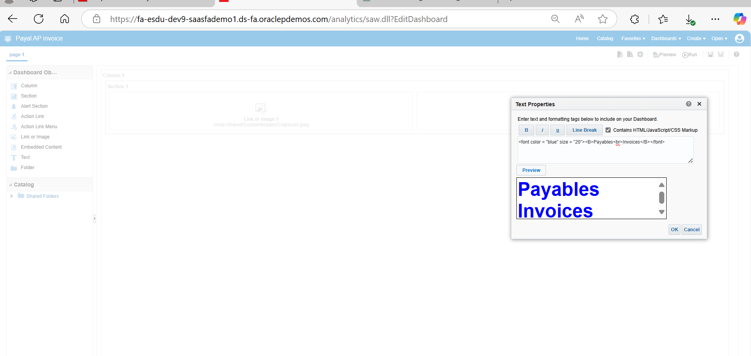

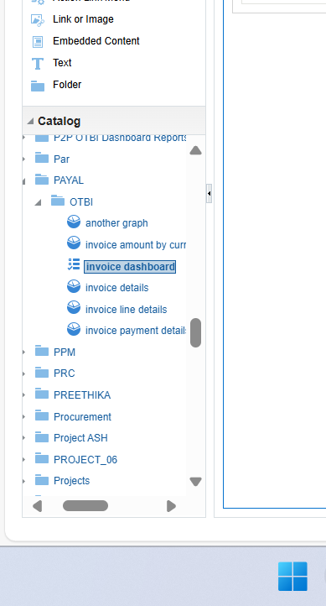

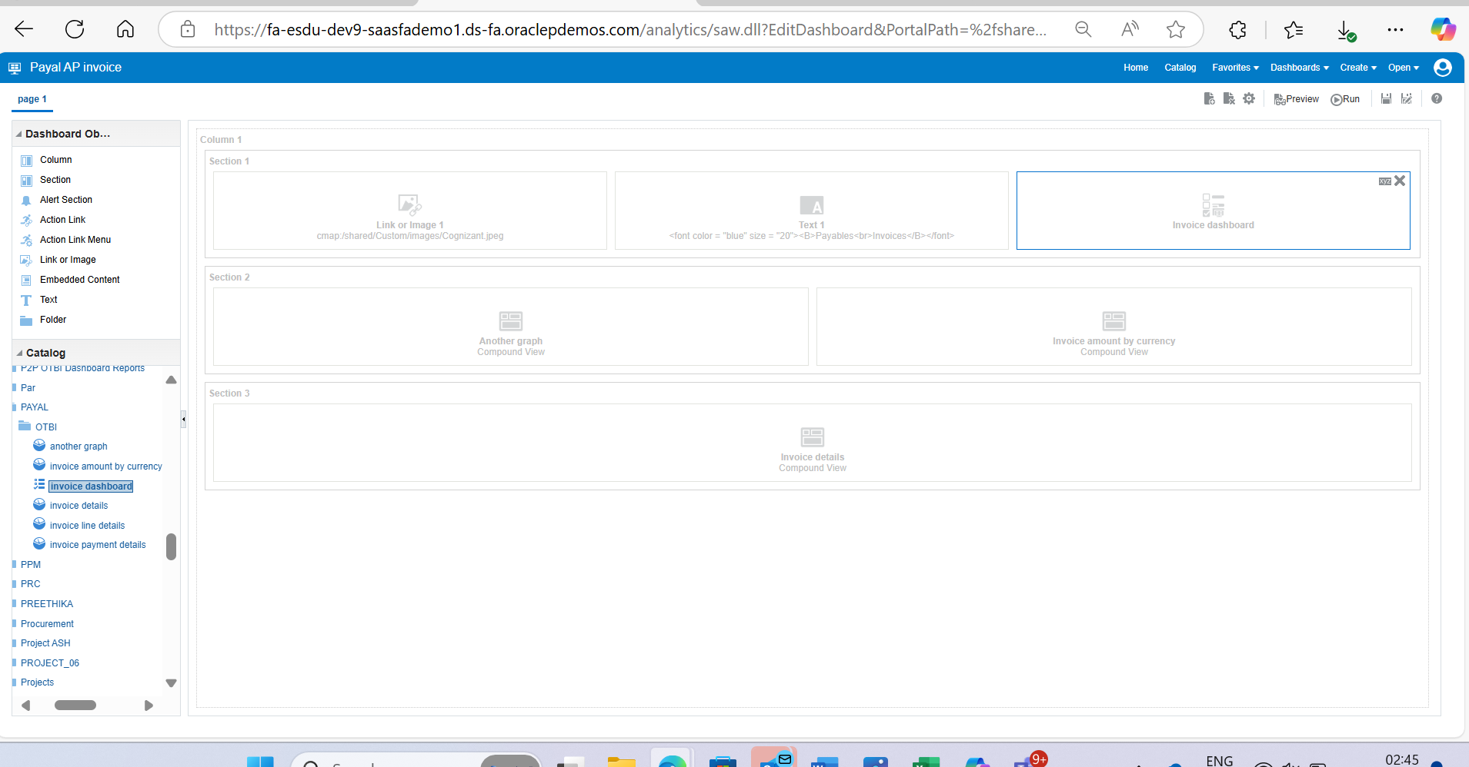

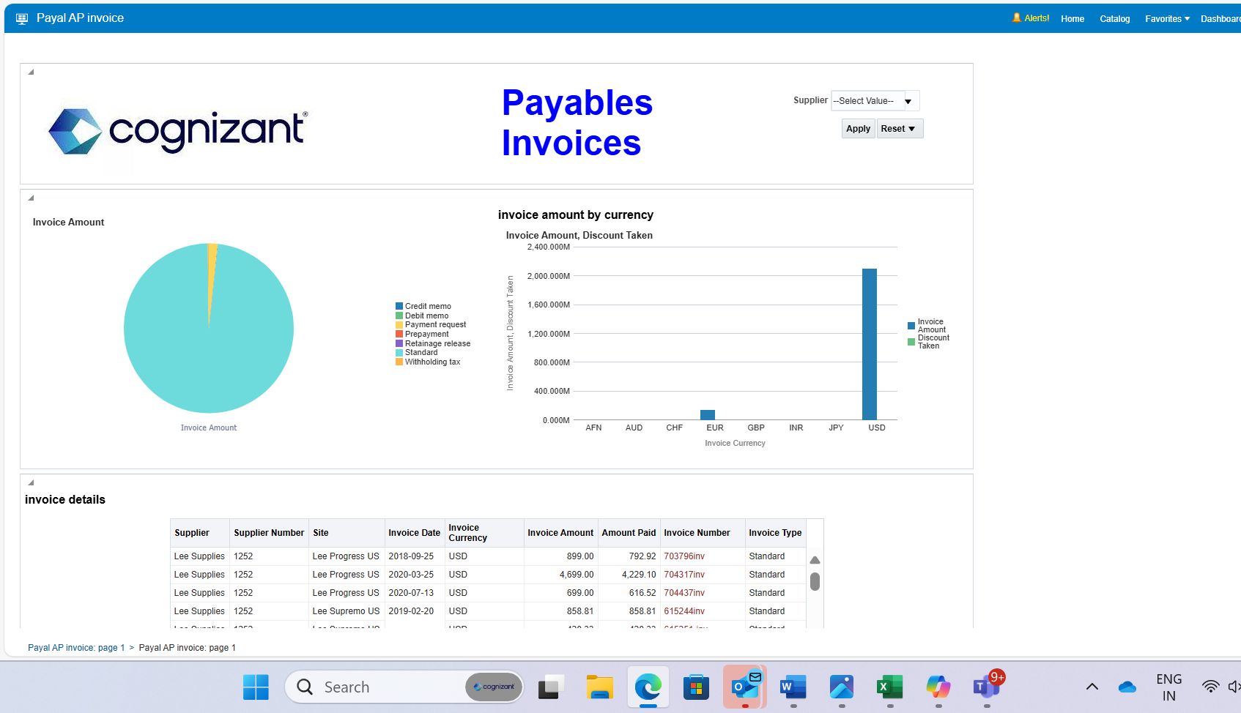

**LETS CREATE ANOTHER REPORT FOR HEIRARCHY**

**CATALOG……CREATE ANALYSIS NAME AS INVOICE AMOUNT HIRARCHY ……..**

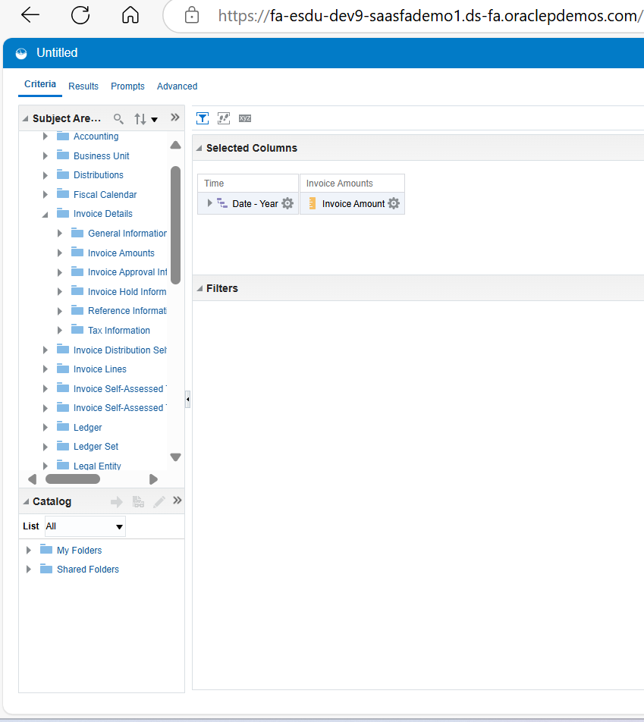

**CREATE ANOTHER REPORT TO UNDERSTAND CROSS RELATIONSHIP BETWEEN TWO DIMENTION**

**FOR MAKING PIVOT TABLE IT IS IMP TO HAVE TWO DIMENSIONS , MIN TWO DIMENSTION AND ONE Fact TO SHOW CROSS RELATION**

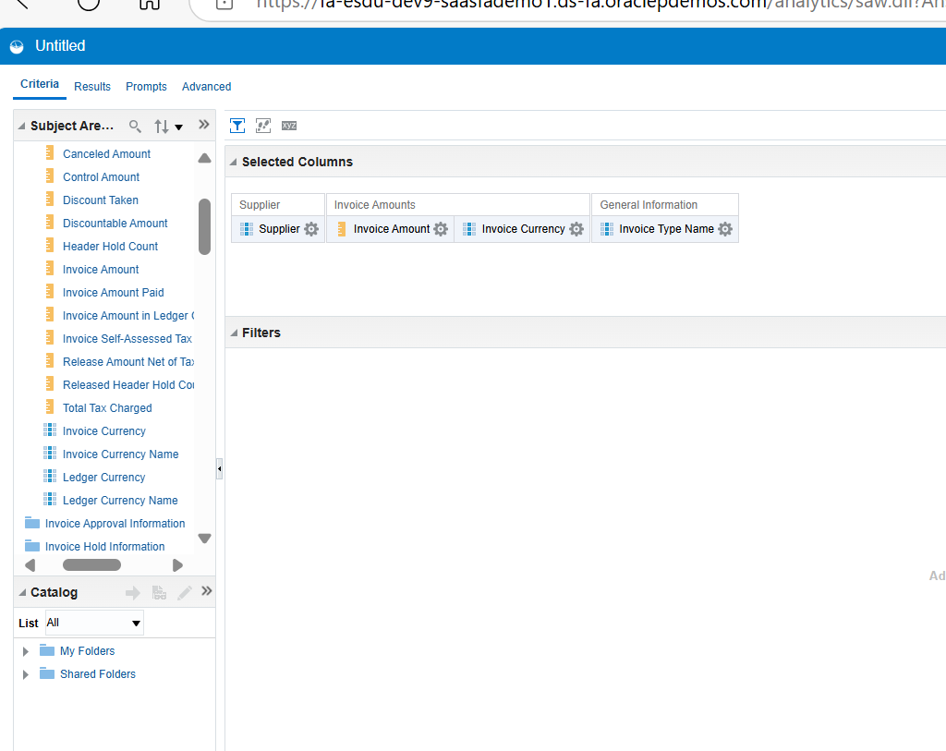

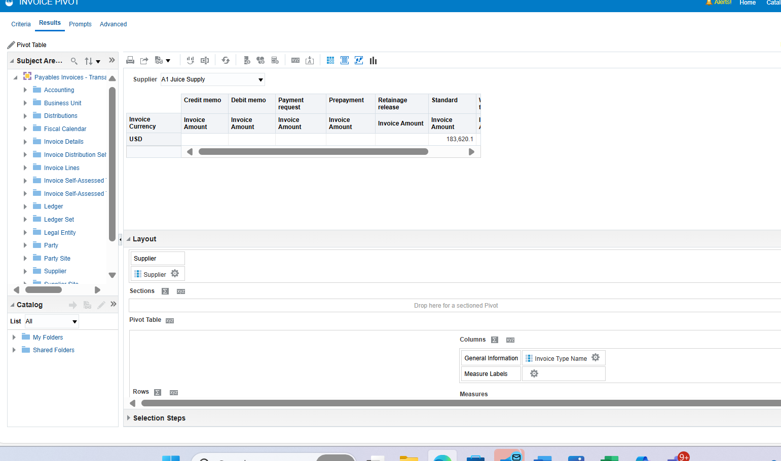

**ALSO DO SAME TO FOR HEAT MATRIX …GO TO VIEW**

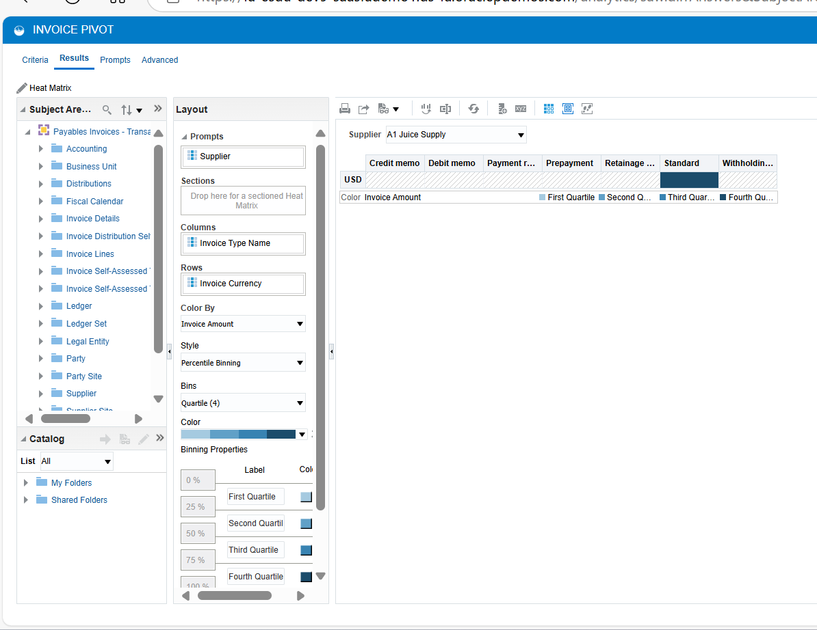

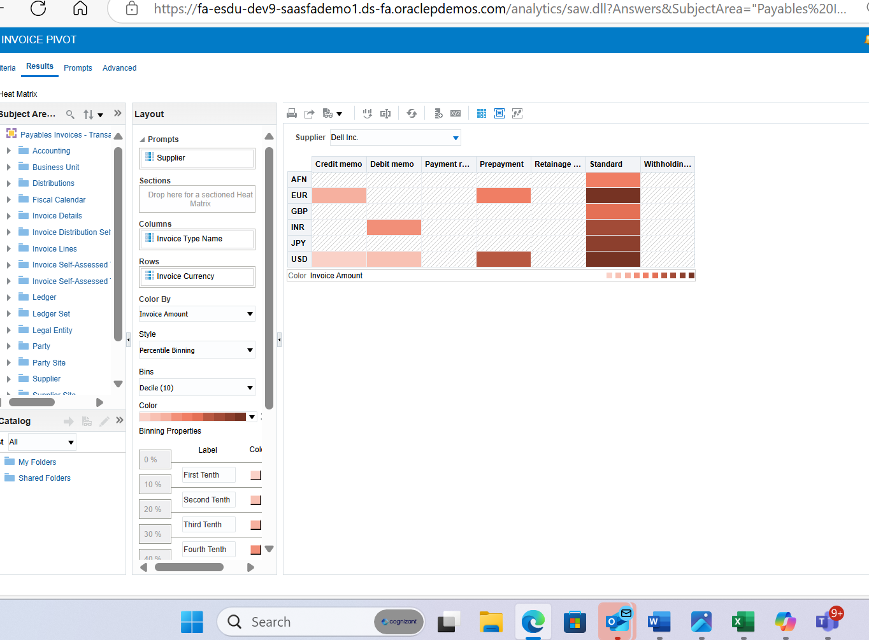

**NOW DO DONE**

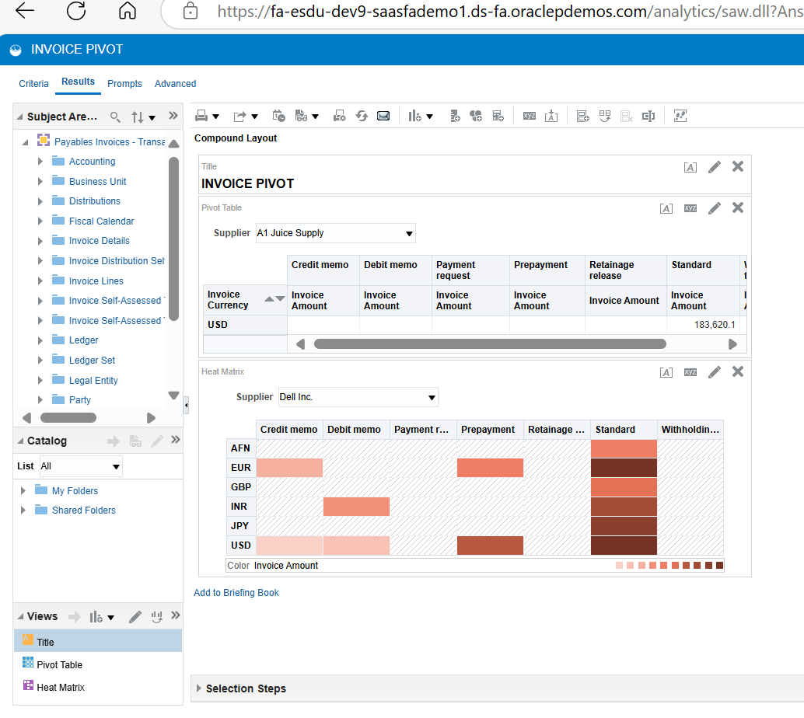

**FRS FINIANCIAL REPORTING Specification**

**This also works under facts and dimensions**

**Example**

**Fact = balance**

**Dimension = accounting date , accounting name**

**Report will be like pivot table**

**lov : list of view is the collection of dimensions rather than row and column dimensions**

**ex of report is trial balance report**

**opening bal activity closing bala**

** a/c**

**Report have three section**

**Page header :**

**Body : (data table) here sql query is written**

**Footer :**

**Steps to create report**

**Others……..financial reporting center ……..open workspace for financial report ……..tool..financial reporting studio……….click on new report……insert …grid…drag…au council database**

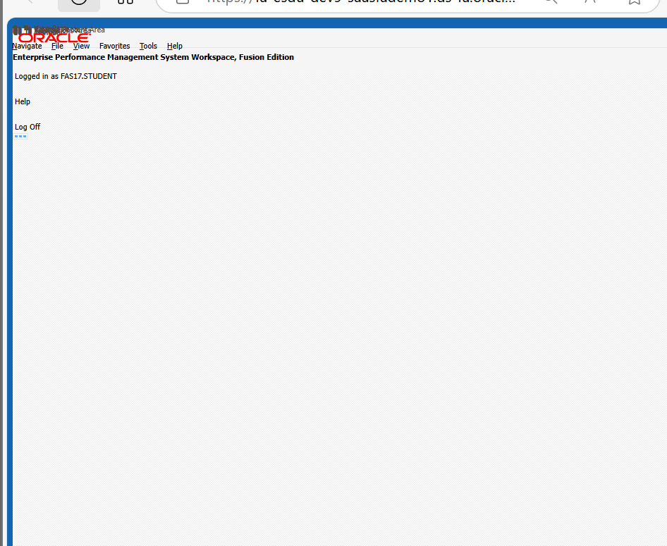

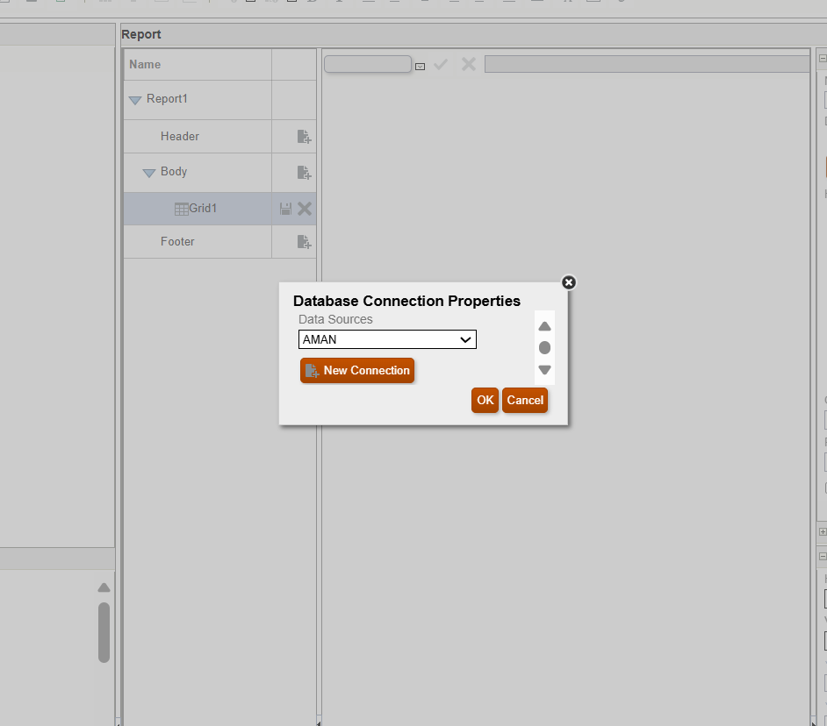

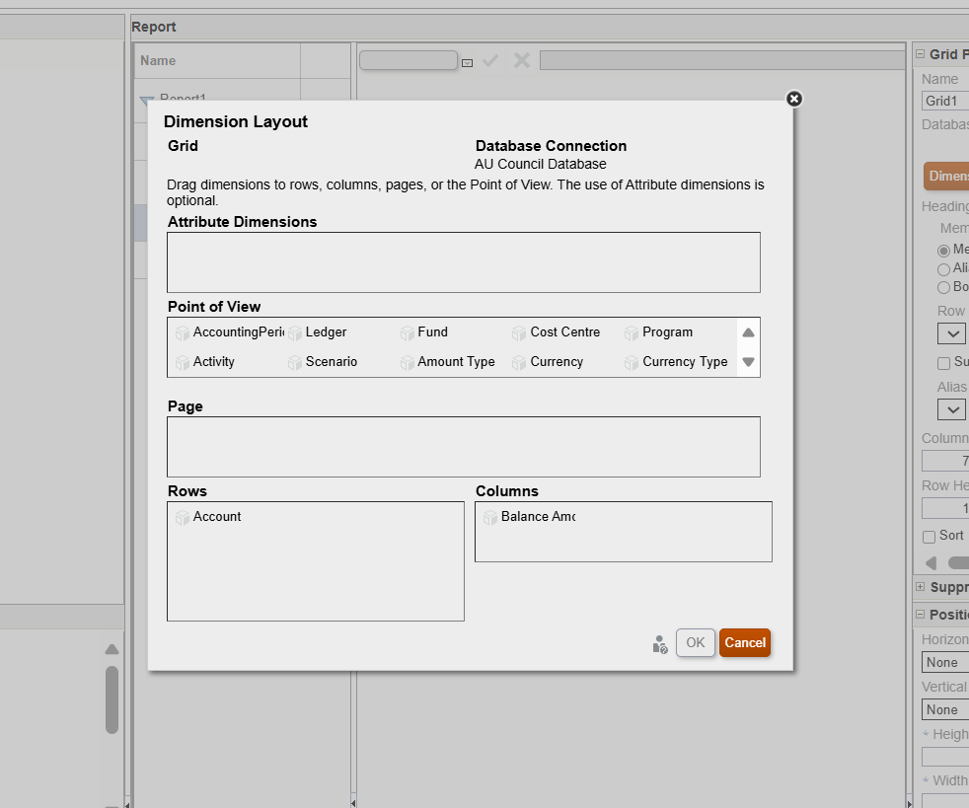

**We will put anything in page that we wanted to use as parame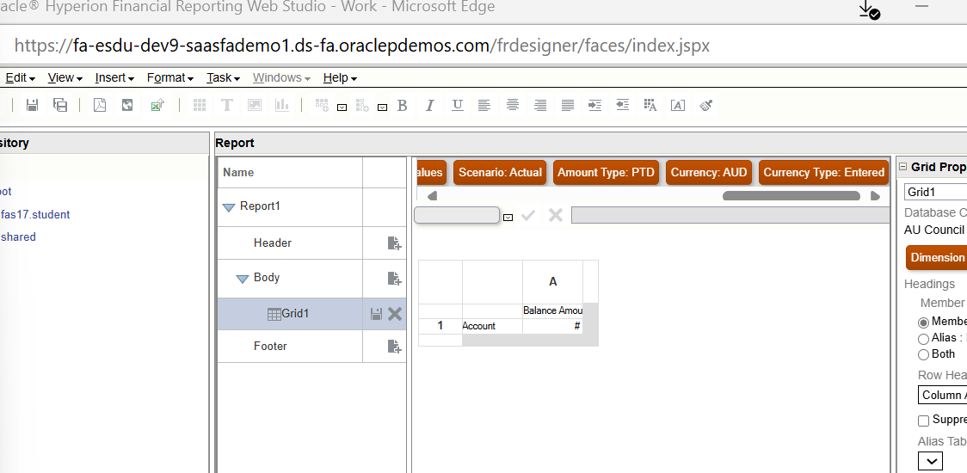ter**

**Save …**

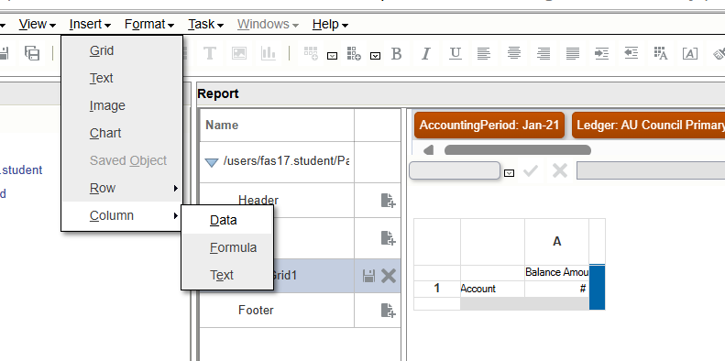

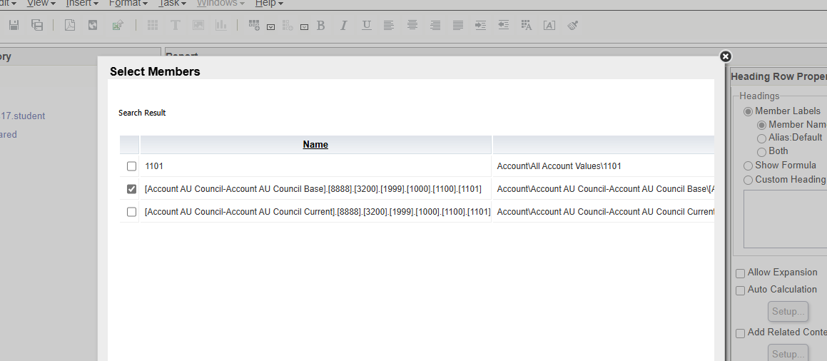

**For rows 1101**

**1111**

**5757**

**6616**

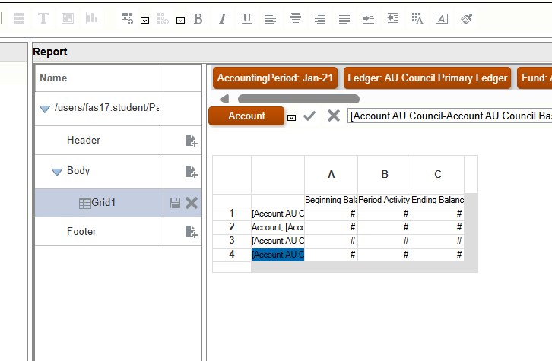

**Then go html preview**

**Select al the accountand in right side choose aloas default then do html preview**

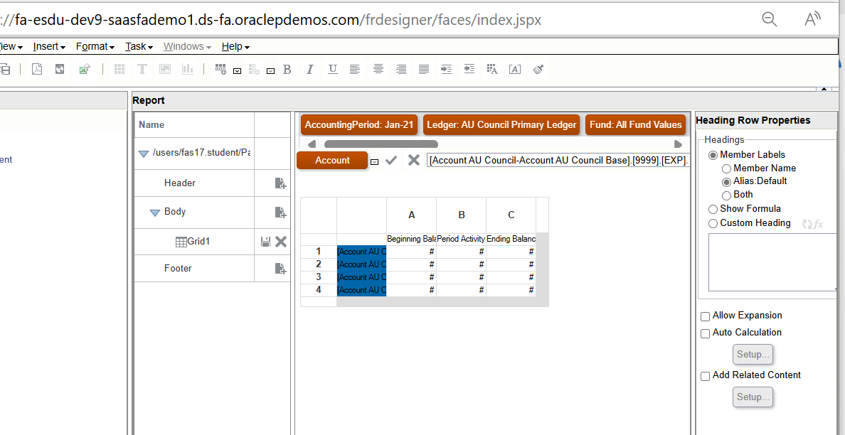

**Change format go to upper row…format**

**Then select account colunmn and do allow expansion**

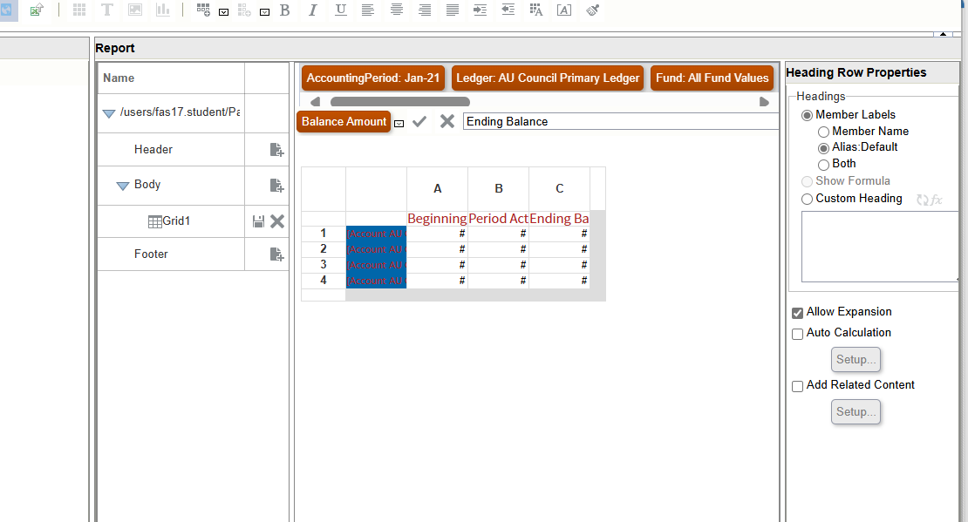

**Now we are getting #missing in the output now to remove that we’ll make few change and also #zero is there so to change it into 0**

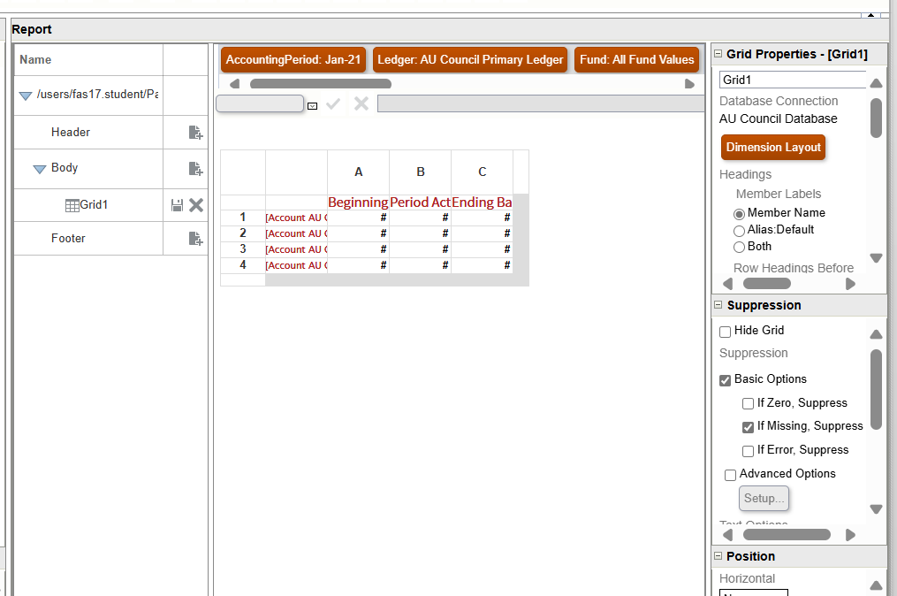

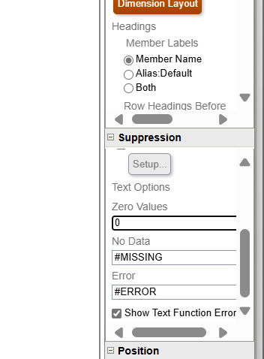

**If you want to change number format, select column and go to format**

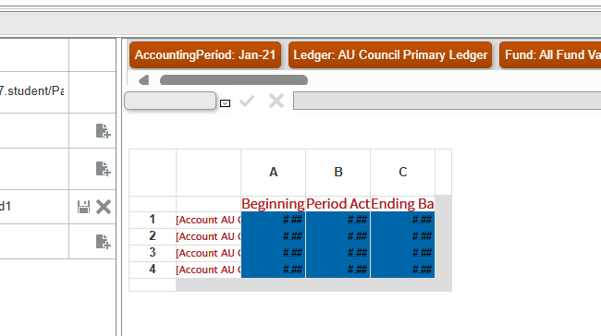

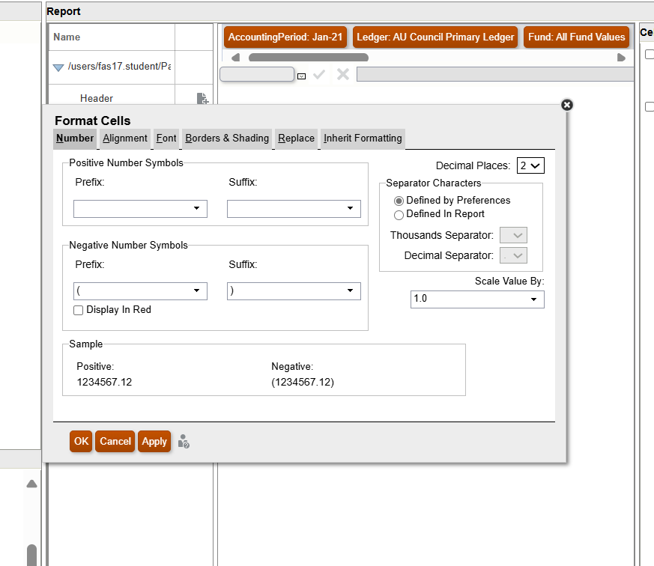

**Now add text and formula row**

**Go to insert …add row…….add text**

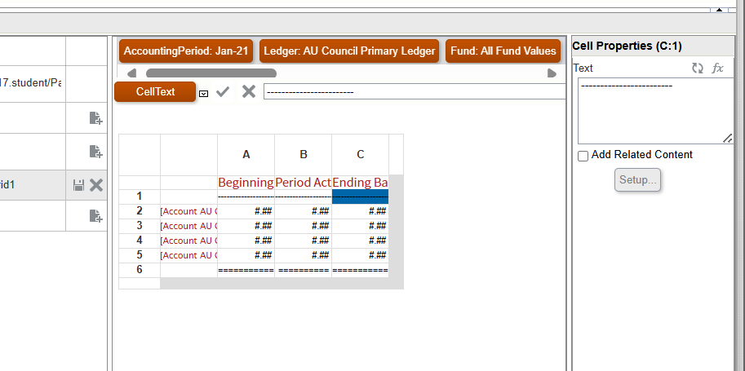

**Insert …..add row……add formula……..NOW HOW TO ACCSESS CELL**

**[b,5] b column and row**

**[]b] currenct row but b column**

**[5] current column but 5 row**

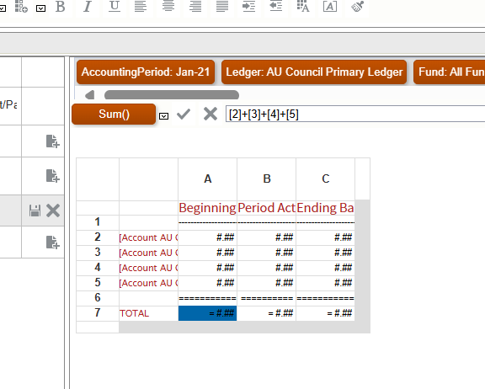

**CUSTOMIZE SEEDED REPORT**

**ESS – enterprise scheduler service and jobs in that are called as ess**

**In Oracle Fusion, seeded reports are pre-built reports that come with the Oracle Fusion applications. These reports are designed to provide standard, out-of-the-box functionality for various business processes and can be used as-is or customized to meet specific business needs.**

**Seeded reports are available across different modules, such as General Ledger, Global Human Resources, Procurement, and more. They help organizations quickly access critical information and insights without having to build reports from scratch.**

* 1. **Open this in one tab**

**If any customization is needed in report**

**Go tool………schedule process ….schedule new process …..**

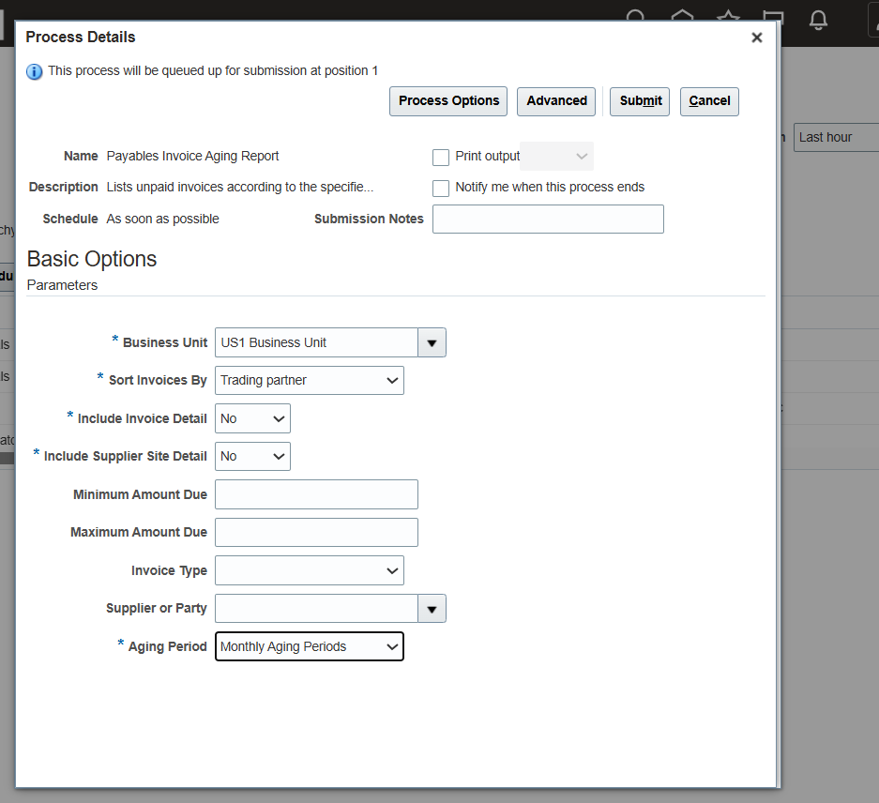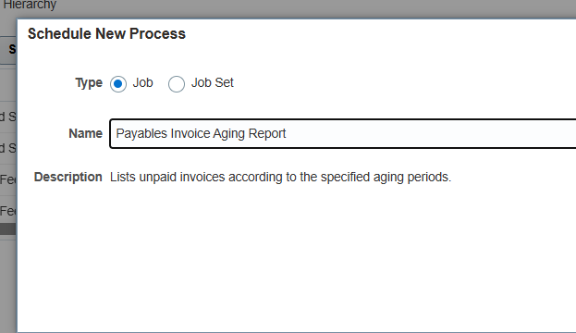

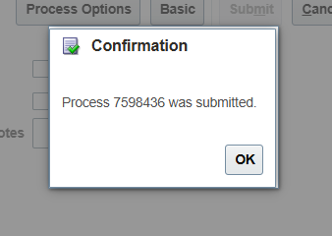

**We can only modify report when its job type is bip job**

* 1. **Open this in duplicate tab**

**Check report’s location for that two ways are there first is**

**Tool….report and analytics.browse catalog…home…job history**

**• Verify Customization Needs: Identify the exact location and path of the seeded report to ensure you are modifying the correct report.**

**• Accessing the Report: Ensure you know where the report is stored, so you can access and work on the right one**

**Now go to set up and maintenance ……search for %sched%job%**

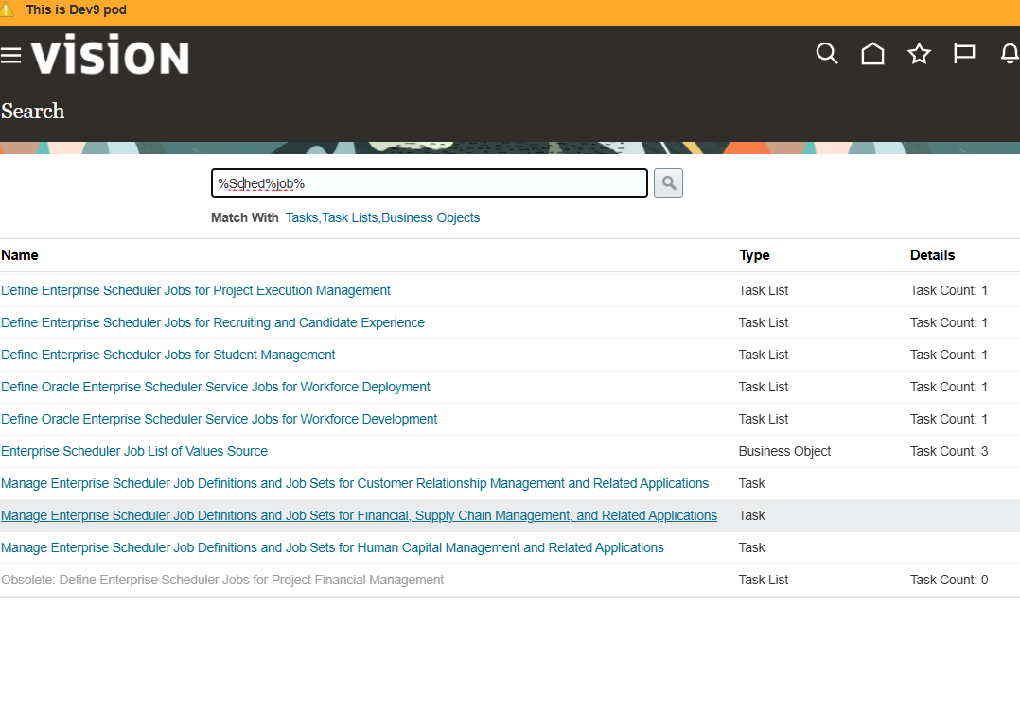

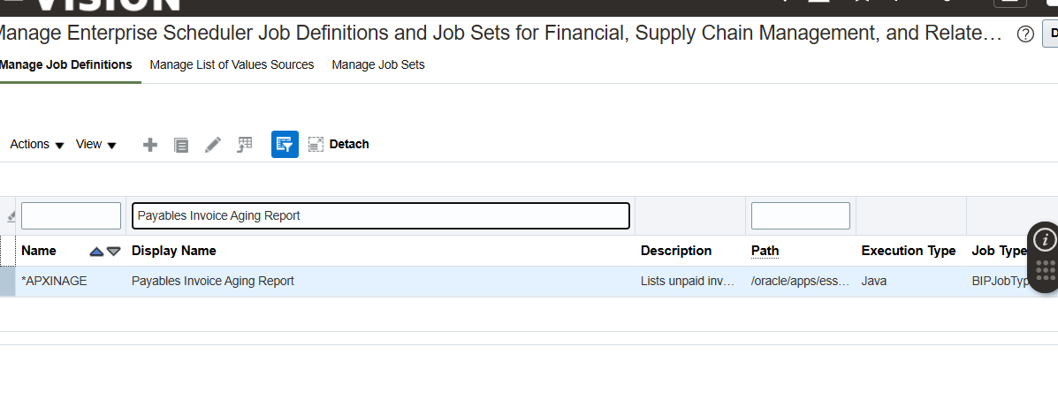

* 1. **Open this in third tab**
  2. **Go to catalog ..here we will check is that the same report**

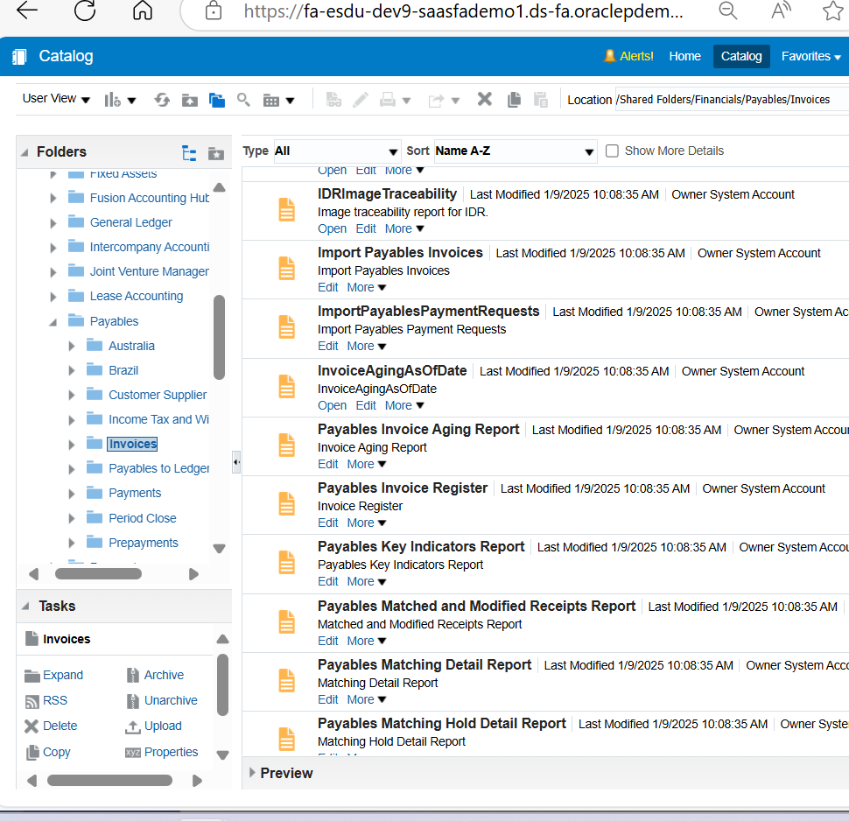

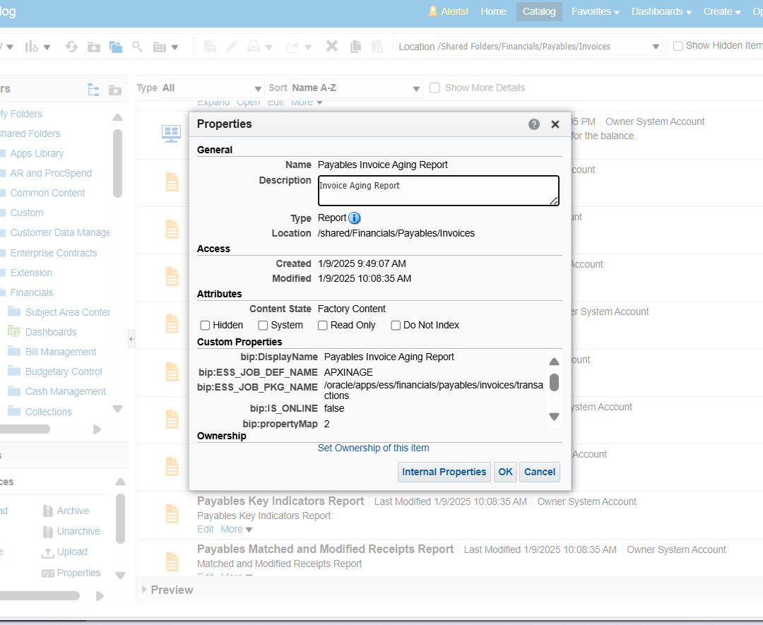

**Now to customize**

**4 th ….open 4th window …open this** [**https://fa-esdu-dev9-saasfademo1.ds-fa.oraclepdemos.com/xmlpserver**](https://fa-esdu-dev9-saasfademo1.ds-fa.oraclepdemos.com/xmlpserver) **…go to catalog …..financial …..payable….invoices…payable invoice ageing …click more …customize**

**Bcz too many reports are being change that’s why we will come back again to third window there go to shared folder .financial..invoices…..copy payable invoice ageing report ……go to shared folder ……custom …….folder …create folder payable……paste it**

**Again go to catalog…shared folder..finacials….payables…invoices…data model…**

**Copy ageing payable invoice ageing data model…..then go back to customes…my folder..payables…paste it there…edit the report…click the search model …select the data model that you pasted…edit it ..it will get downloaded…...open it in word**

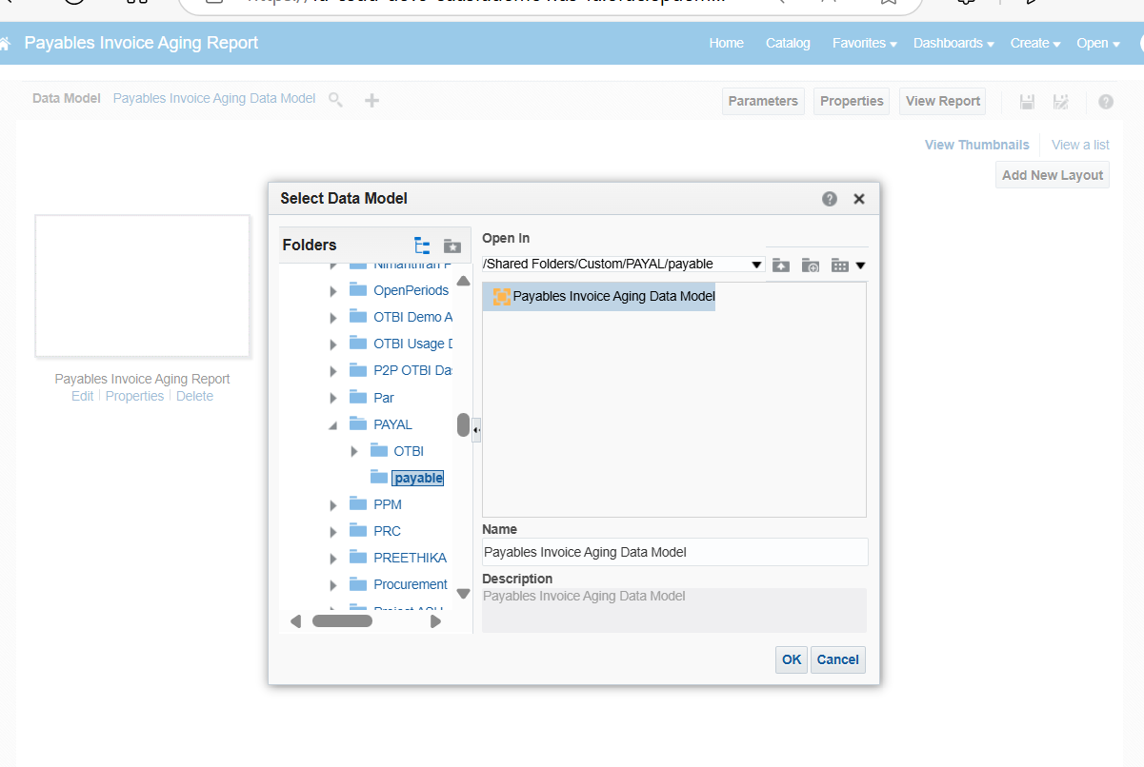

**After editing the file (change image) …after editing we will change name of current layout to new name such payable invoice old(this can be done by using view list )…save and refresh page…..click on data model in report tap on propertirs of data model ….upload sample data…..upload downloaded xml file……..after that press return…..add new layout….upload…rtf file….after renaming the downleded file as payable invoice ageing report………..click save…go back to view list again….select default format pdf ……………..again go to catalog …..go to ageing report in payable…go to history…copy that path….** **/Custom/**

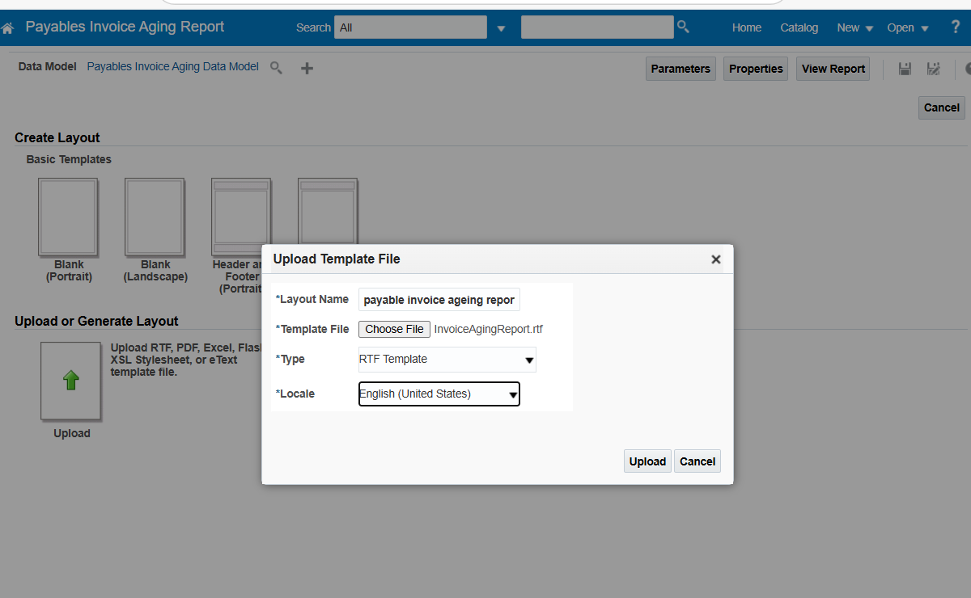

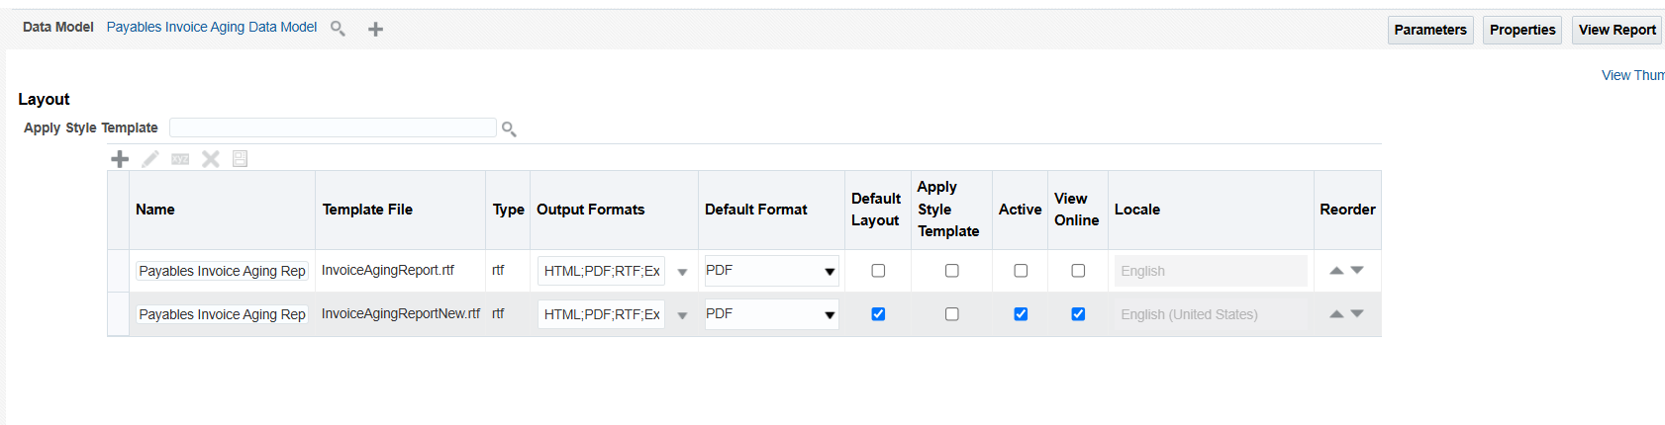

**Now go back to %shed%job…….** **Manage Enterprise Scheduler Job Definitions and Job Sets for Financial, Supply Chain Management, and Related Applications………..**

**Search payable invoice ageing report…….select and duplicate…edit the duplicate(it will not have ay internal name)….edit…give your display name…etc path name after custom (folder name/payalable) where as we can directly copy past the path with everything…..then save and close..now smile**

**Rfd**

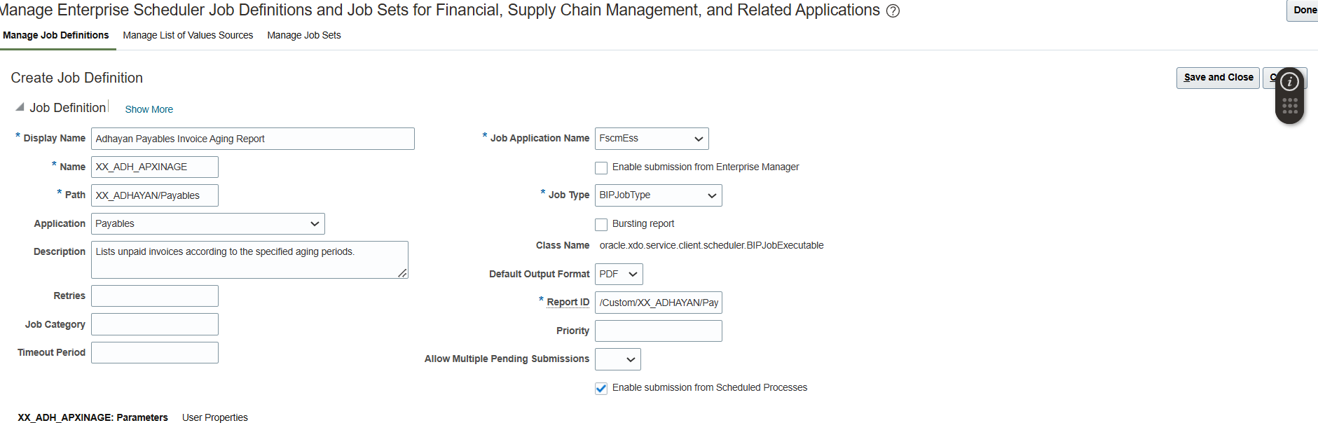

**Now go to tool in another tab … …schedule process……select your report submit..(although it not uploading)**

**To check if our changes in report are working or not**

**For parameter**

**Tools.eshedule process…schedule new process…..search payable invoice ageing report…..go to home…go to report job history………latest executed thing..open that ..copy parameters…..**

**t Parameters**

|  |  |
| --- | --- |
|  | |
|  | |  |  |  | | --- | --- | --- | | **P_PERIOD_TYPE** |  | **Monthly Aging Periods** | | **P_FORMAT_OPTION** |  | **N** | | **P_SUMMARY_OPTION** |  | **N** | | **P_SET_OF_BOOKS_ID** |  | **300000046975971** | | **fusionapps_request_id** |  | **7598436** | | **P_BUSINESS_UNIT** |  | **300000046987012** | | **P_SORT_OPTION** |  | **Vendor Name** | |

**Next**

**Create a new report… ….select the data model…. upload new layout where we made changes inpictures in word document ….save**

**Next**

**Create new report job …..select the new report that you created……give the parametrer that you copied and output should be pdf……submit**

**Again go to job history……see your job name ie. Payal job…open it…..click output**

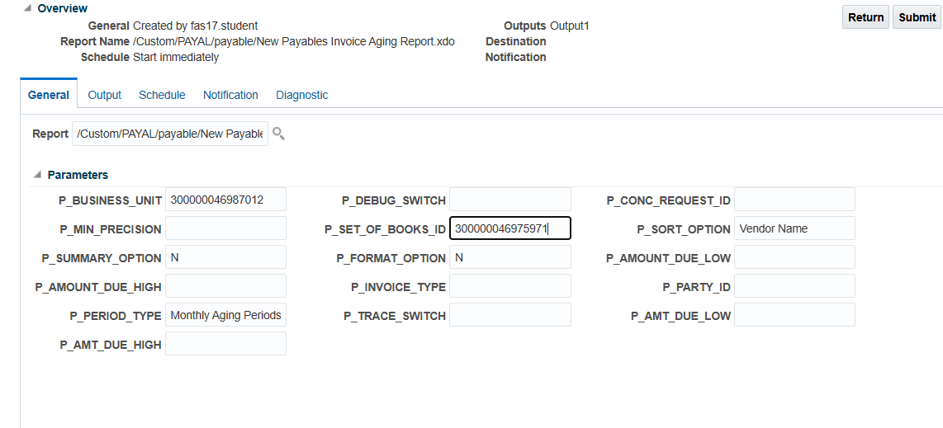

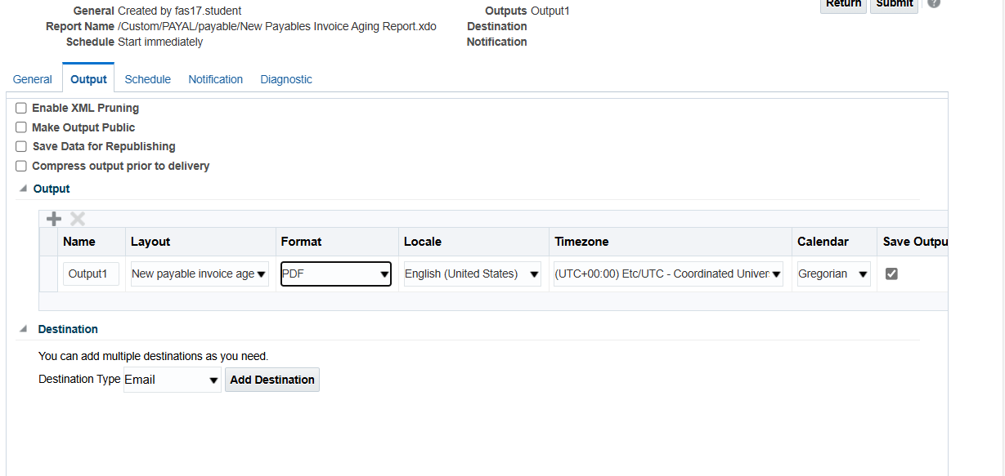

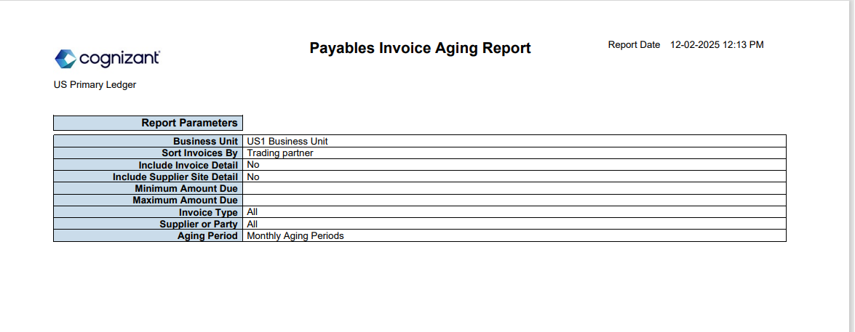

**GENERAL LEDGER ACCOUNTING FLEXFIELD**

**See yesterday we did financial reporting …when someask to make report on finacials**

**And this is general ledger**

**Here only P_ACCOUNT ACCOUNT, &P_ACCOUNT_DESC ACCOUNT_DESCRIPTION this thing is asked from combinations table but we have to make parameter based on p_coa_id as parameter and to put values in parameter we have take values from both the tables and the main thing is while joining we should join all the primary keys bcz if join with one primary key we will get many duplicate values..therefore to get unique values we are joining all primary keys**

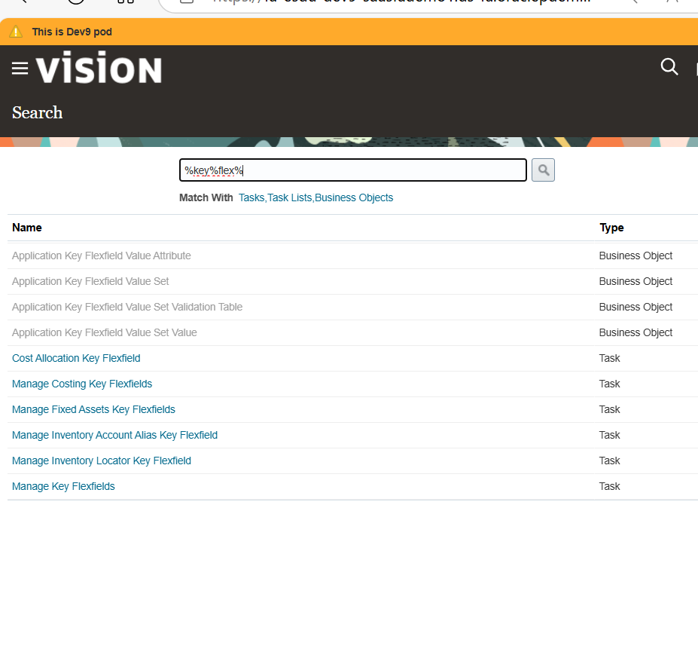

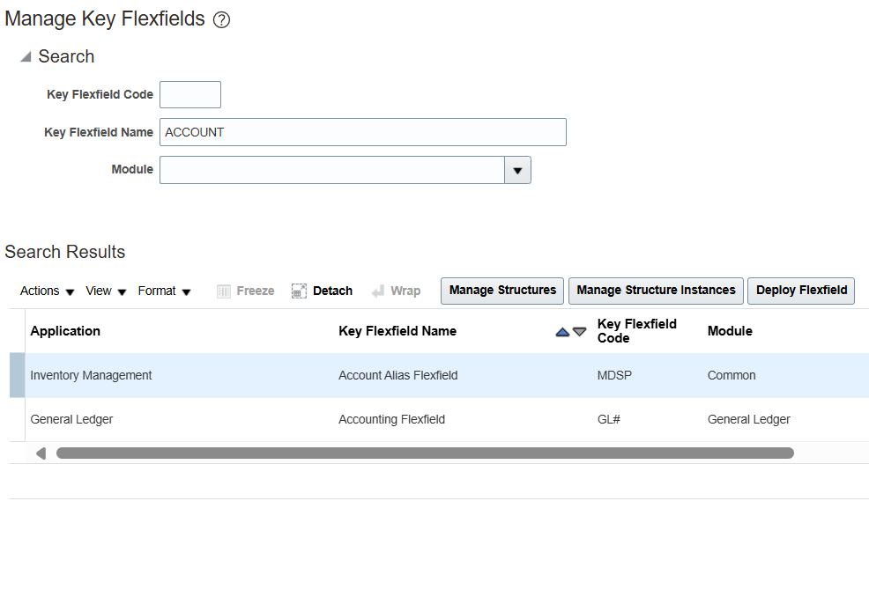

**FND_KF_STR_INSTANCES_B Stores the details of key flexfield structure instances.**

**FND_KF_STR_INSTANCES_TL** **Stores the translated text for key flexfield structure instances.**

**SELECT T.NAME ,B.STRUCTURE_INSTANCE_ID**

**FROM FND_KF_STR_INSTANCES_B B, FND_KF_STR_INSTANCES_TL T**

**WHERE B.APPLICATION_ID = T.APPLICATION_ID**

**AND B.KEY_FLEXFIELD_CODE = T.KEY_FLEXFIELD_CODE**

**AND B.STRUCTURE_INSTANCE_CODE = T.STRUNCTURE_INSTANCE_CODE**

**AND B.ENTERPRISE_ID = T.ENTERPRISE_ID**

**AND T.KEY_FLEXFIELD_CODE = ‘GL#’**

**AND T.LANGUAGE = USERENV(‘LANG’)**

**GL_CODE_COMBINATION ….THIS TABLE STORES COMBINATIONS**

**SELECT &P_ACCOUNT ACCOUNT, &P_ACCOUNT_DESC ACCOUNT_DESCRIPTION**

**FROM GL_CODE_COMBINATIONS GCC**

**WHERE CHART_OF_ACCOUNTS_ID = :P_COA_ID**

**NOW GO TO CREATE REPORT**

**TOOL….REPORT AND ANALYTICS….browse catalogue…create new model …..paste the second query…..check box ab first box is ‘A’ AND SECOND BOX IS ‘B’ …..now go to parameters …create parameter on p_coa_id….now create list of values FOR THAT PASTE THE FIERST QUERY….NOW CREATE FLEXFIELD**

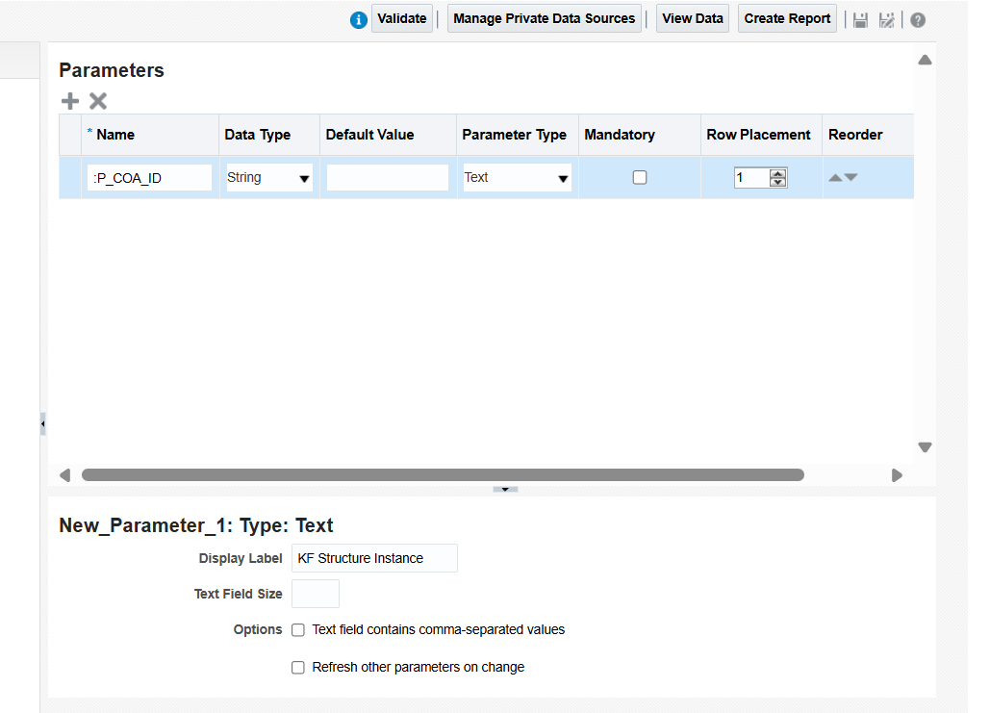

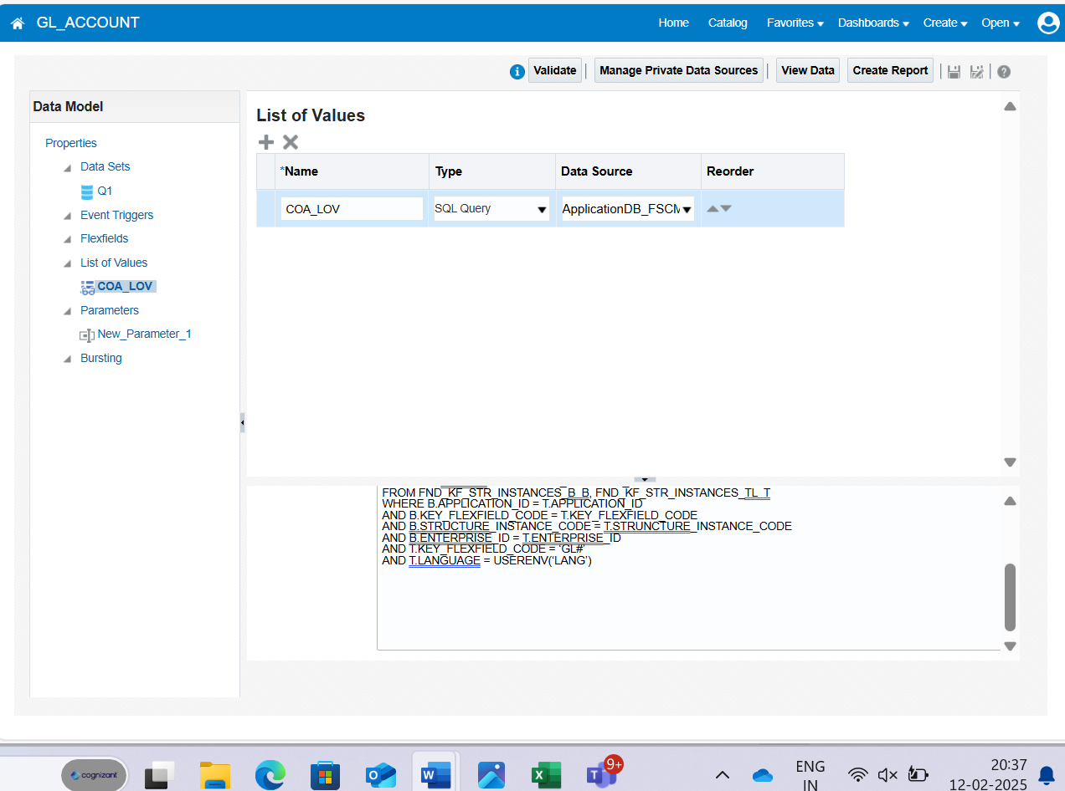

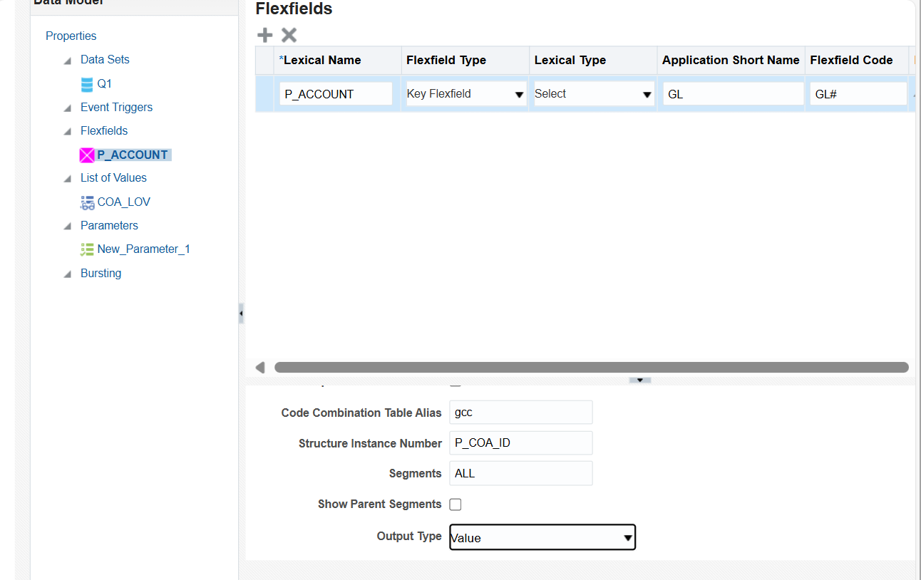

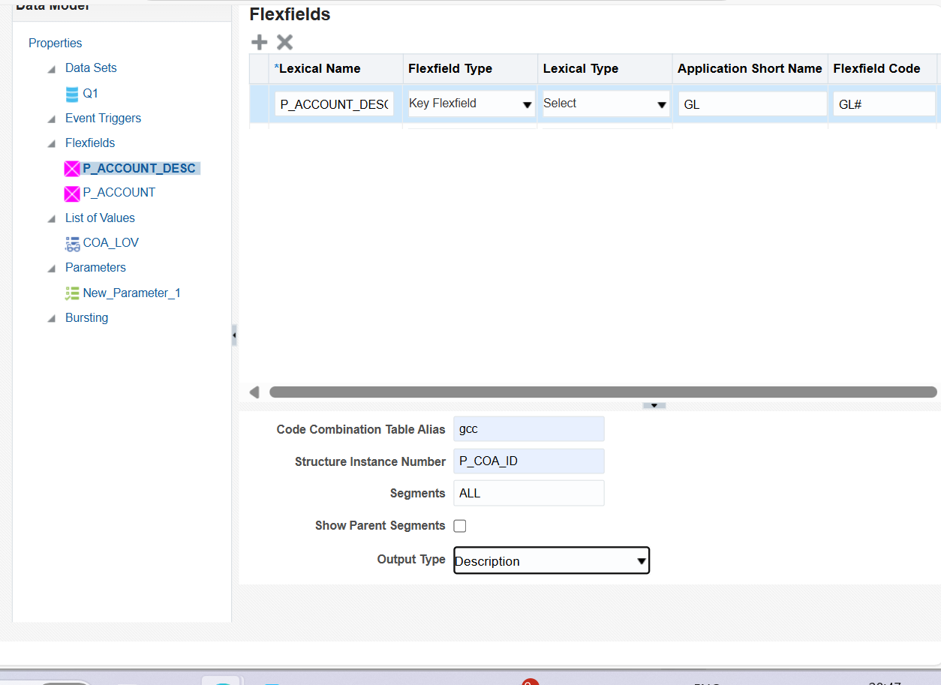

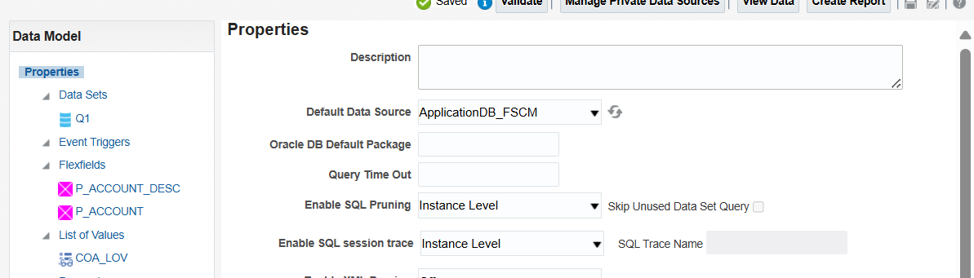

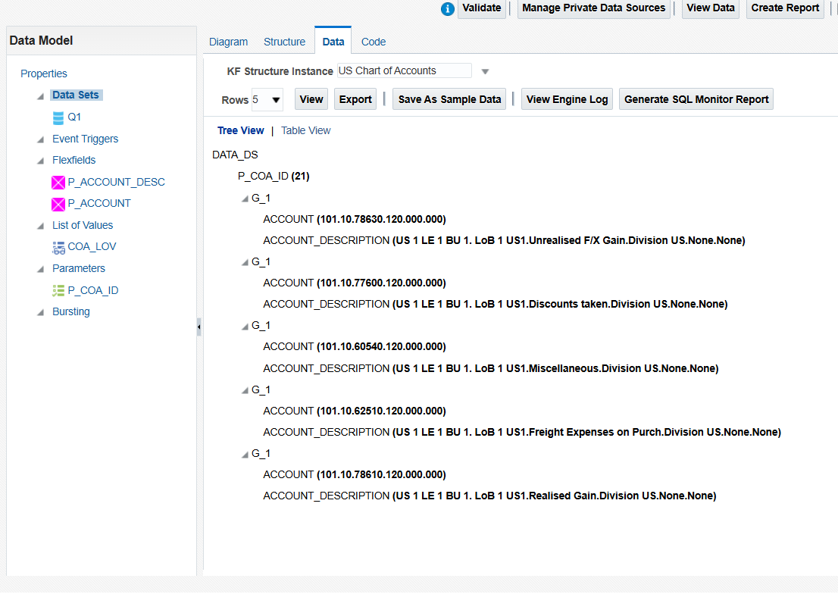

**FINANCIAL**

**Only legal structure is used**

**Enterprise(only 1 enterprise is there)**

**Legal entity ledger**

**Bu financial**

**Inv org**

**Sub inv SCM**

**Loc**

1. **Ledgers**

**How will you check your daily rates**

**Setup and maintenance ………action**

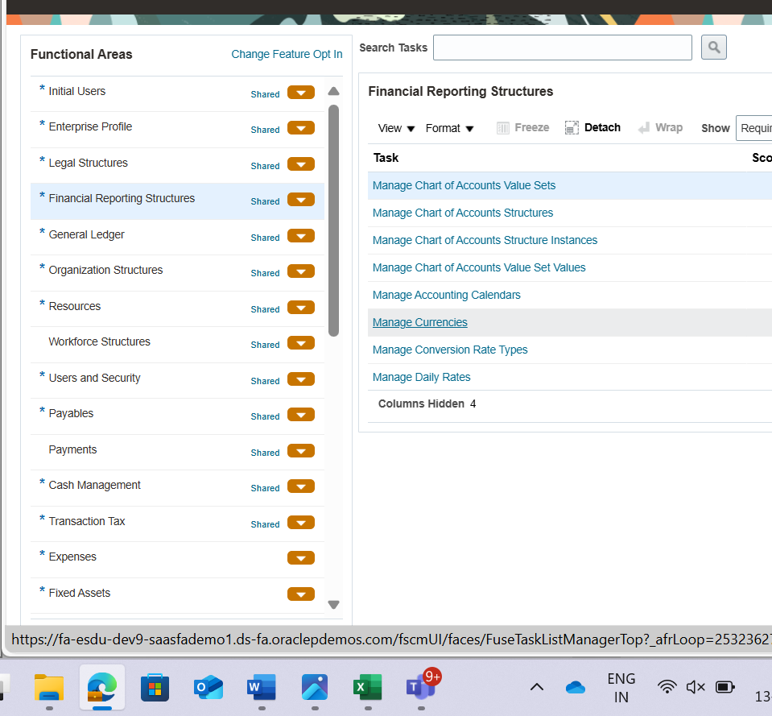

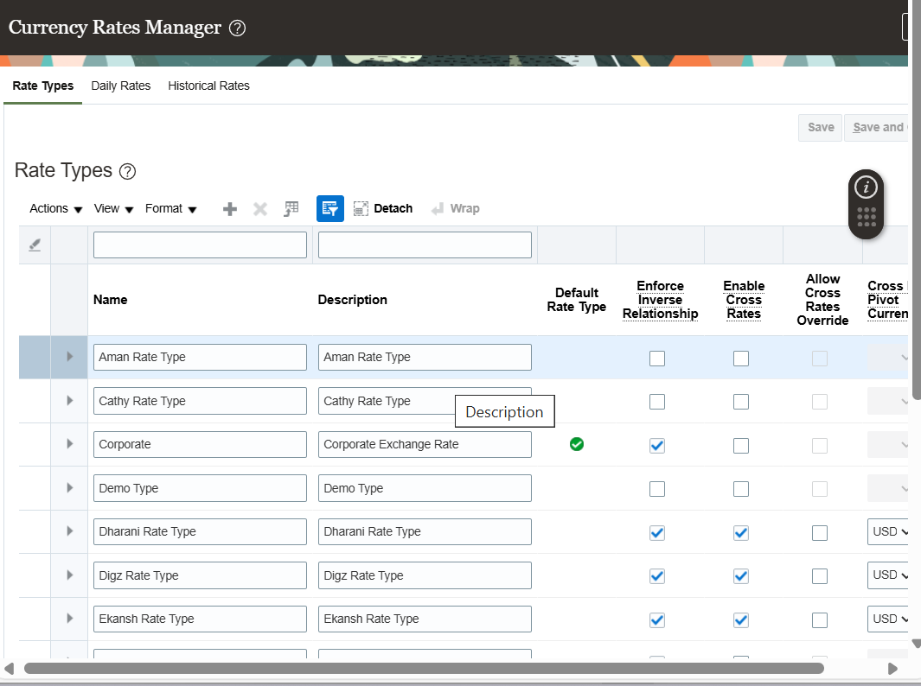

**Define a rate type..go to plus sign..after creating ……give exchange value by going on daily rate…..now go to fbdi(File-Based Data Import)….go to ledger …..impoort and calculate …..download xlsm template….unblock it…open in excel sheet…enable editing…press cntr+shift+end select and delete …then type new thing…use cntrl+d to copy….after changes …click on generate file to download it in zip file(bkl …desktop p gl folder bnake save kiya h..bhulna mt )….then go to tools…schedule process….give parameters exactly shown in ss…..refresh It…and all should be succeeded**

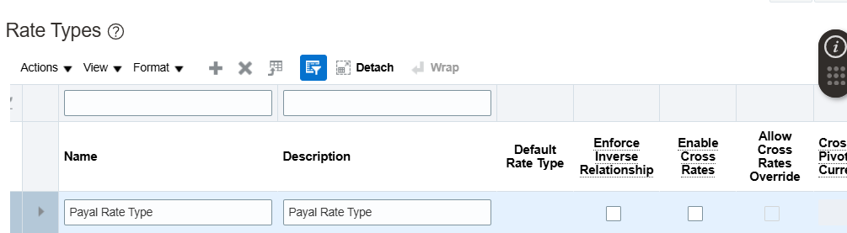

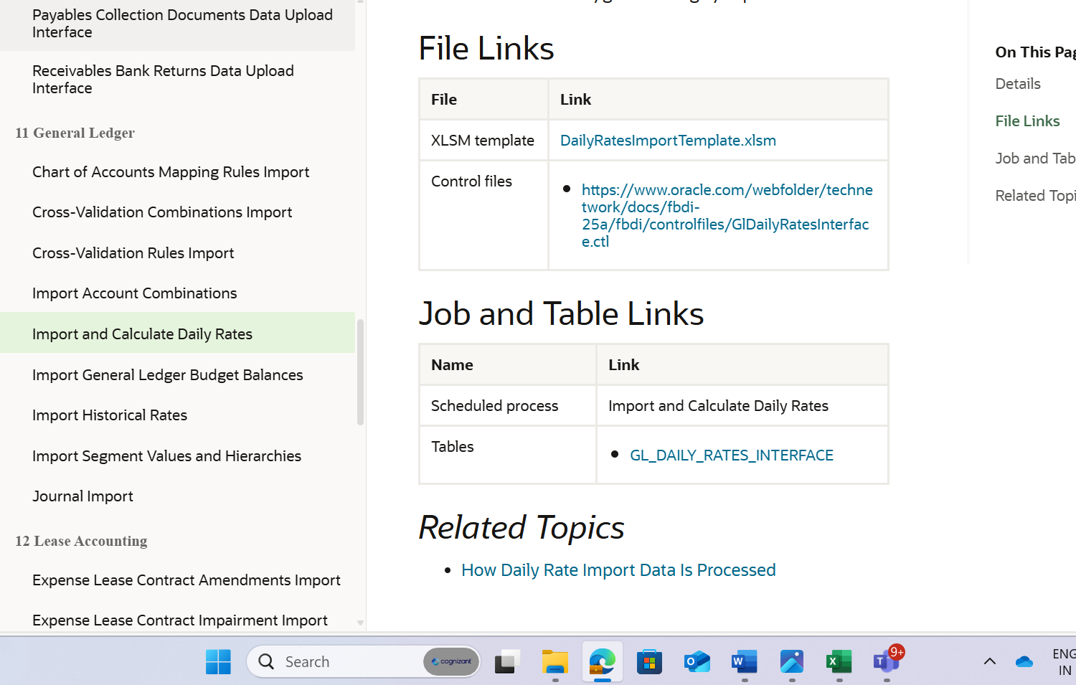

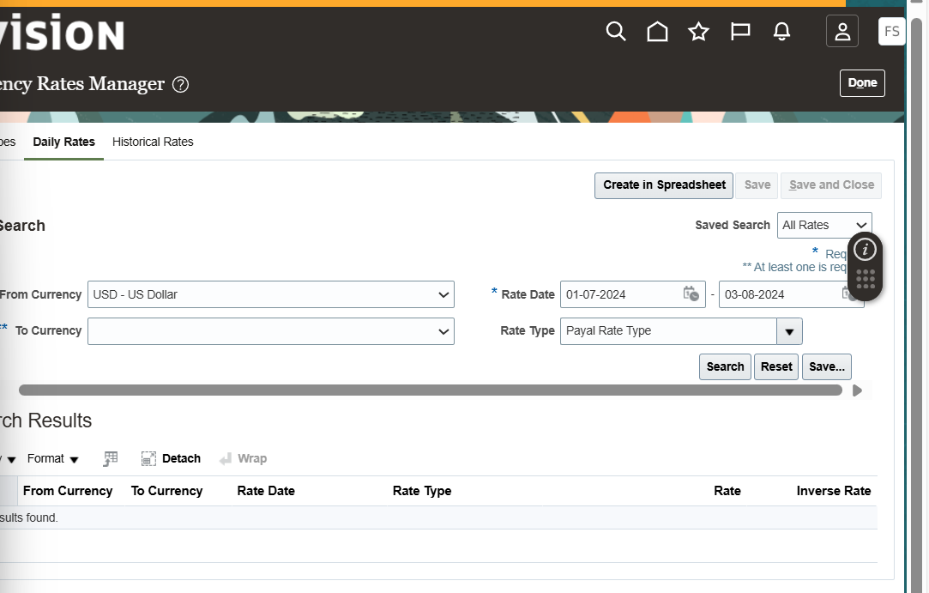

**Xlsm csv zip ucm(universal content managment) (every report is saved in ucm , any data want to upload is in ucs, any data want to import is In usm) interface table (data from ucm is loaded into the interface table for validation and transformation ) base table (and then validated data is transferred to the base table whereit is stored permanently and will be deleted from the interface table )**

**Two schedule processes first is ucm to interface and next is read interface table to base table**

**Zip file name we can change..csv we cannot**

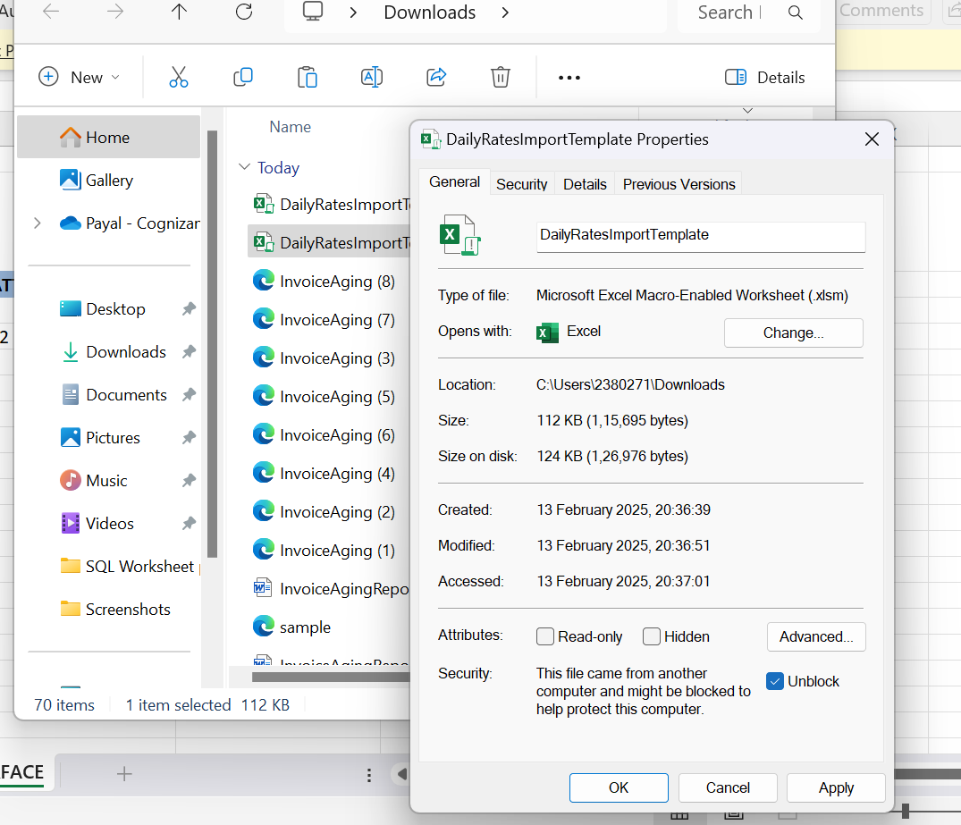

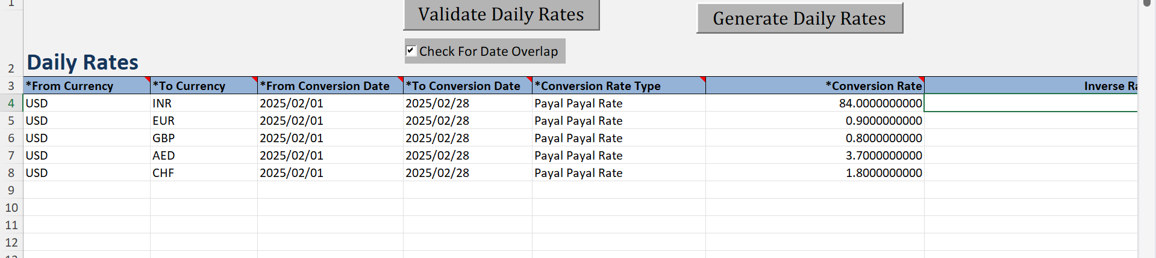

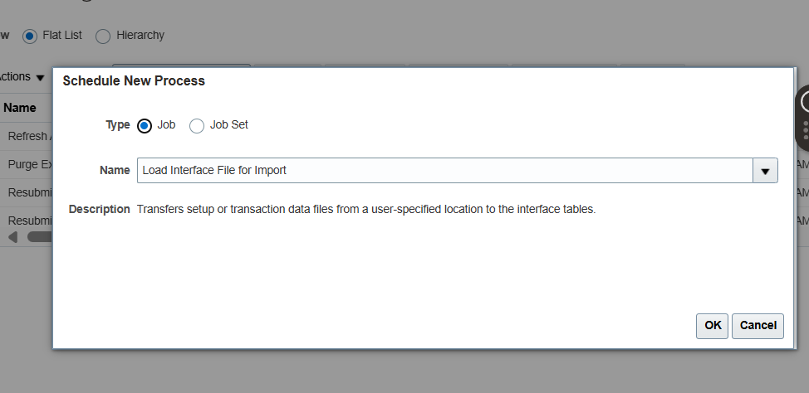

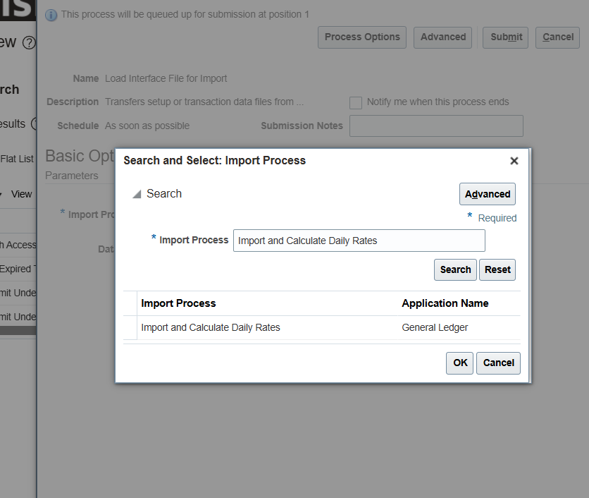

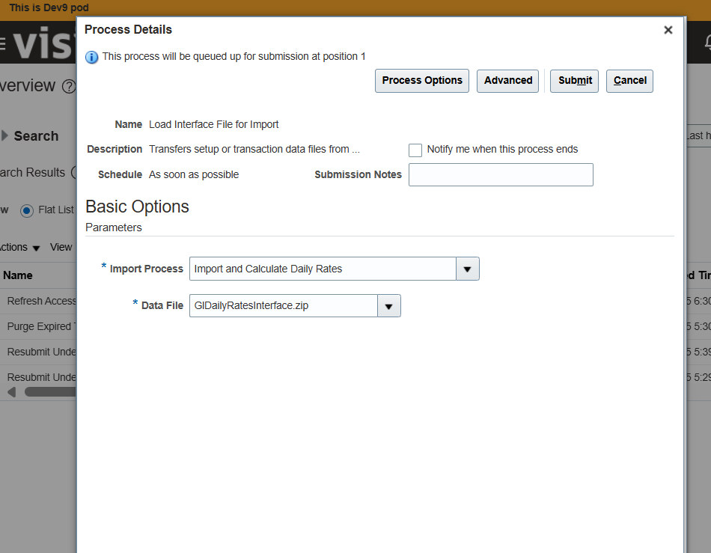

**Manage accounting calender**

**Set up…..frs…….manage accounting cale…….create…then next..then save**

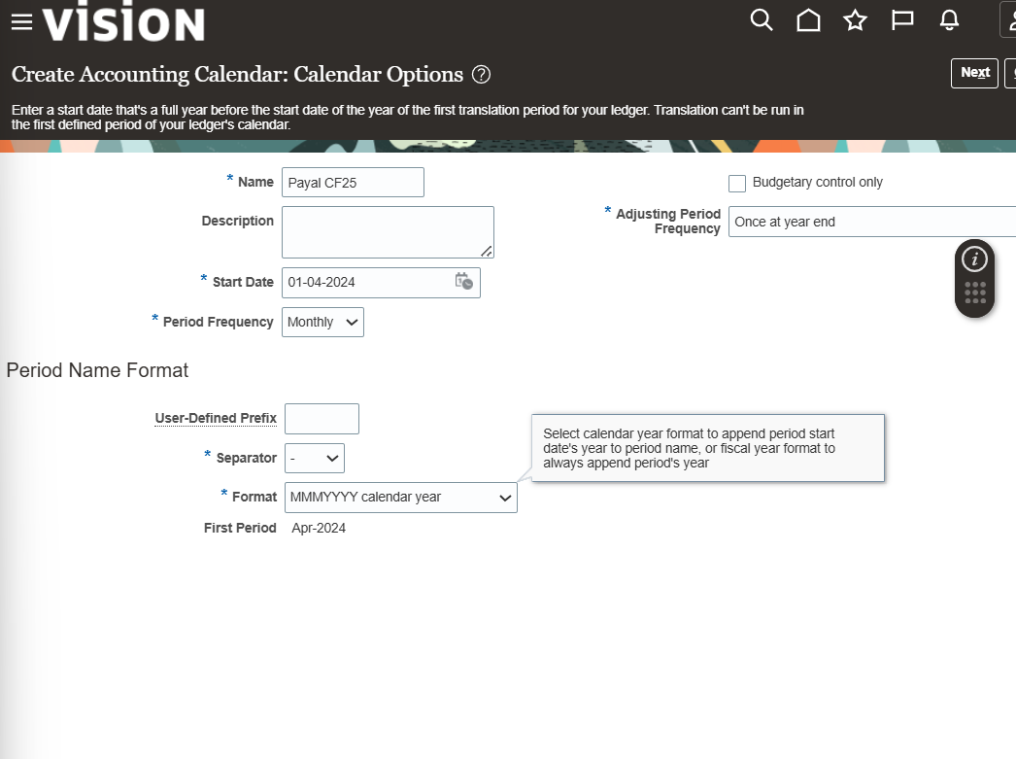

**Manage chart of account :**

**These 3 segments are mandatory otherwise chart of account will not compile Primary account**

**Natural account segment**

**Cost center segments**

**We cannot change struc..but we can change the labels**

**Manage chart of account value set value:**

**Search manage value set values …search au council…search…1101 is child of 1100is child of 1000 is 0000 …if the summary is no the allow posting is yes, always vice versa bcz if the posting is yes then the sum of child will directly put into parent**

**Allow budgeting is ignored only while creating balance sheet bcz credit and debit is of no use there**

**Create structure instance:**

**Setup….frs…..manage structure instance……click search or if doesn’t come seach AU COUNCIL into it…general ledger will come…then go to manage structure instance …create instance…..make it required and there is also dynamic combination creation allowed if it is checked that means even if the combinations are not there it will create combination and if it not checked it will give error……...also shorthand should be enabled bcz even we can search instance by giving alias name**

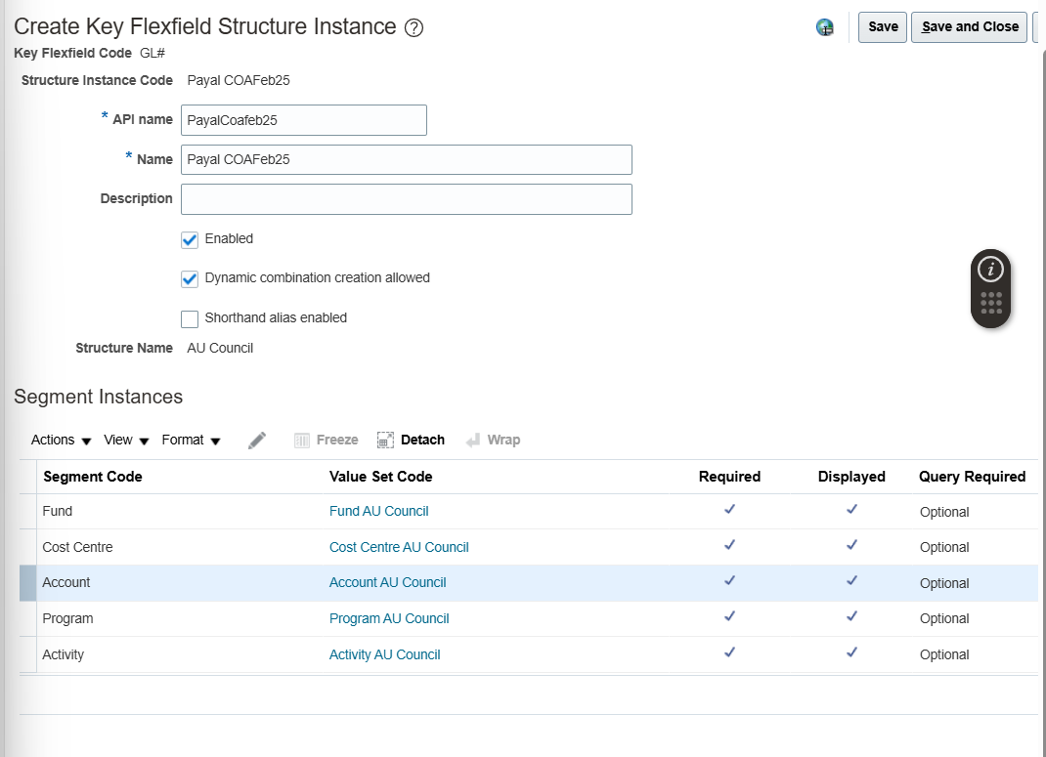

**Create combination will create by fbdi :**

**Import account combination …download xlsm file….unbloack it…cntr+shift+end………no we have to**

**First go to manage account council…copy name from it..and make everything y**

**Second is go to manage structurs …seach account…general ledger …manage structure instance …au council…funds….edit….copy that tree**

**Third go to manage value sets …search that tree code in value set code….manage value….plane search……..pick only values where summary is no……….do the same for rest of the values to create different combination …and make unique number in import group identifier(AL) in excel….then go to left side and generate file…**

**Now go to tools ….shedule process…the way din in above for uploading zip file…three files will succeed one will be in wait for that we need to manually schedule it for that again go to schedule new process…search for import ACCOUNT COMBINATION…select your structure instance and import group identifier (excel) then submit**

**Now go to manage account combination…search payalCOAFeb25**

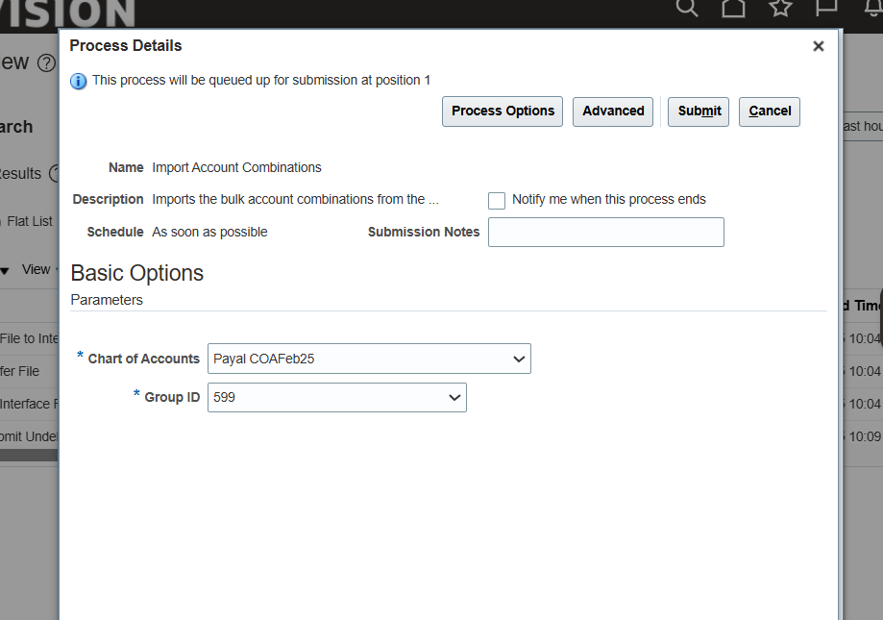

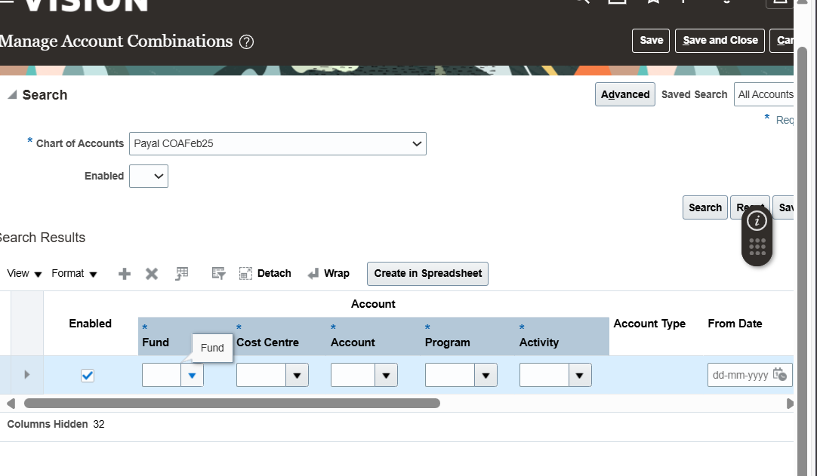

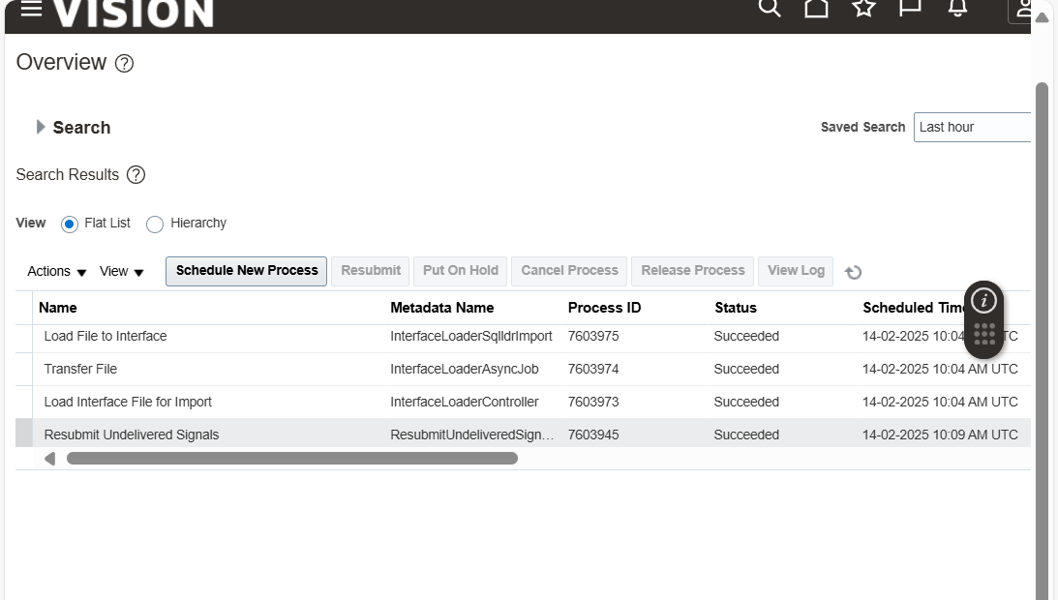

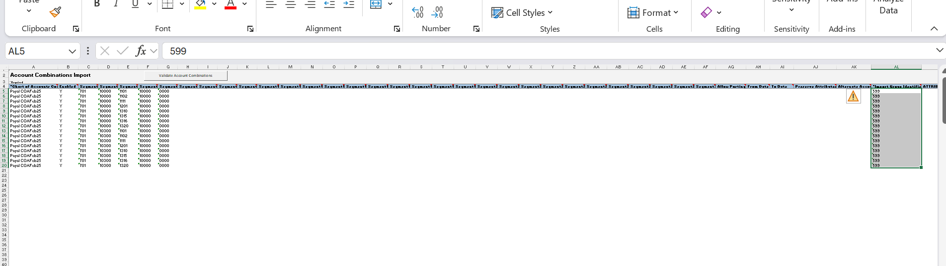

**Manage Primary ledgers: -**

**Go to setup & maintenance—setup financials(top left)—general ledger---manage primary ledger---create a new primary ledger(as we can see all 4 C’s are available)—after creating new ledger—go back to setup page---we can see scope next to manage ledger option(next to that will be a ledger name, we can click on that and change the primary ledger to select and add)—apply and go to task---and select the ledger we created---(we will not create ledger we use US primary ledger)now the scope option will reflect our newly created ledger after saving and closing--- we can go to manage secondary ledgers and see all the secondary data ledgers available.**

**Immediately after creation of Primary ledger we need to specify in manage specify ledger.**

**After primary ledger we create secondary ledger and follow same steps as primary ledger.**

**calendar:-**

Never opened:- Next month after future month(June)

Future:- Next month after the 1st financial Month

Opened:- when financial month starts(April 1st)

Closed :- end of first month(end of April month)

Finally closed:-After completion of the 2nd month the first month will be in finally closed(after may end, april will be in finally closed)

**JOURNAL**

**In business, a journal is a detailed record of all financial transactions.**[**It’s often referred to as the “book of original entry” because it’s where transactions are first recorded before being posted to the general ledger1**](https://businessjargons.com/journal.html)[**2**](https://www.investopedia.com/terms/j/journal.asp)**.**

**Here are some key points about journals in business:**

* [**Purpose: Journals are used to keep a chronological record of all transactions, which helps in reconciling accounts and preparing financial statements2**](https://www.investopedia.com/terms/j/journal.asp)**.**

**difference between general ledger and journal**

**Copilot**

**Sent by Copilot:**

**The general ledger and the journal are both essential components of a company’s accounting system, but they serve different purposes and have distinct characteristics:**

**General Journal**

* [**Purpose: The journal is the book of original entry where all financial transactions are first recorded in chronological order1**](https://www.investopedia.com/ask/answers/030915/whats-difference-between-general-ledger-and-general-journal.asp)**.**
* [**Detail: It includes detailed information about each transaction, such as dates, accounts affected, and amounts debited or credited1**](https://www.investopedia.com/ask/answers/030915/whats-difference-between-general-ledger-and-general-journal.asp)**.**
* [**Types: There are general journals for all types of transactions and special journals for specific types, like sales or purchases**](https://www.investopedia.com/ask/answers/030915/whats-difference-between-general-ledger-and-general-journal.asp)[**2**](https://www.wallstreetmojo.com/general-journal-vs-general-ledger/)**.**

**General Ledger**

* [**Purpose: The general ledger is the book of final entry that summarizes all the transactions recorded in the journal by account1**](https://www.investopedia.com/ask/answers/030915/whats-difference-between-general-ledger-and-general-journal.asp)**.**
* [**Structure: It organizes transactions into accounts, such as assets, liabilities, equity, revenues, and expenses1**](https://www.investopedia.com/ask/answers/030915/whats-difference-between-general-ledger-and-general-journal.asp)**.**
* [**Summary: The general ledger provides a summary of all transactions affecting each account, which is used to prepare financial statements2**](https://www.wallstreetmojo.com/general-journal-vs-general-ledger/)**.**

there is batch

header

line

inside batch there can be any number of header and inside header there can be min 2 line for credit and debit and the total of credit and debit should be same

Posting will be in batch ..thats why the whole batch will post..

This is we are going to create manually…after that it will be using fbdi

General accounting………journal..task…create journal..(it is imp that we should be under us primary ledger )…fill data properly …then see ss …save it…after creating one header then create another header..and then save it…then complete …post

No of lines under credit and debit might very but the total should match.

Batch will be under GL_JE_Batches and header will go into GL_JE_Headers and lines under GL_JE_Lines

Account will be in GL_BALANCE. Total transaction under same transactions will be under GL_Balance.

ADD and delete is allowed before posting. View-T-Account is for different visual

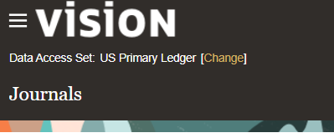

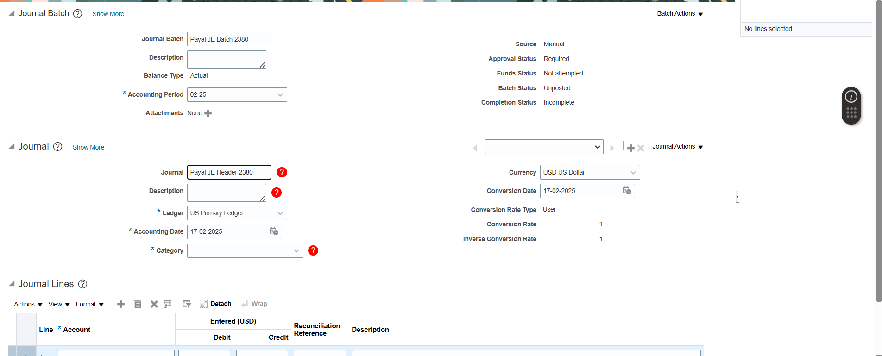

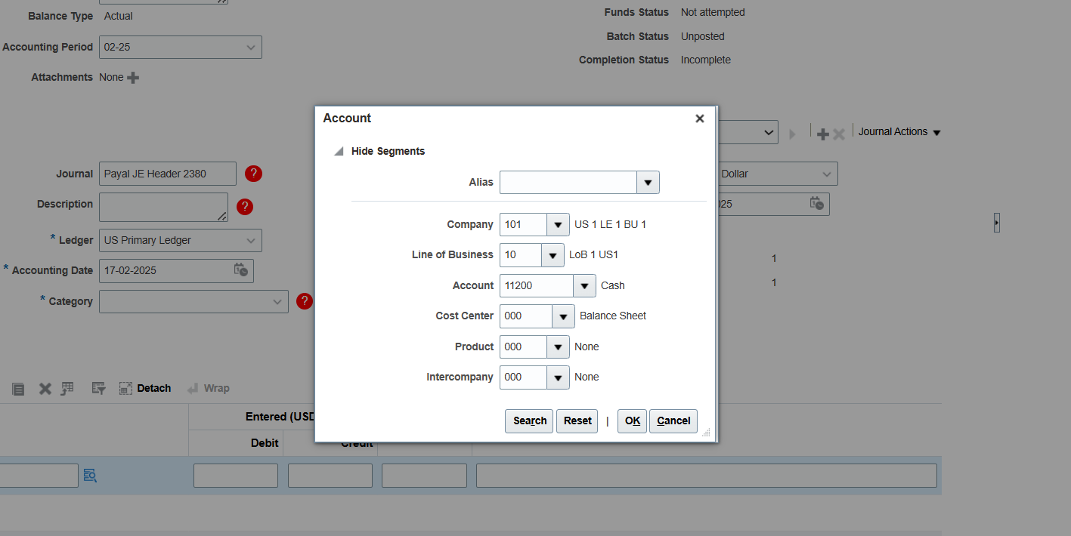

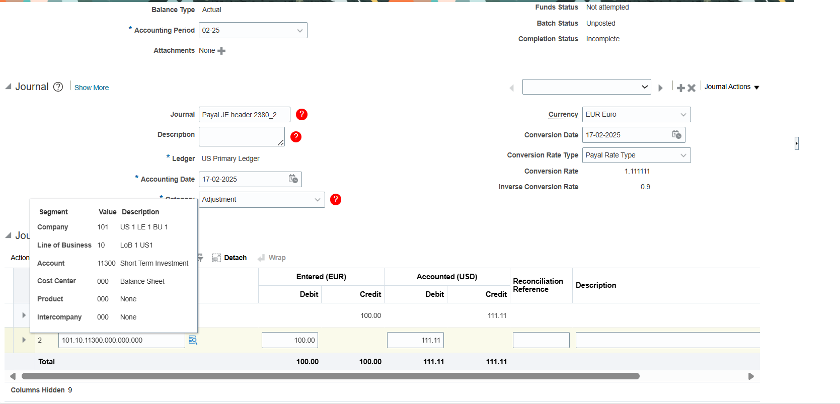

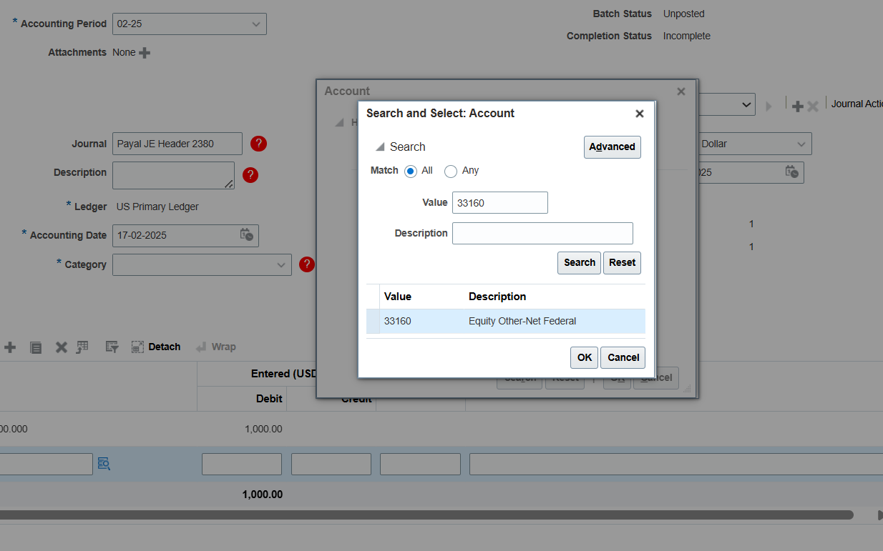

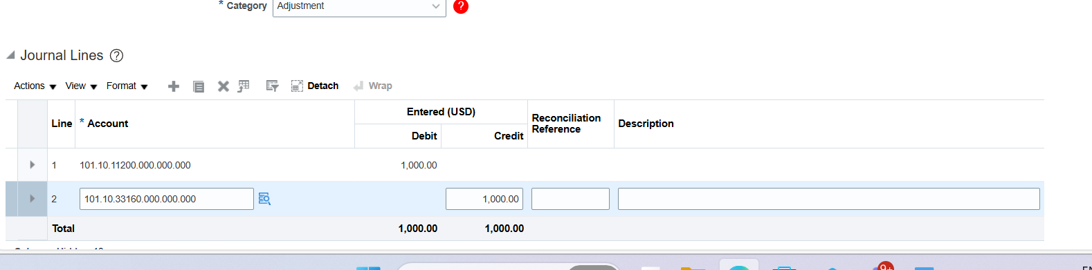

How to check…do cancel…go to manage journal…

To reverse credit and debit …click on your journal…select journal…select batch reverse

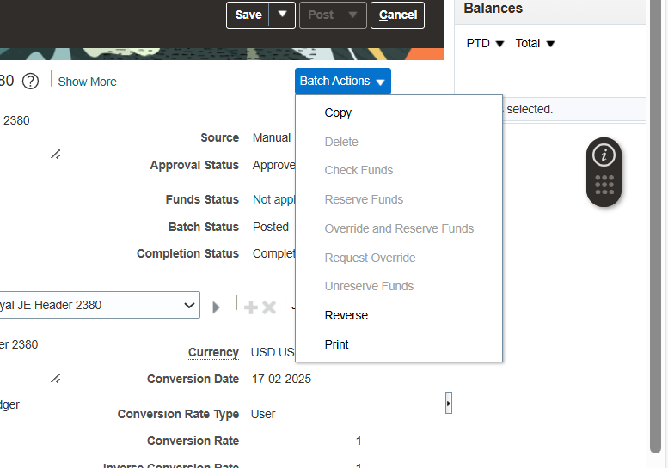

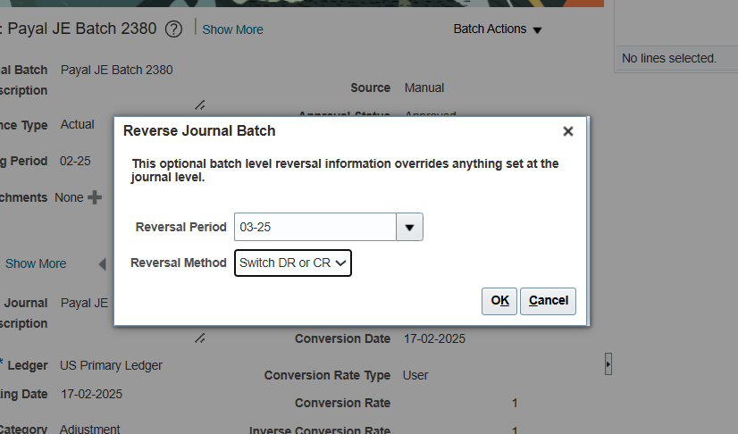

**Now we will do by FBDI**

**Search journal import report in fbdi…unblock the template…..here for taking the values we will first go to manage journal…there we check the values that is needed to fill in the excel but the batch name and header name will be put according to us..**

[**JournalImportTemplate Jaggu.xlsm**](https://cognizantonline-my.sharepoint.com/:x:/g/personal/2380261_cognizant_com/ETlv_69ialVNnJHbfKSK5rEBzUQUO7SjJBzWuMni8u1uuA?e=YMXE5o)

**Then you will go to tools ..schedule process ….**

**LEGAL ENTITY**

**In simple words if a company or an organization is registered and able to perform business operation and has to pay taxes under a obligation to gov. it is a legal entity.**

**First need to define legal address**

**Set up main…legal structure…manage legal addres …create address…after creating go to manae legal entity…create legal entity…save ..save and close..**

**Now to check ..again go to ..manage legal entity…select and add….search your entity..save and close..**

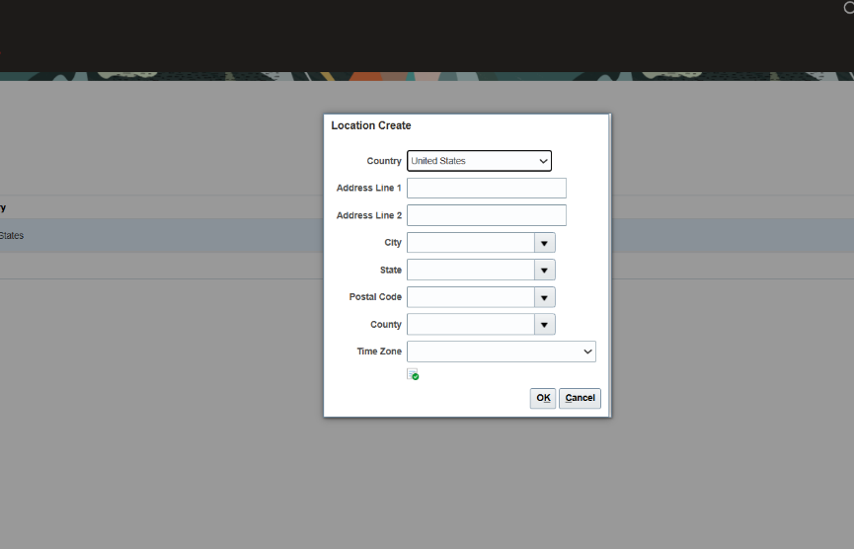

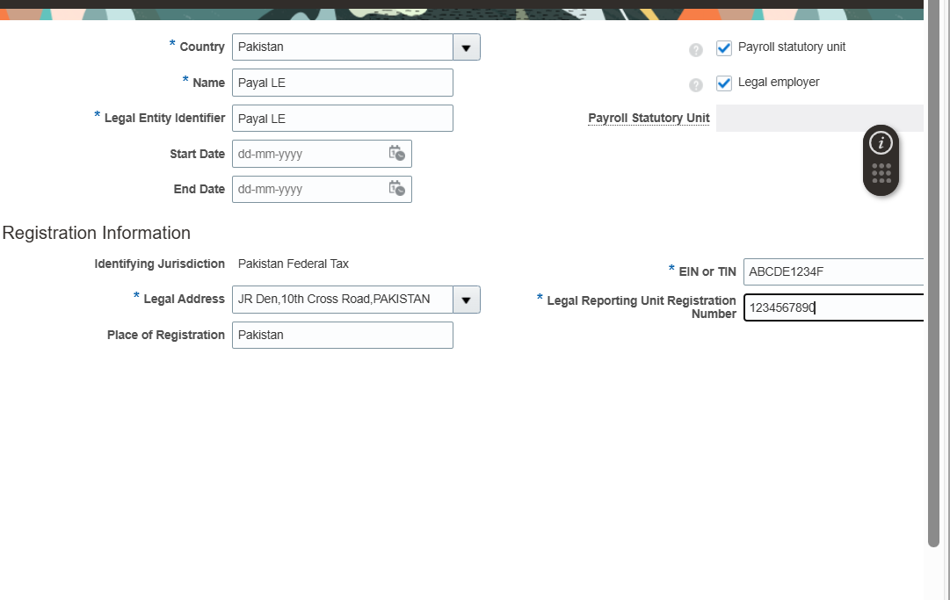

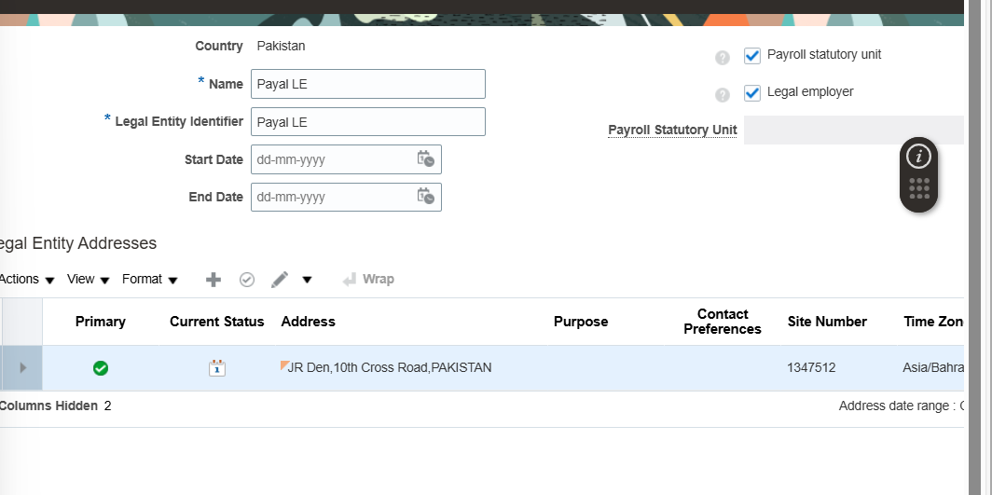

**Now go to manage legal entity registration…edit…**

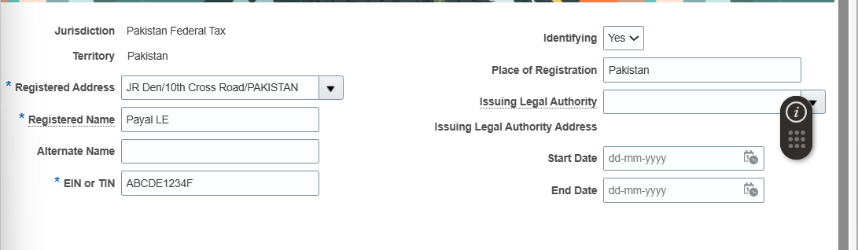

**Now go to organization structure from the left side then go to manage business unit …create ……now go to assign business unit ……do select and add…search your bu name(payal bu)….save and close…**

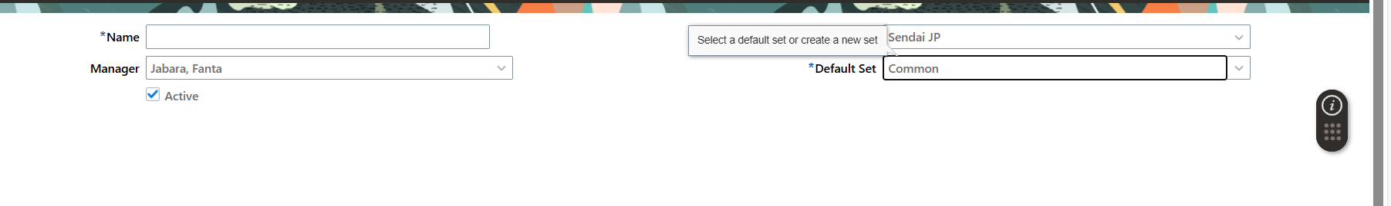

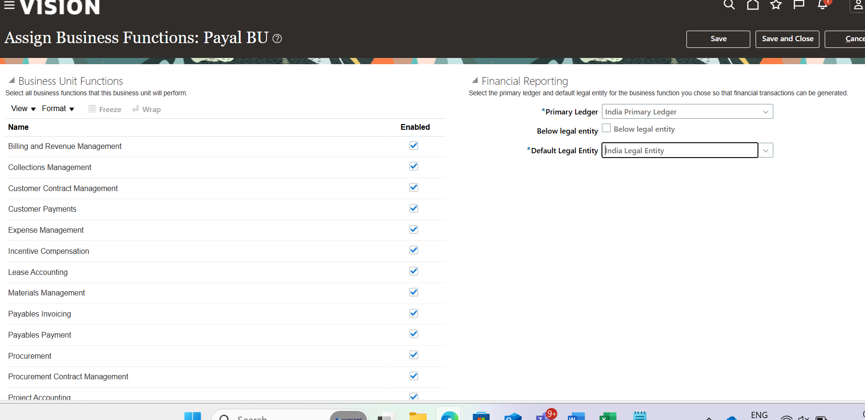

**QUESTIONS**

* 1. **Which column used to link gl_ledger with gl_period_statuses entity**

**ANS : Period_set_id**

* 1. **WHICH TABLE STORES ALL ALL LEGAL ENTITY**

**ANS: HR_ALL_ORGANSATION_UNITS_F**

**AR ACCOUNT RECIEVABLE**

**Table affect is cust_account**

**First wewillcreate customers…gotohome……recievable……manage customer…create**

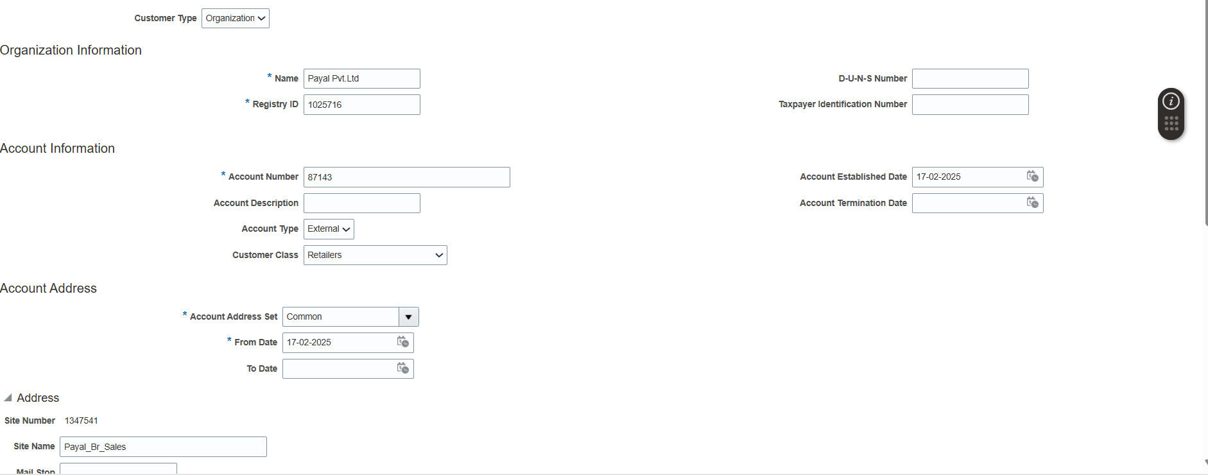

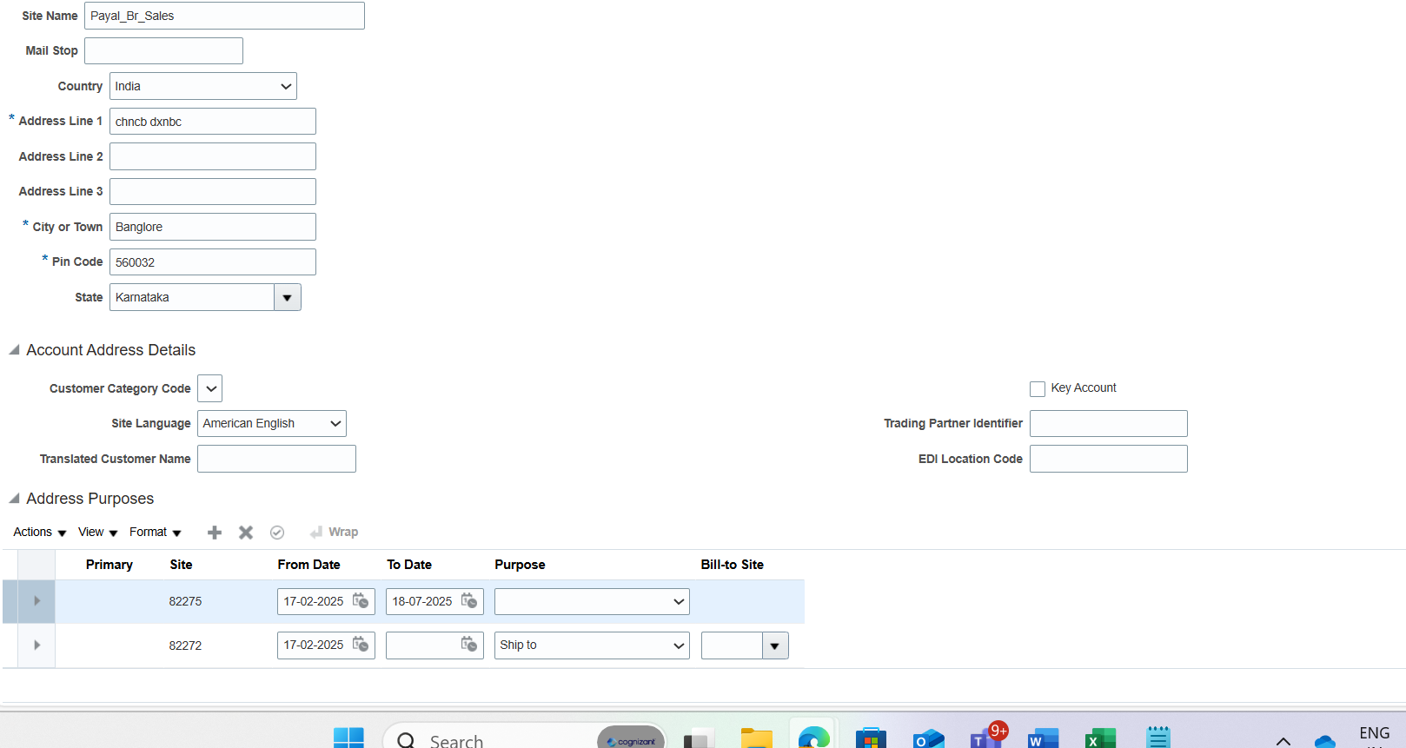

Select bill to purpose and select something bill_to -site of 82272

**CREATE TRANSACTIONS**

PARTY SITE INDIA BU SET BU

PARTY SITE US BU SITE BU

USER

REFERENCE DS BU

For doing transaction we need to select any of the reference

Receivables …..create transaction…..now here only us option is there therefore we need to create customer that use US BU …for that we need to again go to manage customers ..search payal…and again create sites…then save and close….again search your ame ..click your pvt limited……..reference..instide of US write Cust..give values according to ss and click save and close…

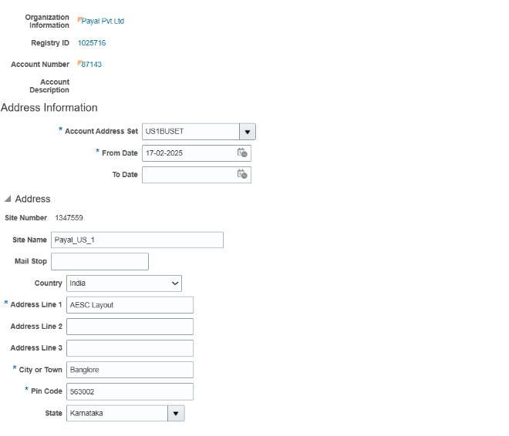

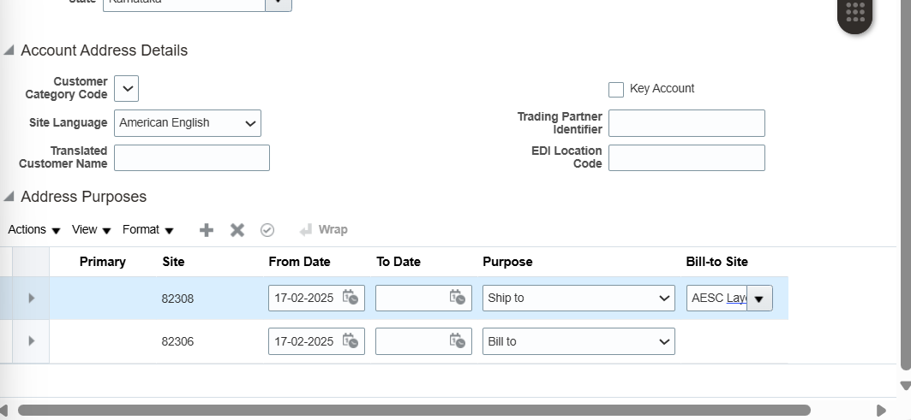 **l**

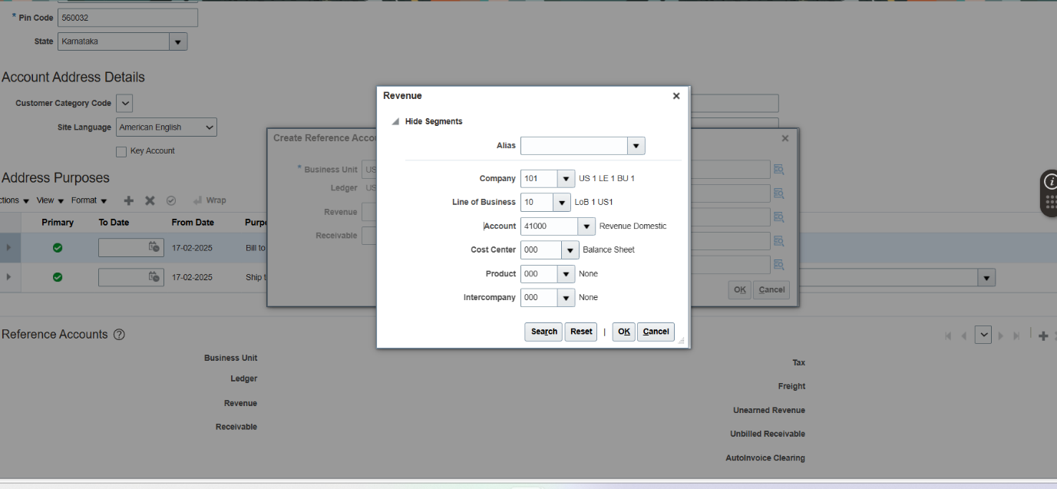

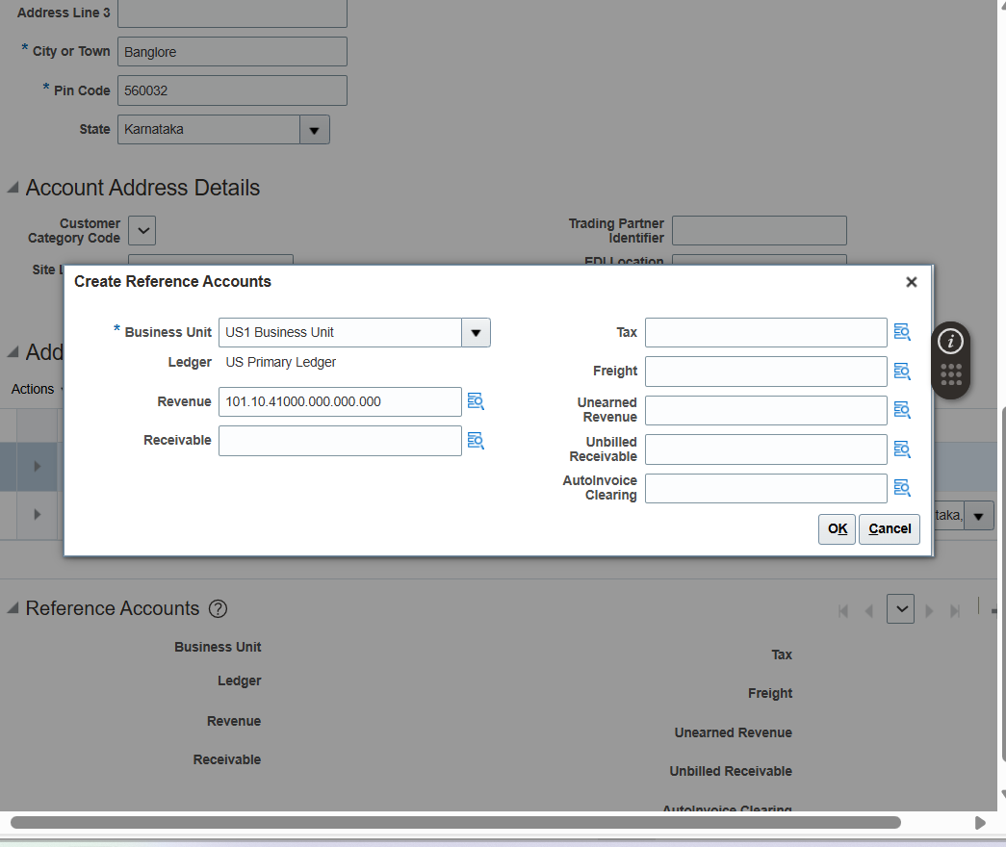

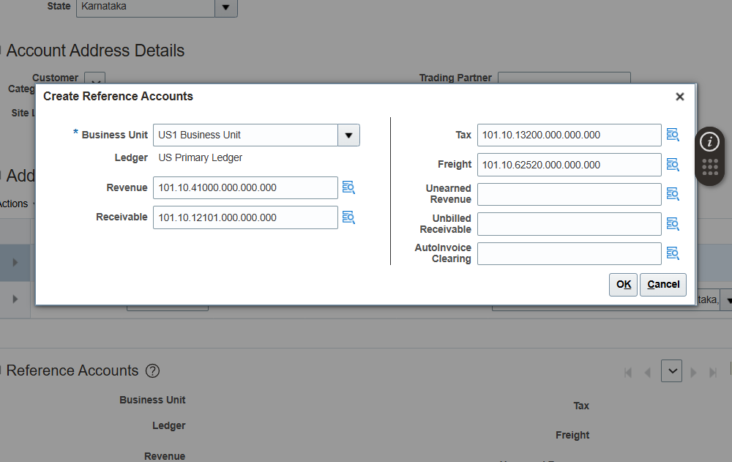

**Customer --à party +account**

**|**

**Site ----à Resource set ---àBU---à**



**Users**

**Recievable credit memo means we will pay money**

**Payable credit memo we will receive money**

**Create transaction**

**Recievable….create transation ….**

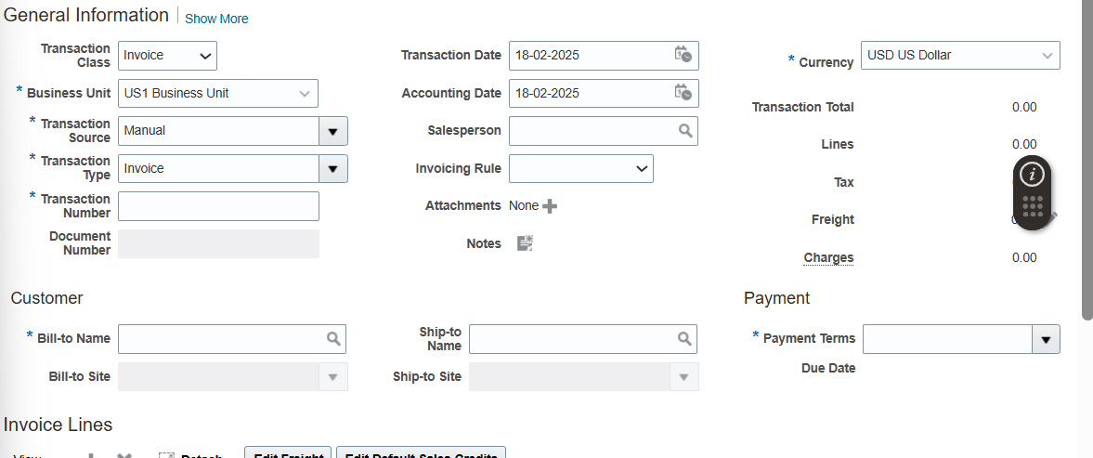

**Do show more…**

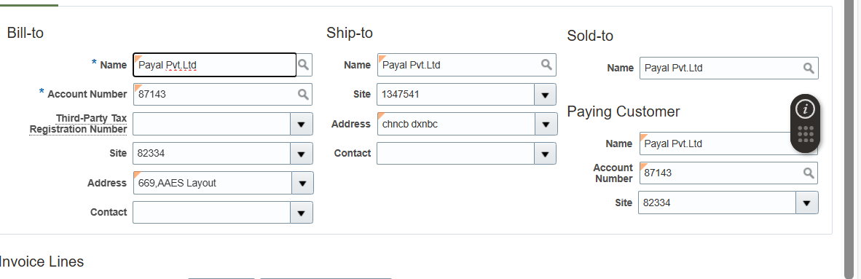

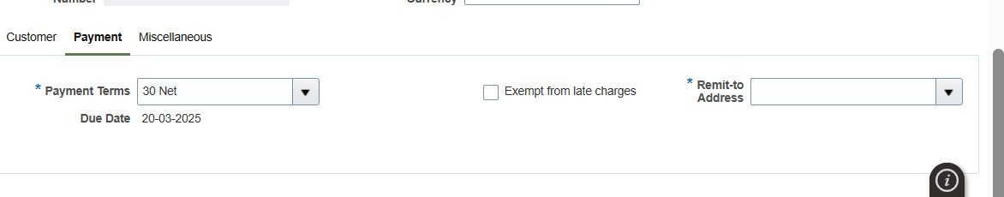

**All these values stores I RA _CUSTOMER_TRX_ALL**

**Recievable invoice is stored in RA**

**Receivable payment is stored in AR** 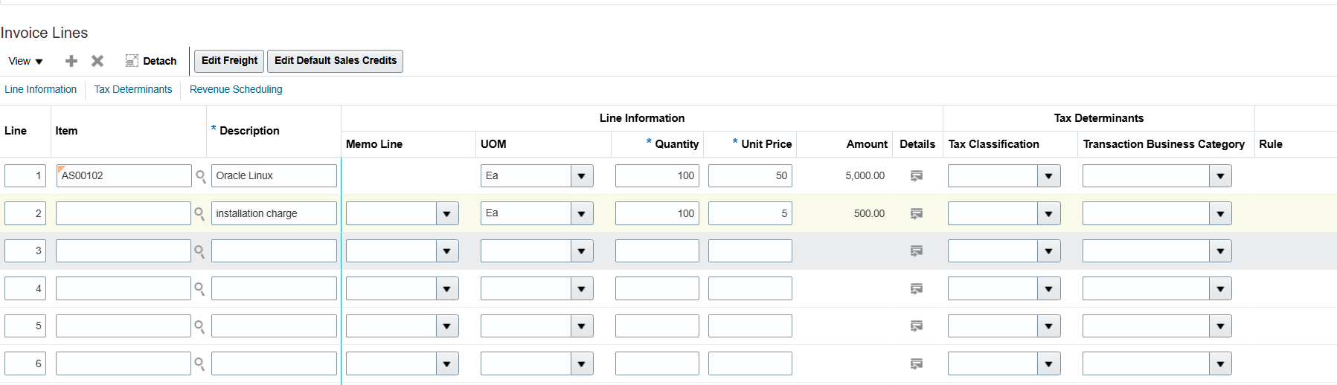

Save and close…complete and review….

Foreign Transactions

Go back..create transation …..

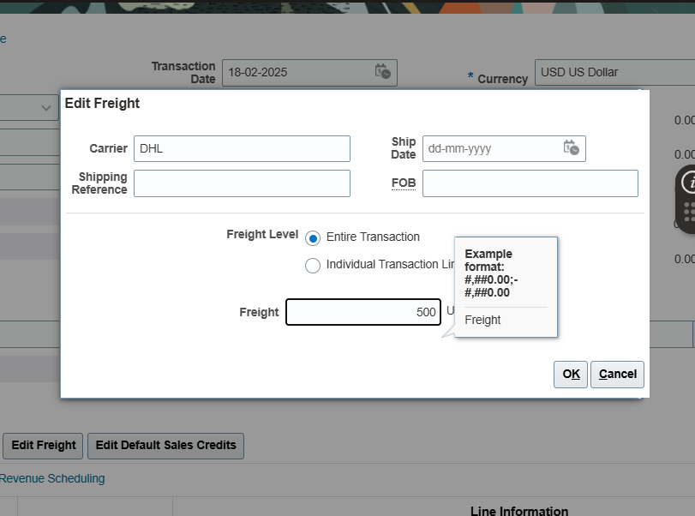

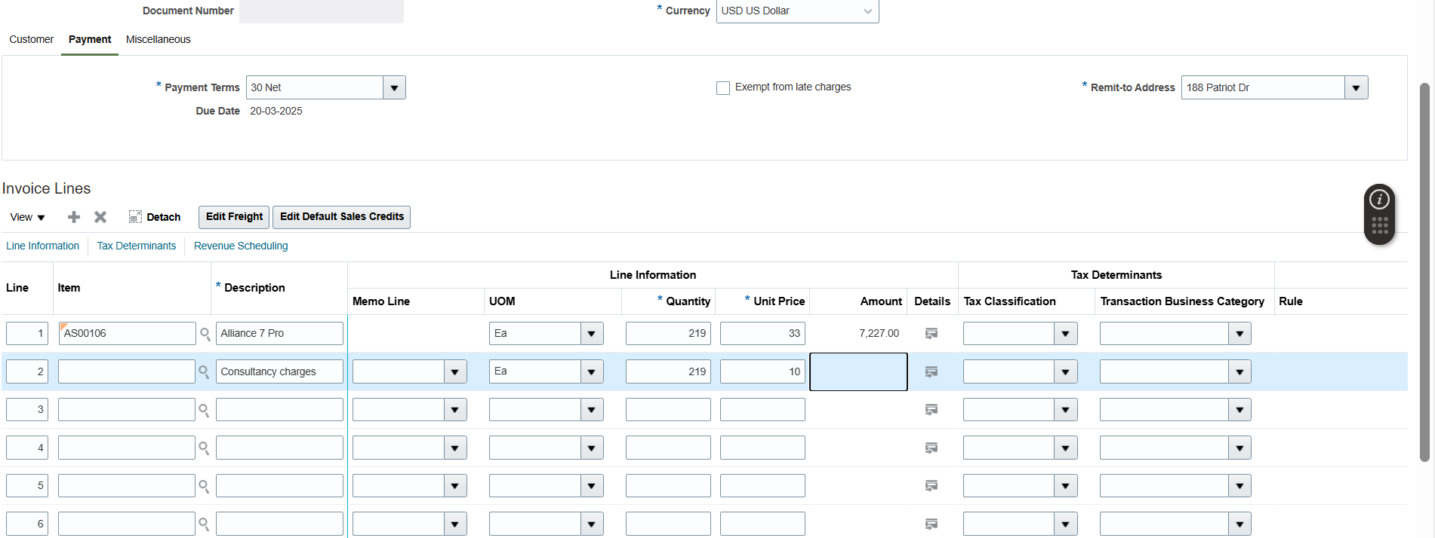

Create credit memo

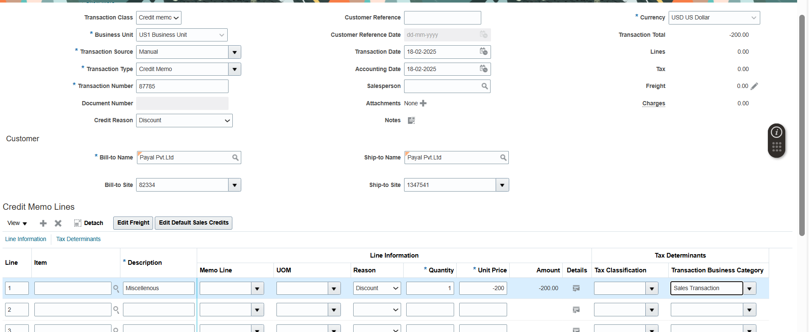

Manage Transaction

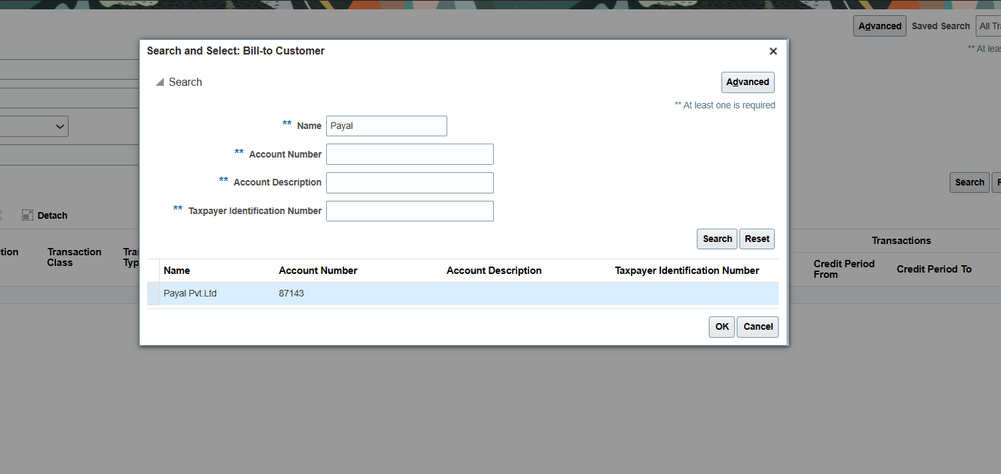

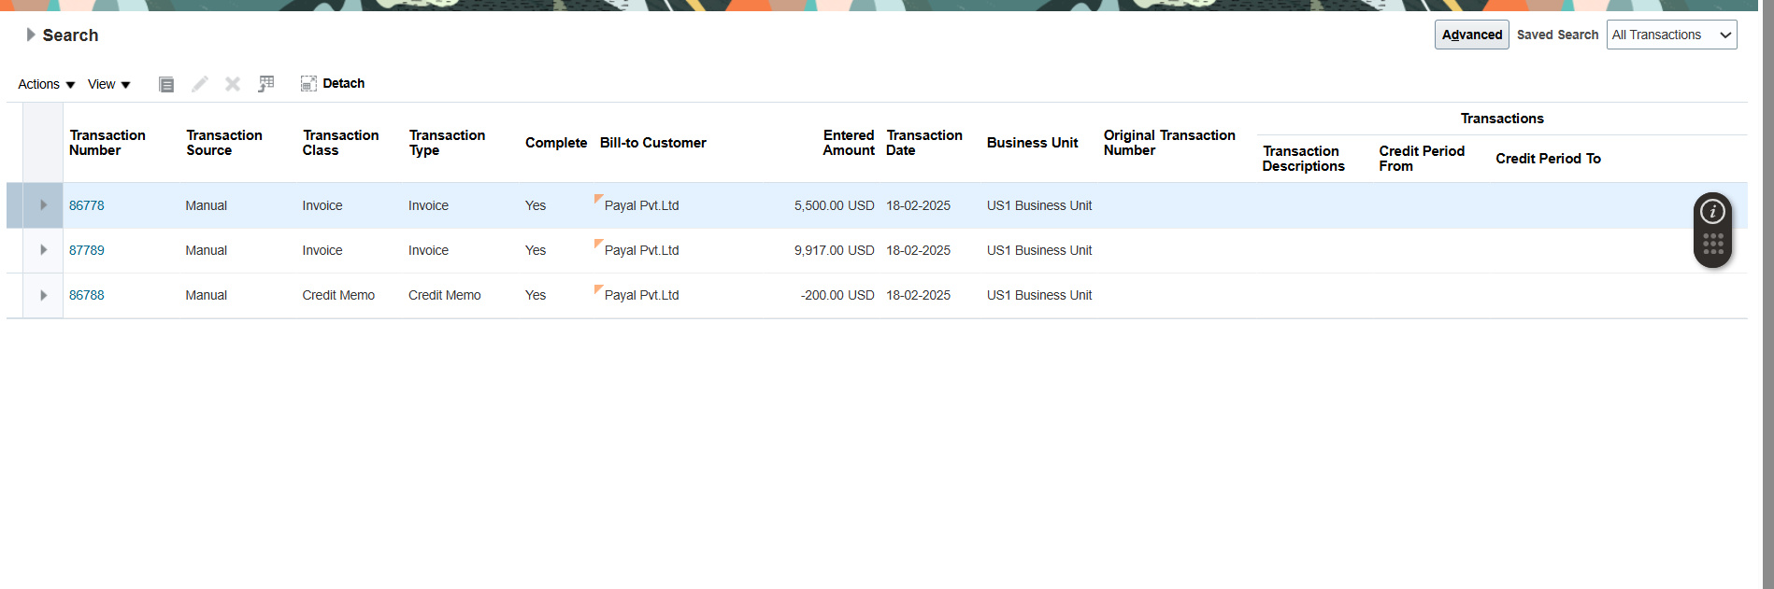

To create reciept

Home…recievable….account recievable….create reciept in the task

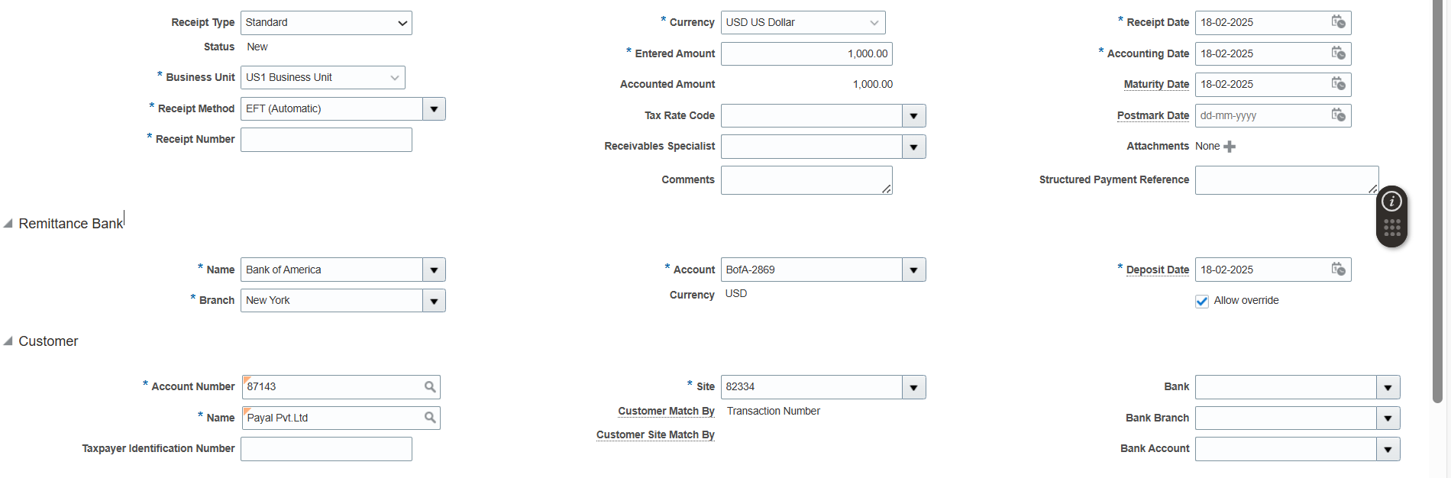

Create bank account….then save and create manually

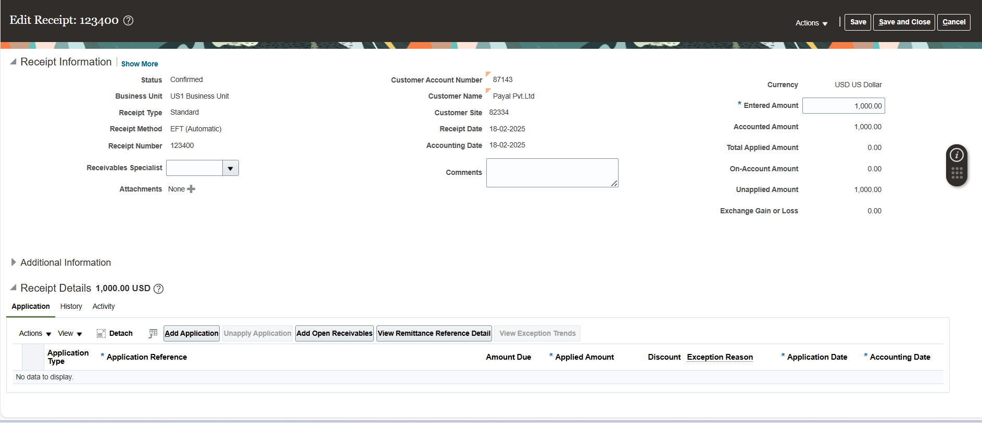

Now how to adjust transactions

go to manage reciept…search your name….select and click edit…add transction…now here to give transaction it..open duplicate…go to manage transaction…search your name….copy..transaction id from it…and paste it to add transaction column which is in another tab…….paste all three transaction….and now make the reciept details 00by adjusting the amount

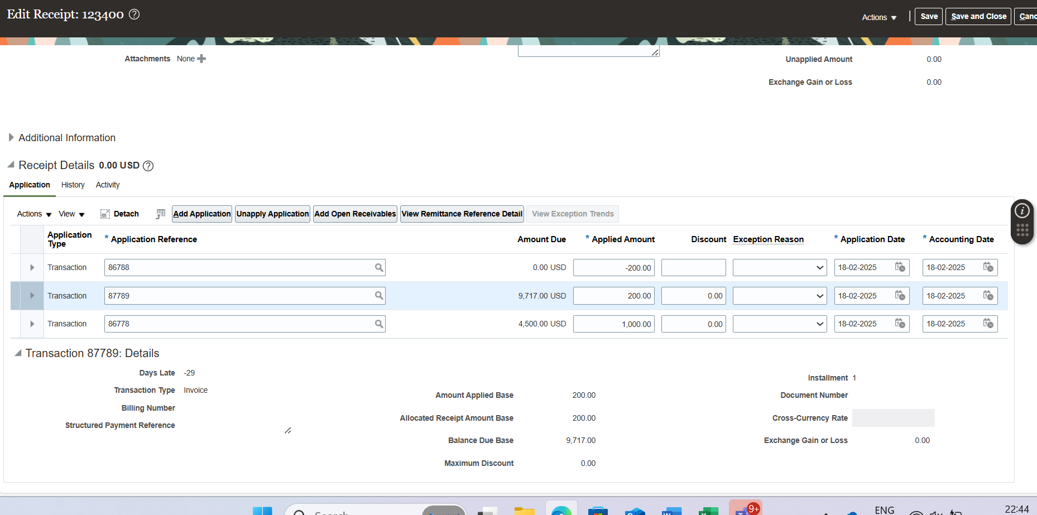sa

**PAYABLES**

**SIDES ---------àBU**

**USER------------àPROCUREMENT**

**There are three types of payment. Quick payment, manual payment,batch payment**

1. FIRST WE NEED TO CHECK WE ARE EMPLOYEES OR NOT…ONLY IF WE ARE EMPLOYEES WE CAN DO PROCERUMENT …for that…go to tool…security console…..user….search FAS17
2. Set procurement

Set up and maintenance…..PAYABLES….manage procerument agent….search US 1 …SAVE and close………search your student,fas17….if it there then it wil get search..if it is not we have to create it….after this go to home ……..procuremet……supplier……CREATE supplier….first create profile…then address…then save and close…using this address we will make site…contact..save and close……..

1. Payables….invoice……..Create an invoice …do pre payment………create general…..then accounting ……..into accounting see down…create line………save it will show never validate…….then go to its next option that is invoice actions ……..validate…..after validatiojn…it will another error for that go to general and change amount to 1090..then again validate….it will show unpaid…manage4e invoice…search your name…select and above it is pay in full..
2. Now we will create standard invoice

Again create invoice……….

1. Create invoice for credit memo…create invoice….
2. Create invoice with multiple distributions…after filling values select the first item and click on distribution
3. Now go to manage invoices there pre payment has been already done…so to manage that pre payment(1000) we will pay it through other payments except credit payment for that select that payment go to actions select apply and pre apply…..then again validate all invoice
4. Now to do the whole payment ………..home…payable...payment…create payment…then add invoices to pay by select and add…….change amount….save and close…then to check..go to manage payment and search

This was quick payment now we will do batch payment in which we can do payment to multiple supplier………..at one

1. Go to .payable…payamnt………task…..submit payment process request………



